**Social Studies Review**

**Chapters 1 – 9**



INTRODUCTION – **OUR WORLDVIEWS**

**Worldview** – is a collection of values (a moral standard of behaviour) and beliefs (something accepted as true) about life that is common to a group. . . in other words, the basis for the way you act, way your react and way you feel about the world.

**Society** - a group of people linked by common activities or interests and sharing a location; a group of humans defined by mutual interests, shared institutions and a common culture

**Western world** – societies that are based on the worldview that developed in western Europe

Example: A worldview of people in the western world

* All people are treated equals
* Individuality is important
* Basic education should be available to all
* Democracy
* Gaining wealth is important in order to have comfortable life
* Humans are superior to all other life forms

As Canadians we have common values and beliefs in our approaches, ie. medical care, education, religion, arts, etc. that is different from worldviews from other countries.

Due to Canada’s size, our worldview may change slightly if you live on the East Coast, West Coast, Ontario or prairie provinces. It may be slightly different again if you are aboriginal (oral traditions, ties to the land) vs francophone (religion, language and education rights) vs Anglophone.

Canada is multicultural and immigrants bring their worldview with them to Canada, as they become part of Canadian society, they begin to understand and adopt our values and beliefs.

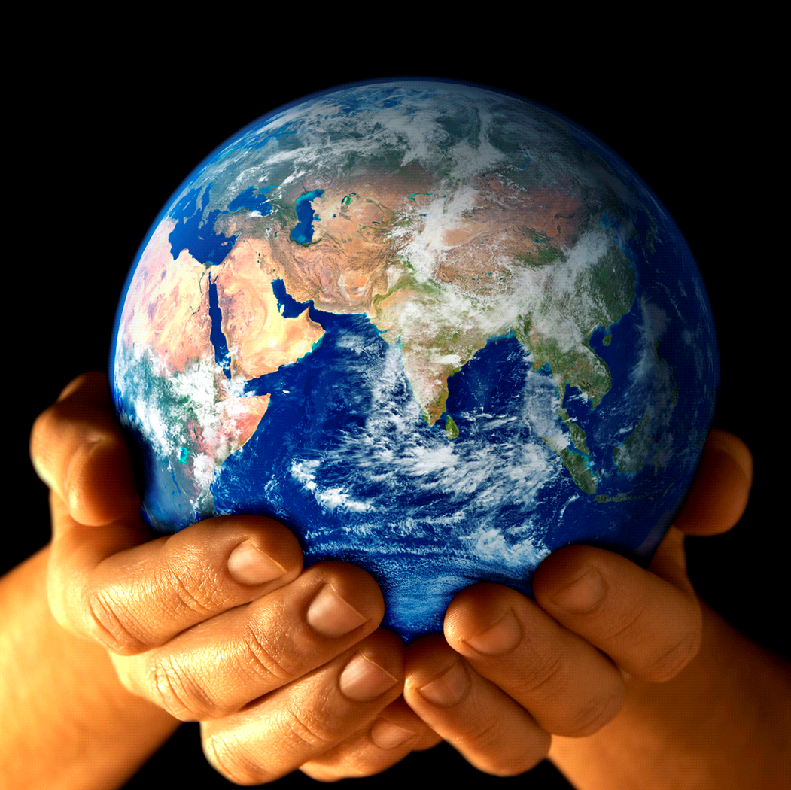

**ELEMENTS OF SOCIETY AFFECTED BY WORLDVIEW**

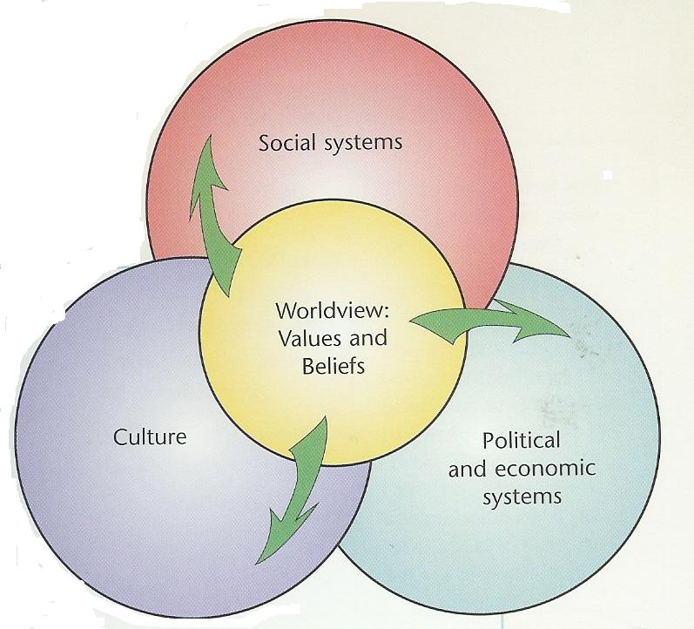

Social systems – organization and relationships among people, such as the types of education, medical and social services a society provides

Political and economic systems

* political system relates to the way government is organized, the role of citizens in gov’t, and rights given to citizens
* economic systems relate to methods by which people produce and distribute goods and services they need

Culture – way of life of a group of people, including language, rules of behaviour, religion, spirituality, arts, literature, sciences, traditions, and other everyday aspect of life

***1. What are the elements of society affected by worldview:***

1. _______________________________________________
2. _______________________________________________
3. _______________________________________________

**FACTORS AFFECTING WORLDVIEW**

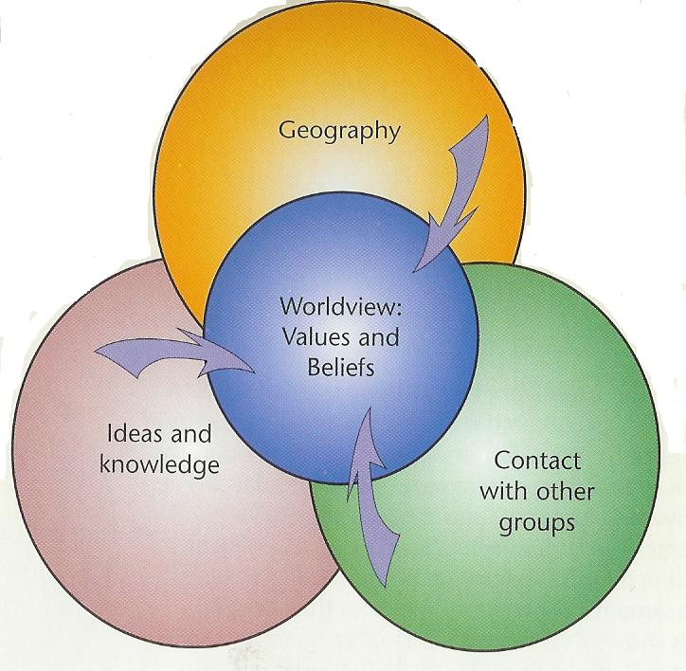

Different factors influenced and caused changes in the societies and their worldview:

**Geography** – where a group of people live, the climate, land formations, plants and animals, bodies of water, and natural resources

**Ideas and knowledge** – what a group knows; scientific, intellectual, technological, artistic, and spiritual knowledge

**Contact with other groups** – contact and interactions between societies and between different groups in a society

Worldview is usually a gradual change over time based on the above factors but it also can be unexpected, earth shattering event that shakes society and causes citizens to examine their worldview. Example: twin towers, BSE

***2. What are the factors affecting worldview***

* 1. _______________________________________________
  2. _______________________________________________
  3. _______________________________________________

**HOW DID THE EXCHANGE OF IDEAS AND KNOWLEDGE DURING THE RENAISSANCE SHAPE THE WORLDVIEWS OF THE WESTERN WORLD?**

***3. Define the following terms:***

**Renaissance -** _____________________________________________________________________________

_________________________________________________________________________________________

**CE** – ____________________________________________________________________________________

**Era** – ____________________________________________________________________________________

**Century** – _________________________________________________________________________________

**Middle Ages** – _____________________________________________________________________________

_________________________________________________________________________________________

**Astrolabe - _______________________________________________________________________________**

**Crusade** – ________________________________________________________________________________

_________________________________________________________________________________________

**Judaism** – ________________________________________________________________________________

**Christianity** – _____________________________________________________________________________

**Islam** – ___________________________________________________________________________________

**Pilgrim** – _________________________________________________________________________________

**Feudal system** – __________________________________________________________________________

_________________________________________________________________________________________

**diplomacy** – _______________________________________________________________________________

**alliance** – _____________________________________________________________________________

**hierarchical** – _______________________________________________________________________________

**Renaissance Introduction**

* 1350 CE – 1600 CE
* renaissance is a French word *renaitre*, meaning “to be born again”
* period of time in which innovations based on the rediscovery of ancient Greek and Roman thinking and the thinking of other civilizations Europeans came into contact with
* many advanced ideas of the Greek and Romans had been lost or ignored in Europe for 1000 years
* European scholars rediscovered classical documents and discovered new ideas and ways of looking at the world

**History**

* 2000 years ago Europe was part of Roman Empire
* empire was divided into 2 sections during the 4th century to prevent civil war
* Roman empire (Europe and west coast north Africa)
* Byzantine Empire (East coast of Mediterranean Sea and east coast north Africa)
* Roman Empire broke apart into smaller states and was plunged into what is called the “dark ages” or “middle ages”
* Roman Empire succumbed to a loss of civic virtue among its citizens, greed, corruption, internal strife and lazy/soft, [outsourcing](http://en.wikipedia.org/wiki/Outsourcing) their duties to defend their Empire to mercenaries (work for anyone who would pay them) caused the breakdown
* Both Roman and Byzantine Empire were predominantly Christian

**HOW DID OTHER CIVILIZATIONS SET THE STAGE**

**FOR THE RENAISSANCE IN EUROPE?**

* During the Middle ages many civilizations flourished in other parts of the world:
  + Mayan empire reached it’s peak
  + Inca and **Aztec** empires beginning to flourish
  + African empires (Mali, Ghana) were centres of learning, trade and wealth
* Asian and Northern African empires influenced the Europe’s out the Middle Ages into the Renaissance

The Silk Road

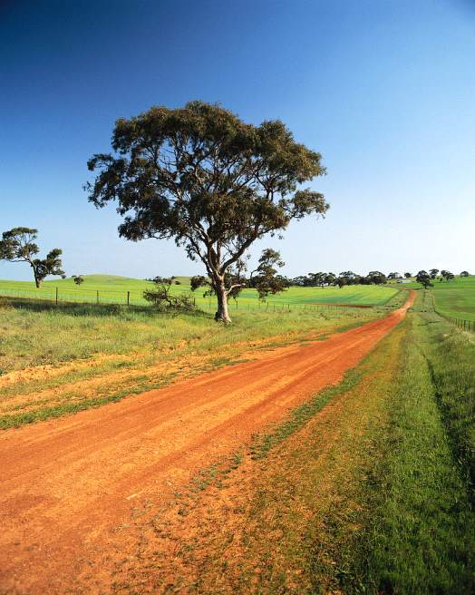

* interconnected series of ancient trade routes through various regions of the Asian continent mainly connecting [China](http://en.wikipedia.org/wiki/China), with [Asia Minor](http://en.wikipedia.org/wiki/Asia_Minor) and the [Mediterranean](http://en.wikipedia.org/wiki/Mediterranean)
* extends over 8,000 km (5,000 miles) on land and sea
* trade on the Silk Road was a significant factor in the development of the great [civilizations](http://en.wikipedia.org/wiki/Civilization)
* it helped to lay the foundations for the modern world
* traded exotic goods: silks, glassware, paper, spices (pepper/cinnamon), apples/oranges, etc.
* trade went both ways from china to Mediterranean and back
* consumers demands increased the size and links of the trade route both for profit and new businesses
* ideas and knowledge, understandings of religion, science, technology, philosophy, music, math passes from society to society also on the route – sharing worldviews.
* inventions such as irrigation waterwheels also moved along the trade route
* Diseases also passed through the route (ie. black death or plague)

4. What is the Silk Road and what role did it play in the development of the Renaissance? Include at least 5 points.

___________________________________________________________________________________________

____________________________________________________________________________________________

___________________________________________________________________________________________

_______________________________________________________________________________________________________________________________________________________________________________________

____________________________________________________________________________________________

Role of Islamic Civilization

* Islamic faith spread from the Arabian area to other areas east to Spain and west to Indonesia
* Centre of Islamic world was at crossroads of Silk road
* Muslim became the middlemen for the Silk road and became very wealthy
* Muslim empire also became the centre of learning during the middle ages
* Scholars collected knowledge, documents, took math ideas from the far east and refined them into the understanding of numbers known today
* Invented aids to help with navigation, such as the astrolabe
* Medical textbooks were written based on studies of disease

5. Islamic civilization impacted the renaissance. In what ways did it impact? Include at least 3 points.

___________________________________________________________________________________________

____________________________________________________________________________________________

___________________________________________________________________________________________

**HOW DID THE RENAISSANCE BEGIN?**

* 1300’s changes were occurring in Europe
* contact with other cultures was increasing and the exchange of ideas was increasing the ability to change
* this change was seen more rapidly in Italy, the hub of the Renaissance
* Middle ages – most Christians believed that God was the centre of human existence, the beliefs of the poor were they had a . . .harsh, short life on earth, they would be rewarded after death
* If you were a wealthy person in the middle ages you could be assured a spot in heaven if you paid money to the church (roman catholic)
* Religion was the central point of their beliefs, no one disagreed with the church as you then couldn’t get into heaven, church then was prosperous and rich
* You couldn’t talk to god yourself but had to go through the priest, therefore paying money you would be assured your message got through
* Art and architecture therefore were heavily influence by religion, as the church hired, thinkers and artists to work for them
* Priest were send as god’s chosen representative
* Pope extremely powerful, ruling both the church and the money, he influenced kings, kingdoms and people’s beliefs and actions – power struggles happened between kings and the pope



**The Crusades**

* Europe tried to recapture areas of Middle East under Muslim control
* Jews, Christians and Muslims considered these areas holy
* Sanctioned by the pope, crusades originally had the goal of recapturing Jerusalem and the Holy land from Muslim rule
* Campaigns against pagans or heretics and people who had been excommunicated for a mixture of religious, economic, and political reason
* Exposed Europeans to more cultures and ways of life
* Thousand of religious pilgrims traveled to these sites to seek god’s favor
* Travelers on these pilgrims brought back new ideas and attitudes that led to new ways of thinking about their own lives and society

***6. Define crusade_____________________________________________________________***

***_______________________________________________________________________________***

**HOW DID THE SOCIAL STRUCTURE DURING**

**THE MIDDLE AGES REFLECT THE**

**WORLDVIEW OF THE TIME?**

* Feudal system well established
* Monarchs granted land to nobles in return for military support
* Wealthy/powerful landholding nobles formed alliances from diplomacy to support monarch
* Land subdivided to lesser nobles/knights (taxes, supplies)
* Serf/peasants (90%)were property of nobles and worked land for them, provided military labour – nobles in return offered them protection from invaders
* Never moved outside of your class, not part of the medieval worldview
* People believed their situation was god’s will and his will was not to be questioned
* Nobles lived in castles and manor homes and peasants in huts

***7. Match the following words with there definition.***

**Definitions:**

**________ Urbanization**

**________ Value judgment**

**________ papacy**

**________ republic**

**________ despot**

**________ oligarchy**

**________ sovereignty**

**________ aristocracy**

**________ guild**

**________ basilica**

**________ armory**

**________ fresco**

1. pope and the gov’t of the Roman Catholic Church
2. the nobility or those with inherited titles
3. an opinion based on a person’s individual values and beliefs
4. a Roman Catholic cathedral of particular honour
5. an organization of craftsmen or merchants
6. a supreme power and authority; the freedom of a country or political unit from outside control
7. leader with unlimited power; a tyrant or oppressor
8. the movement of population away from the countryside and into cities
9. a place where weapons and ammunition are kept
10. a state in which power is held by the people or their representatives
11. a form of government in which a few people have the power
12. a watercolour painting done on a wall or ceiling on wet plaster

**HOW DID THE GROWTH OF CITIES CONTRIBUTE TO A CHANGING WORLDVIEW?**

**Trade**

* European wanted more exotic spices, silks, etc,
* Merchants hired to open new trade routes to all parts of known world (North Africa, Middle East, India and China)
* New trade routes began a revival in business and shipping
* Increase contact with traders from Islamic societies
* Merchants and traders grew wealthy in Europe and a new class outside of the feudal system was forming
* Increase trading meant increase in city growths (ie. Paris, Florence, Venice, population of at least 100,000 each)
* Increase population meant demand for foods and products and led to change in way people lived:
  + Establishment of new business
  + Industries began to form (textile, furniture, handicrafts, etc.)
  + Workers finding jobs and less dependent on nobles
  + Communities became prosperous/powerful in trade, industry and banking and formed city-states(a city that governs itself and the countryside surrounding it)
  + Individuals began to feel sense of belonging to a community (citizens) vs serf belonging to a local lord

**Urbanization**

* Peasants that survived the plague wanted a better life for themselves and moved to cities to find work
* Nobles did not have enough peasants to plant and harvest land and a lot left their lands to move to the cities
* Most people migrated to Italian cities because they were in the middle of the established trade routes and a successful shipping industry
* Florence, Genoa, Venice and Milan became very powerful cities due to success in commercial centres of banking, trade, commerce and industry
* These city-states prospered for the following reasons:
  + Mountains to north help protect Italy from northern invaders and water around Italy helped protect it
  + Italy had been involved in the trade routes since 10th century
  + Feudal system was not strong due urban lifestyle and lack of agricultural land
  + Ancient city of Rome reminded people how effective that style of government had been
  + Power of Roman Catholic Church of Italian city-states weakened when they move the papacy to Avignon South France. Pope and top clerics were French.
  + Italian city governed themselves without much interference from church.
  + Many city-states organized themselves into republics (a group of citizens, rather than a monarch, governs the state)
* By 14th century most city-states had failed and were usually ruled by despots and oligarchies.
* Warfare among city-states over territory and trading routes was common
* City-states of Florence, Venice, Milan and Naples signed a Treaty of Lodi 1454 which brought stability to area – basically no city-state was allowed to become powerful enough to overthrow any other city-state. This allowed those cities to focus on improving trade and amassing huge wealth.
* Around 15th century, city-states sent ambassadors to foreign courts/states to keep in touch with allies and enemies
* These alliances were achieved through diplomacy and marriages

***8. Why was trade so important in the growth of the city-states?***

**_________________________________________________________________________________________**

_________________________________________________________________________________________

_________________________________________________________________________________________

**HOW DID THE CITY-STATE OF FLORENCE REFLECT THE RENAISSANCE WORLVIEW?**

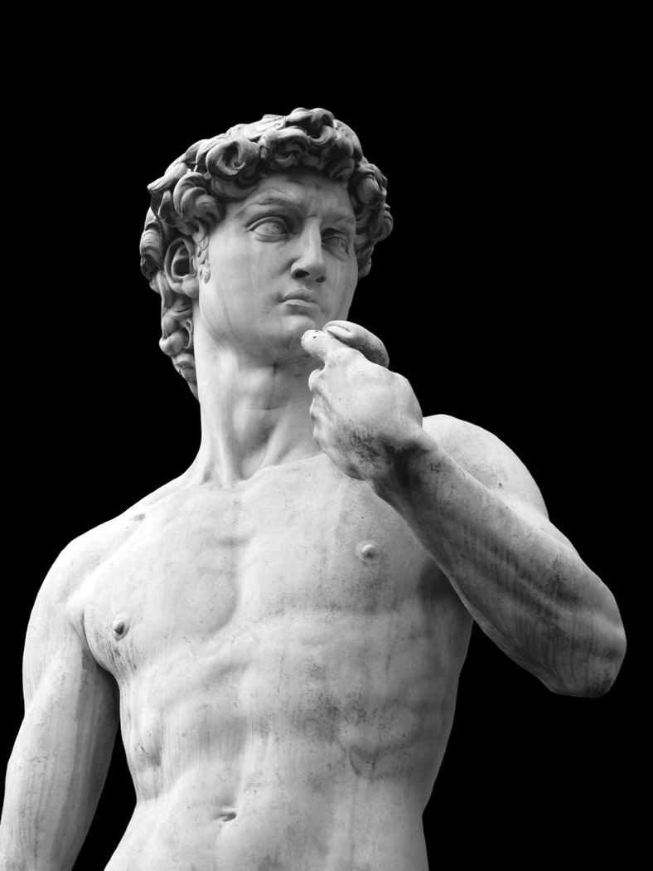

**Political and Economic Systems**

* Built on Arno River, trade route before renaissance period
* During renaissance time trade increased and became centre of successful bankers, silk and wool merchants
* Hilly terrain was not good for farming but perfect for sheep
* Bankers supported pope and pope gave bankers papacy financial business
* So rich bought surrounding cities (Aresso, Lucca, etc)
* Started as a republic, many to power struggles among groups ending in Medici family taking control of city

**Social Systems**

* Florence based on class system but merchant class people moved up the social ladder
* Merchant class people were call the *popolo grasso* (fat people)
* Merchant class people organized into guilds (silk manu, wool manu., bankers, etc.)
* Workers and shopkeepers called *popolo minuto* (little people), peasants from the country, not allowed to belong to the guilds
* Nobles still owned land and live on estates outside of city

**Culture**

* Florence became major centre of Renaissance culture under Medici family control
* Medici family support arts, architects and scholars developing the city
* Ideas of citizenship were promoted
* Catherine de Medici married to King of France to form alliances, she was also niece of the Pope at that time

**HOW DID THE CITY-STATE OF VENICE CONTRIBUTE TO THE ITALIAN RENAISSANCE?**

* Well established in trading since 5th century
* Controlled most of the ports in Adriatic Sea and Eastern Mediterranean

**Social System**

* 3 social classes
  + aristocracy, original noble families who controlled Venice and vote for government
  + *Cittadini Originarii* or “original citizens” of republic who could hold public office but not vote
  + Common people, some rights, apply for some gov’t positions

**Government**

* Aristocracy rule they could only vote for doge (head of government) and belong to government
* 2% of population made up oligarchy that ruled Venice
* “Original Citizens” bought positions in the aristocracy if wealthy enough
* government or great council made decisions and doge was elected for life but was overshadowed in the government by the great council members

**Scuole**

* Citizens of Venice implemented new social institutions during Renaissance out of civic duty
* Scuole assc. met for prayer and masses , collected money for good causes
* Scuole developed from fear of punishment in the afterlife for sins committed
* Donations and good deeds lessened the punishment after death
* Rich and poor donated money to support the sick, elder, widows etc.

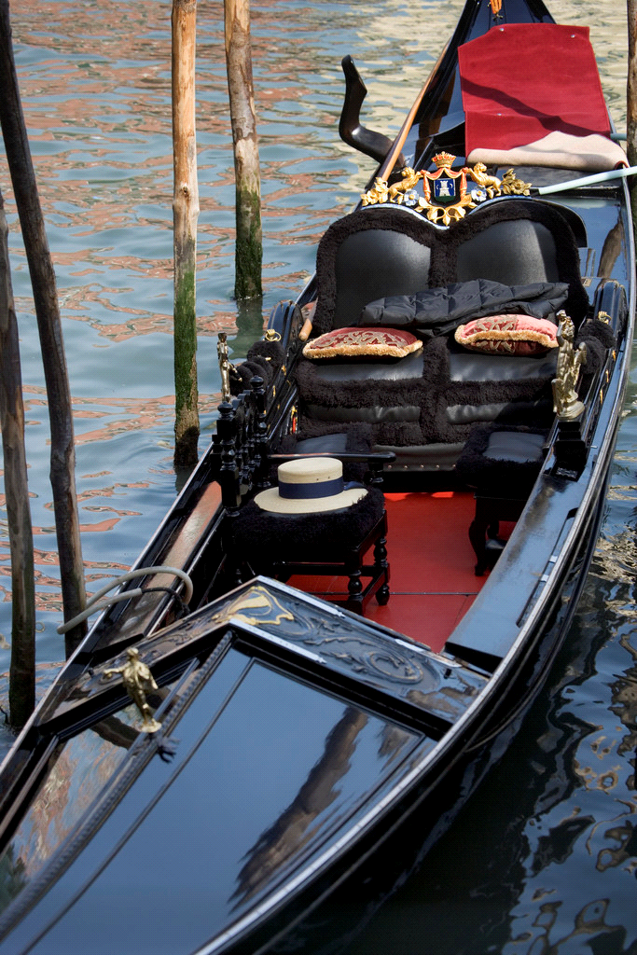

* This was the precursor to employment insurance

Venice Gains Importance because:

* Stable form of government
* Successful sea trade (shipyards, naval base, armory)
* Merchant class support the arts
* First city-state to use mechanical printing press and you could get books
* Created university to promote science, medicine and law

**HOW DID THE CITY-STATE OF   
GENOA HELP SHAPE THE RENAISSANCE WORLDVIEW?**

* Port city surrounded by high walls to protect inhabitants from invaders
* Major city of trade and commerce
* Played strong role in crusades for transporting crusading armies to the Holy Land
* Genoa citizens paid well for this service
* Genoa’s traders quickly developed markets at key ports on the Black sea and trade flourished as did the navy, shipbuilders, traders
* Venice and Genoa were rivals and fought to gain control of lucrative trading posts

**Government and Social System**

* A republic governed by rival clans or families
* Families agreed to a truce in 13th century and split the city into sections each could control
* Genoa’s strength declined to loss of key port (Constantinople) by the Black Sea
* Genoa experienced the Renaissance in art and architecture later in 15th century

***9. List 3 points for each of the city states (Florence, Venice and Genoa) why they were important in shaping the renaissance worldview?***

**Florence**

1. **______________________________________________________________________________________**
2. **___**___________________________________________________________________________________
3. ______**________________________________________________________________________________**

**Venice**

1. **______________________________________________________________________________________**
2. **___**___________________________________________________________________________________
3. ______**________________________________________________________________________________**

**Genoa**

1. **______________________________________________________________________________________**
2. **___**___________________________________________________________________________________
3. ______**________________________________________________________________________________**

**Chapter 2**

**How did the ideas of the Italian Renaissance spread throughout Europe?**

***10. Define a Capitalist Society._______________________________________________***

_______________________________________________________________________________________

**Where and How did Renaissance ideas begin to spread?**

* Scholars and artist from all over Europe traveled to Italy to study and exchange ideas
* Brought back ideas to their area which then adapted to their own uses
* Writers, scientists, mathematicians, etc. applied these ideas to their daily works and new ideas were formed

The following ideas prevented the Renaissance from spreading beyond Italy until early 15th century.

Feudalism

* lands beyond Italy were agricultural and therefore feudal system well established and being used, not welcome to new ideas
* tension between monarchs and nobles who owned fiefdoms
* monarchs wanted change but nobles didn’t
* nobles undermined the monarch

War

* 15th century many wars between England, France, Germany, Netherlands
* resources used for military campaigns, survival, expansion and not arts/sciences
* war also limited travel

Religion

* Church played strong role in Northern Europe due to move to Avignon France in 1309 to 1377
* Church maintained status quo and didn’t want people to think for themselves

**What allowed the Renaissance ideas after early 15th century?**

Ideas of Renaissance spread beyond Italy in the early 15th century because:

* Decline of feudalism helped monarchs gain more power and allow people more freedom to explore changes in society and new ideas in arts, sciences and philosophy
* War between France/Germany and Italy brought the Renaissance movement into the spot light: northern Europe hired many Italy craftsmen and scholars to come to their courts to show what they could do and to increase the sophistication of their people
* Growth of humanism and power of the monarchs led to competition for the authority over the people against the RC church
* Invention of the printing press, books could now be produced and distributed for anyone to read instead of the previous copying the book by hand. Allowed anyone to learn to read.

***11. List 3 reasons why the renaissance was slow to spread before the 15th century and why it began to spread in the 15th century.***

|  |  |
| --- | --- |
| **Before 15th century** | **Early 15th century** |
|  |  |
|  |  |
|  |  |
|  |  |

***12. Vocabulary Crossword***

|  |  |  |  |  |  |  |  |  |  |  |  |  |  |  |  |  |  |  |  |  |  |  |  |  |  |  |  |  |  |  |  |  |  |  |  |  |  |  |  |  |  |  |  |  |  |  |  |  |  |  |  |  |  |  |  |  |  |  |  |  |  |  |  |  |  |  |  |  |  |  |  |  |  |  |  |  |  |  |  |  |  |  |  |  |  |  |  |  |  |  |  |  |  |  |  |  |  |  |  |  |  |  |  |  |  |  |  |  |  |  |  |  |  |  |  |  |  |  |  |  |  |  |  |  |  |  |  |  |  |  |  |  |  |  |  |  |  |  |  |  |  |  |  |  |  |  |  |  |  |  |  |  |  |  |  |  |  |  |  |  |  |  |  |  |  |  |  |  |  |  |  |  |  |  |  |  |  |  |  |  |  |  |  |  |  |  |  |  |  |  |  |  |  |  |  |  |  |  |  |  |  |  |  |  |  |  |  |  |  |  |  |  |  |  |  |  |  |  |  |  |  |  |  |  |  |  |  |  |  |  |  |  |  |  |  |  |  |  |  |  |  |  |  |  |  |  |  |  |  |  |  |  |  |  |  |  |  |  |  |  |  |  |  |  |  |  |  |  |  |  |  |  |  |  |  |  |  |  |  |  |  |  |  |  |  |  |  |  |  |  |  |  |  |  |  |  |  |  |  |  |  |  |  |  |  |  |  |  |  |  |  |  |  |  |  |  |  |  |  |  |  |  |  |  |  |  |  |  |  |  |  |  |  |  |  |  |  |  |  |  |  |  |  |  |  |  |  |  |  |  |  |  |  |  |  |  |  |  |  |  |  |
| --- | --- | --- | --- | --- | --- | --- | --- | --- | --- | --- | --- | --- | --- | --- | --- | --- | --- | --- | --- | --- | --- | --- | --- | --- | --- | --- | --- | --- | --- | --- | --- | --- | --- | --- | --- | --- | --- | --- | --- | --- | --- | --- | --- | --- | --- | --- | --- | --- | --- | --- | --- | --- | --- | --- | --- | --- | --- | --- | --- | --- | --- | --- | --- | --- | --- | --- | --- | --- | --- | --- | --- | --- | --- | --- | --- | --- | --- | --- | --- | --- | --- | --- | --- | --- | --- | --- | --- | --- | --- | --- | --- | --- | --- | --- | --- | --- | --- | --- | --- | --- | --- | --- | --- | --- | --- | --- | --- | --- | --- | --- | --- | --- | --- | --- | --- | --- | --- | --- | --- | --- | --- | --- | --- | --- | --- | --- | --- | --- | --- | --- | --- | --- | --- | --- | --- | --- | --- | --- | --- | --- | --- | --- | --- | --- | --- | --- | --- | --- | --- | --- | --- | --- | --- | --- | --- | --- | --- | --- | --- | --- | --- | --- | --- | --- | --- | --- | --- | --- | --- | --- | --- | --- | --- | --- | --- | --- | --- | --- | --- | --- | --- | --- | --- | --- | --- | --- | --- | --- | --- | --- | --- | --- | --- | --- | --- | --- | --- | --- | --- | --- | --- | --- | --- | --- | --- | --- | --- | --- | --- | --- | --- | --- | --- | --- | --- | --- | --- | --- | --- | --- | --- | --- | --- | --- | --- | --- | --- | --- | --- | --- | --- | --- | --- | --- | --- | --- | --- | --- | --- | --- | --- | --- | --- | --- | --- | --- | --- | --- | --- | --- | --- | --- | --- | --- | --- | --- | --- | --- | --- | --- | --- | --- | --- | --- | --- | --- | --- | --- | --- | --- | --- | --- | --- | --- | --- | --- | --- | --- | --- | --- | --- | --- | --- | --- | --- | --- | --- | --- | --- | --- | --- | --- | --- | --- | --- | --- | --- | --- | --- | --- | --- | --- | --- | --- | --- | --- | --- | --- | --- | --- | --- | --- | --- | --- | --- | --- | --- | --- | --- | --- | --- | --- | --- | --- | --- | --- | --- | --- | --- | --- | --- | --- | --- | --- | --- | --- | --- | --- | --- | --- | --- | --- | --- | --- | --- | --- | --- | --- | --- | --- | --- | --- | --- | --- | --- | --- | --- | --- | --- | --- | --- |
| |  |  |  |  |  |  |  |  |  |  |  |  |  |  |  |  |  |  |  | | --- | --- | --- | --- | --- | --- | --- | --- | --- | --- | --- | --- | --- | --- | --- | --- | --- | --- | --- | |  |  |  |  |  | 1 |  | 2 |  | 3 |  |  |  |  |  |  |  |  |  | |  |  |  |  |  |  |  |  |  |  |  |  |  |  |  |  |  |  |  | |  |  | 4 |  |  |  |  |  |  |  |  |  |  |  |  |  |  |  |  | |  |  |  |  |  |  |  |  |  |  |  |  |  |  |  |  |  |  | 5 | |  |  |  |  |  |  |  |  |  |  |  |  |  |  |  |  |  |  |  | |  |  |  |  |  |  |  |  |  | 6 |  | 7 |  |  |  |  |  |  |  | |  |  |  |  |  |  |  |  |  |  |  |  |  |  |  |  |  |  |  | |  |  | 8 |  |  |  |  |  |  |  |  | 9 |  |  |  |  |  |  |  | | 10 |  |  |  |  |  |  |  |  |  |  |  |  |  |  |  |  |  |  | |  |  |  |  |  |  |  |  |  |  |  |  |  |  |  |  |  |  |  | | 11 |  |  |  |  |  |  |  |  |  |  |  |  |  |  |  |  |  |  | |  |  |  |  |  |  |  |  |  |  |  |  |  |  |  |  |  |  |  | | 12 |  |  |  |  |  |  |  |  |  |  |  |  |  |  |  |  |  |  | |  |  |  |  |  |  |  |  |  |  |  |  |  |  |  |  |  |  |  | |  | 13 |  |  |  |  |  |  |  |  |  |  |  |  |  |  |  |  |  | |  |  |  |  |  |  |  |  |  |  |  |  |  |  |  |  |  |  |  | | 14 |  |  |  |  |  |  |  |  |  |  |  |  |  |  |  |  |  |  | |  |  |  |  |  |  |  |  |  |  |  |  |  |  |  |  |  |  |  | | 15 |  |  |  |  |  |  |  |  |  |  |  |  |  |  |  |  |  |  | |

|  |  |
| --- | --- |
| **ACROSS**  3. a branch or category of learning or study 4. a system of thought that centres on humans and their values, potential and worth; concerned with the needs and welfare of humans 9. the art of persuasive speaking and writing 10. a piece of land under a person’s control 11. of the time 12. having to do with physical things; the opposite of spiritual 13. the language and nationality of the powerful medieval principality of Flanders, now divided among Belgium, France, and the Netherlands 14. the artistic technique of showing depth and 3-dimensional objects on a 2-dimensional surface 15. the sense of safety, comfort, security, health and happiness that a person has in his or her life | **DOWN**  1. the existing way of doing things 2. a Christian belief that God consists of 3 parts: the father, the son and the Holy Spirit 5. the science of reasoning and proving arguments 6. a perfect world 7. an opinion against the beliefs of a given religion 8. a local, common, or native, referring in particular to languages |

**fiefdom status quo humanism**  **vernacular contemporary perspective trinity**

**Flemish heresy utopia discipline quality of life** s**ecular rhetoric**

**logic**

**How did Humanism affect the Renaissance worldview?**

* Scholars became more aware of classical writings of the Greeks, Romans and Islamic cultures
* Scholars felt these classical writings were superior to their own thinking and writings
* Classical writing suggested that life on Earth during people’s lifetimes had value vs previous thinking preparing for the afterlife was more important than daily life
* Classical writings also suggested that people as INDIVIDUALS could do great things in their lives and not be limited to strict social roles of the middle ages
* Humanism thus was born – it focused on human beings, their values, abilities and individual worth and human society that could be improved
* Humanism led to new attitudes, people started to surround themselves with beautiful art and architecture, wanted a rich and full life now as well as preparing for the afterlife
* Humanism also led people to learn new languages such as Greek, Latin and Hebrew so they could read the original documents (to find the truth for themselves) not just the translators version

***13. Humanisn was a major factor in the Renaissance time period. Describe what humanism is.***

__________________________________________________________________________________________

__________________________________________________________________________________________

__________________________________________________________________________________________

**How did Scholars and Philosophers spread the ideas of Humanism?**



* Scholars/philosophy travel to from different university exchanging ideas
* Nobles now started to believe that civic duty was important and promoted these ideas at their courts and to their subjects
* Note. . .the peasants were still not be educated
* Northern Europe humanism differed slightly by combining the bible with the study of the classics (roman/greek writings) – they wanted to become better citizens and better Christians

**Some best known scholars/philosophers:**

**Petrarch (1304 – 1374)**

* Best known for translating ancient classical Greek and Roman text
* He believe in god and believed that there was value in life on earth

**Erasmus (1466-1536)**

* Consider the greatest renaissance Christian humanist
* He believe role of church was to teach and support faith and faith part of life
* Wanted bible translated into common language so ALL people could read it
* Value of studying literature was the discussion and sharing ideas and not rote memorizing

**Guillaume Budé (1467-1540)**

* Believe lawyers should study the original text of roman law and apply that to new cases instead of applying French interpretations that had been passed down for 1000 years

**Michel de Montaigne (1533 – 1592)**

* Wrote his ideas of how people should act (honour, respect, love, courage themselves and others) in short opinion pieces known as the essay
* Interested in education reform

**How did Artists help spread the ideas of the Renaissance?**

* Artist began to change their painting style
* Renaissance art focused on religious themes in 14th and 15th century
* Use realistic proportions, perspective, facial expressions and new knowledge of body proportions gained from human dissection
* During 15th century non-religion subject (greek and roman myths) were painted as well as the concept of humanism (individual portraits)
* Artist now paid by wealthy families to due individual and family portraits
* Artist were marketable commodity and began to sign their name and even incorporate their own portrait into the picture in the background
* Artist:
  + Created more realistic image of human form
  + Shared techniques with other artists
  + Free to paint subject matter as how they saw it (within limits)
  + Paid for work, gained class status and respected

**Donatello (1386-1466)**

* created technique to cast bronze statues

**Brunelleschi (1377-1446)**

* first person to use perspective in a design, he converted math into art and architecture

**Masaccio (1401-1428)**

* used linear and aerial perspective



**Michelangelo (1475-1564)**

* one of the great renaissance artist, [painter](http://en.wikipedia.org/wiki/Painter), [sculptor](http://en.wikipedia.org/wiki/Sculptor), [architect](http://en.wikipedia.org/wiki/Architect), [poet](http://en.wikipedia.org/wiki/Poet) and [engineer](http://en.wikipedia.org/wiki/Engineer)
* created Sistine Chapel, statue of David, Pièta
* bodies or sculpted near perfect showing muscle and veins
* created images that were beautiful and realistic

**Leonardo da Vinci (1452-1519)**

* one of the best known painters of Renaissance time
* introduced new techniques *sfumato*, intentional blurring of lines
* [Italian](http://en.wikipedia.org/wiki/Italian_people) [polymath](http://en.wikipedia.org/wiki/Polymath): [scientist](http://en.wikipedia.org/wiki/Scientist), [mathematician](http://en.wikipedia.org/wiki/Mathematician), [engineer](http://en.wikipedia.org/wiki/Engineer), [inventor](http://en.wikipedia.org/wiki/Inventor), [anatomist](http://en.wikipedia.org/wiki/Anatomist), [painter](http://en.wikipedia.org/wiki/Painter), [sculptor](http://en.wikipedia.org/wiki/Sculptor), [architect](http://en.wikipedia.org/wiki/Architect), [musician](http://en.wikipedia.org/wiki/Musician), and [writer](http://en.wikipedia.org/wiki/Writer).
* ideas vastly ahead of his own time, [helicopter](http://en.wikipedia.org/wiki/Helicopter), [tank](http://en.wikipedia.org/wiki/Tank), concentrated [solar power](http://en.wikipedia.org/wiki/Solar_power), [calculator](http://en.wikipedia.org/wiki/Calculator), and the [double hull](http://en.wikipedia.org/wiki/Double_hull), and outlining a rudimentary theory of [plate tectonics](http://en.wikipedia.org/wiki/Plate_tectonics).

**How did ideas spread among Scientists and Mathematicians?**

* During Middle ages progress of science was slow:
  + Scientific questioning discourage in favour of religion
  + People believed in astrology, magic and witchcraft
  + Money spent on arts/architecture
  + Education on classical liberal arts not science/math
* Renaissance made people ask questions and search for natural cause vs supernatural powers
* Scientists recorded observations which later led to scientific discoveries

**Scientists/Mathematicians worth noting:**

**Copernicus (1473-1543)**



* Proved earth and other planets revolved around the sun and NOT the earth was the centre of the universe
* Proved earth rotated on its axis once a day
* Thoughts were banned by the Roman Catholic Church and were not published until shortly before he died due to fear of retaliation by Church

**François Viète (1473-1543)**

* Wrote books on trigonometry and geometry
* Provided solutions to doubling cubes, trisecting angles all used for engineering and architecture

**Peter Henlein (a german) (15th century)**

* Invented spring-powered clock
* Clocks were used instead of sun dials, hour glasses and the church bell

**How did Writers influence the Renaissance Worldview?**

* Sense of pride and national identity began to develop in states leading to writers writing in their own languages
* Therefore, standardization of language developed in areas of vocab, spelling and grammar

**Geoffrey Chaucer (1343-1400)**

Wrote *Cantebury Tales*, wrote about social and political circumstances

**Sir Thomas More (1478-1535)**

Wrote *Utopia*, advocated religious tolerance, he influenced education

**François Rabelais (1494-1553)**

Wrote *Pantagruel*, a satire that poked fun at the institutions in society, he wanted to entertain and educate people, his booked banned by church

**William Shakespeare (1564-1616)**

Writing that was inventive use of language and their insights into human nature, wrote for people from all classes

***14. Complete the following chart. What contributions did philosphers, artists, writers, and mathematicians/scientists contribute to humanism and the renaissance movement. Include 3 points for each and contributing individuals.***

|  |  |  |
| --- | --- | --- |
|  | **Contribution Points** | **Individuals** |
| **Philosphers** | **1.**  **2.**  **3.** | **1.**  **2.** |
| **Artists** | **1.**  **2.**  **3.** | **1.**  **2.** |
| **Writers** | **1.**  **2.**  **3.** | **1.**  **2.** |
| **Mathematicians/Scientists** | **1.**  **2.**  **3.** | **1.**  **2.** |

**How did the ideas of the Renaissance change Social and Economic Systems?**

During renaissance

* feudal system broke down,
* rural peasants moved to urban areas,
* middle class of trade and manufacturing,
* increase number of people learn to read, write and do arithmetic
* creation of the middle class contributed to the growth of a capitalist society based on trade and MONEY (barter system was used up to this time)
* religion remained central to people’s lives but middle class/merchants wanted to improve their lives and surrounding by beautifying it through support of the arts and architecture - this made everyone’s lives better
* belief system changed from their lives were no longer destined to remain the same as their parents and ancestors, bug could see that through hard work and taking advantage of opportunities they ***could*** improve their lives and social class – individuals could create their own identity

***15. List 4 changes to the Social and Economic systems during the Renaissance.***

1. ____________________________________________________________________________________

2. ____________________________________________________________________________________

3. ____________________________________________________________________________________

4. ____________________________________________________________________________________

**Renaissance Family**

Extended family in the house: father, mother, children, grandparents and unmarried/widowed aunts and uncles. Your roles were determined by society as follows:

* father ruled, finances, property decision making for EVERYONE
* mother maintain household and help children and father succeed
* other members support and helped out
* family life valued
* children were considered mini adults and treated as such: duties, respect father decision’s until death
* children had arranged marriages (unless peasant) to improve social status, political or financial, girls married by 16 and boys not until 30’s or 40’s

***16. What was the role of the father during the renaissance?***

**_______________________________________________________________________________**

**_______________________________________________________________________________**

***17. What was the role of the mother during renaissance?***

**_______________________________________________________________________________**

**_______________________________________________________________________________**

***18. What was the role of the children during the renaissance?***

**_______________________________________________________________________________**

__________________________________________________________________________________________

**Women in the Renaissance**

* Humanist believed in education for both sexes, males tended to be educ more
* Poor males/females had no opportunity for education
* Wealthy women were not usually allowed to be educated, but some were, most never received education past marriage
* Women were under authority of their father or husband, if widowed could live independently if they had money, if not they had to move in with a male relative or join a convent
* Some notable writers of the renaissance were: Agrippa of Nettelsheim, Maria de Zayas Y Sotomayer, Christine de Pizan
* Some women supported and promoted Catholicism, felt they should be able to preach and teach the scriptures but were not allowed to be part of the decision making process

**19. How were woman viewed differently during the Renaissance than they are today? _______________________________________________________________________**

**_____________________________________________________________________________**

**_____________________________________________________________________________**

**Education**

* Provided by RC church focused on grammar, rhetoric and logic; taught nobles, clergy to read, write and arithmetic
* Renaissance brought new learnings to a wider audience, developed new ideas and new discoveries both from old documents and intercultural sharing/contact
* Renaissance brought the idea of individual human life and personal potential to the for front and good citizens that could leader their communities and carry out civic work. . .they asked questions and sought answers not accepting what they were told

***20. Multiple Choice***

1. Humanism was rediscovered when scholars discovered old writings from which culture?
   1. The Greek culture
   2. The Chinese culture
   3. The Islamic culture
   4. The Barbarian culture
2. The Silk road was responsible for which of the following:
   1. Laying the foundations for the modern world
   2. trading exotic goods: silks, glassware, paper, spices
   3. exchanging ideas and knowledge
   4. all of the above
3. What was Nicolaus Copernicus most noted for?
   1. Inventing the use of money
   2. Proving the Earth revolved around the sun
   3. Proved the Theory of Gravity.
   4. Painted the Mona Lisa

4. An opinion against the beliefs of a given religion is called

|  |  |
| --- | --- |
| A. | superstition |
| B. | heresy |
| C. | conflict |
| D. | Bias |

5. Copernicus’ view that the sun, not the Earth, was the center of the universe conflicted with whose theory?

|  |  |
| --- | --- |
| A. | Roman Catholic Church |
| B. | Francois Viete |
| C. | Leonardo da Vinci |
| D. | European philosophers |

6. The exchange of __________ was a key part of the Renaissance spreading throughout Europe.

|  |  |
| --- | --- |
| A. | money |
| B. | ideas |
| C. | art |
| D. | Inventions |

**Chapter 3**

**How did the Western Worldview grow out of the Renaissance?**

* Renaissance brought change to the political, economic and social system of western Europe
* Individuals examined new ideas about religion, national identity, and citizenship,
* exploration grew
* modern western world (North America) world view is similar to the late Renaissance period worldview

**Definitions:**

**Protestant reformation –** 16th century movement that reformed the doctrines and practices of the Roman Catholic church, which resulted in the formation of Protestant churches

**Mother tongue** – one’s native language from birth

**literate –** able to read and write

**Protestant** – a member of any of the western Christian churches that are not Roman Catholic

**Nation –** a group of people, mainly of common descent, history and language often forming a state or inhabiting a territory

**mercenary** – selling services for money, especially military services

**expansionism –** a government policy encouraging territorial or economic expansion to other countries, often by force

**cartography** – the science of mapmaking

**circumnavigate –** to go around the world of the Earth’s circumference

**consumerism** – focusing on collecting and using material goods or products

**indigenous** – referring to the original inhabitants of a region

**imperialism –** the policy of a country or empire to extend its authority or domination by political, economic or military means

**ethnocentrism** – a belief that one’s own race or culture is superior to others

**Meso-America –** a region stretching from central Mexico to Nicaragua, usually used in terms of the region’s ancient civilizations and Aboriginal cultures

**inflation** – an increase in the prices and a decrease in the purchasing power of money

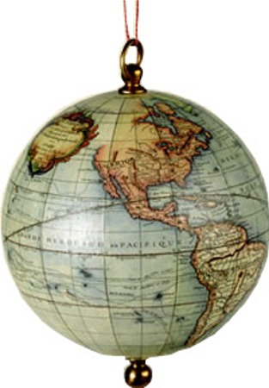

**1. Word Search: use vocabulary words above as your search terms.**

V  I  N  F  L  A  T  I  O  N  J  U  U  B  O  O  K  S  S  L  B

T  R  U  L  X  C  B  O  I  D  Y  H  P  A  R  G  O  T  R  A  C

L  E  T  H  N  O  C  E  N  T  R  I  S  M  X  W  P  S  L  C  M

X  G  L  E  N  F  F  G  H  N  E  Z  Z  E  T  A  R  E  T  I  L

Z  B  W  I  V  M  E  R  C  E  N  A  R  Y  L  Y  Y  X  S  S  N

N  R  I  A  E  K  F  B  A  C  I  R  E  M  A  O  S  E  M  W  T

P  R  O  T  E  S  T  A  N  T  R  E  F  O  R  M  A  T  I  O  N

D  G  I  Y  B  C  S  V  L  B  Q  Z  Q  I  C  L  C  H  S  A  Q

M  S  I  R  E  M  U  S  N  O  C  D  I  N  R  I  J  I  U  B  S

H  S  I  Q  A  I  E  V  J  E  M  O  H  C  R  M  Z  V  R  Q  Y

N  Q  N  B  T  F  M  C  N  L  U  R  L  C  E  V  M  H  E  J  K

M  V  D  P  R  N  S  P  S  G  B  G  U  V  G  D  I  U  E  D  A

S  X  I  W  E  A  A  W  E  T  N  M  N  K  K  N  M  J  F  P  W

N  X  G  C  W  D  Q  T  O  R  N  R  V  O  Q  W  O  C  U  G  D

A  L  E  H  E  W  I  X  S  A  I  E  P  O  T  L  B  X  G  F  T

T  E  N  E  C  Y  T  J  V  E  X  A  V  P  W  R  Q  W  V  A  B

I  F  O  U  E  F  S  I  Q  N  T  R  L  W  G  A  E  A  Q  G  O

O  M  U  Z  P  F  G  G  X  G  J  O  Q  I  P  B  W  H  T  H  H

N  E  S  A  Z  A  B  C  T  J  R  M  R  I  S  J  L  J  T  U  G

F  N  X  R  T  F  Z  O  J  T  M  P  Z  P  M  M  I  Y  D  O  G

Z  C  V  E  Z  M  S  I  N  O  I  S  N  A  P  X  E  B  L  R  M

**How did new Religious views become part of the western world?**

* 2 views on religion now existed



1. individuals follow the rules, rituals and teachings of the RC church without question
2. question religion and respond to the bible personally

* because individuals were questioning behaviour of some of the popes and clergy
* questioning the rules and rituals
* questioned the thought that they were to accept the church totally and it’s authority without question
* individuals wanted to see the RC church reformed but not necessarily break from it – basis of the protestant reformation
* this reformation divided Christians, wars broke out
* invention of printing press brought this idea to everyone who could read,
* people became more literate and could read the bible on their own, they didn’t need the clergy to interpretate it

**Religious Reform**

Martin Luther, a German scholar promoted the church reform, he believed:

* + - * following rules/rituals of church was not enough to go to heaven
      * individuals should seek religious understanding
      * don’t need to pay to receive forgiveness for their sins.
* Luther wrote a book and published it stating his views, his book was burned in Rome and he was expelled from the Church as a heretic
* He started his own church which provide with individual freedom and choice
* Other new churches formed
* RC church looked seriously at their practices and made changes to ensure proper behaviour of clergy and living according to Christian principles
* Protestant reform is an example of the rapid spread of ideas across Europe
* Protestant and catholic states were often at war and political leaders used citizen’s religious beliefs to help build their political power
* Fight for religious freedom created a sense of solidarity and common identity among people that influenced the formation of countries

**2. What did Martin Luther believe in? This was the bases of religious reformation.**

__________________________________________________________________________________________

__________________________________________________________________________________________

__________________________________________________________________________________________

**3. Why was Martin Luther considered a heretic?**

__________________________________________________________________________________________

__________________________________________________________________________________________

__________________________________________________________________________________________

**_____________________________________________________________________________**

**4. After the Protestant reformation what two “types” of Christians were there?**

__________________________________________________________________________________________

__________________________________________________________________________________________

__________________________________________________________________________________________

**_____________________________________________________________________________**

**How did ideas of National Identity and Citizenship begin to develop during the Renaissance?**

Small political units joined together to form larger states, reasons:

* move to urban from rural, monarchs supported growth of cities through trades laws and other laws and in turn cities gave them alliegance and wealth
* development of local identities through language, religion and beliefs
* gunpowder was brought in from China and the ways wars were fought changed, monarchs used taxes from the cities and hired mercenaries to overpower nobles, king gained control of large chunks of land
* printing press brought information and stories about local heroes/tales to the people creating a sense of history and identity
* exploration of other lands led to establishment of colonies and brought prestige and wealth to founding countries

**5. Give three ways that national identity and citizenship began to develop during the Renaissance.**

**___________________________________________________________________________**

**___________________________________________________________________________**

**___________________________________________________________________________**

**___________________________________________________________________________**

**Changes in European Societies show Changing worldviews**

People belonged now to a country or state and not to a feudal property, this changed how the worldview of culture, social, political and economic systems:

**Social Systems**

* people became citizen of country and gave allegiance to monarch
* exploration of new lands promoted feelings of hope and possibilities
* move out of the class structure
* public services began to be provide by central government
* size and power of states gave the authority of the church competition

**Political and Economic Systems**

* monarchs began to centralize their government structures and clearly defined lines of authority, this allowed freedom in dealing with nobles

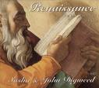

* government policies set up to ensure political/economic independence
* permanent armies set up paid by taxes
* resources provided to large state projects: exploration, war
* centralized laws/rules set by monarch and government
* state policies (tax and trade) created to control trade and business

**Culture**

* common language unified citizens
* middle and upper class became literate
* religious literature published in common language to state
* national language chosen to unify state/country

**6. List 3 examples of each in terms of Culture, Social Systems and Political/Economic System in changing European society?**

**Culture**

1. ________________________________________________________________________________
2. ________________________________________________________________________________
3. ________________________________________________________________________________

**Social Systems**

1. ________________________________________________________________________________
2. ________________________________________________________________________________
3. ________________________________________________________________________________

**Political/Economic System**

1. ________________________________________________________________________________
2. ________________________________________________________________________________
3. ________________________________________________________________________________

**How did a Spirit of Exploration become part of the Western Worldview?**

* Competition for new trade routes increased the need for new trade routes
* Trade meant profit and wealth

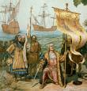

* Exploration increased with new geographical knowledge and new sailing technologies
* European expansion spread their worldview all over the world

**Factors Affecting Expansionism**

* Silk road wasn’t good enough anymore
* Trading trips were organized and went directly to the source and not the middleman
* New trade route to the east had to be found in order to go directly to the source and to avoid middleman, and to find a safe route

**New ideas and Knowledge**

* Concept that the earth was a sphere and not flat, gave sailors confidence that they could sail around the world to asia and not fall off of the world
* Interest created in travel and exploring new areas
* Technological advancement was created by trying to get a competitive advantage in trade such as cartography, designs of faster ships based on Arabic and European designs emerged
* Compass from China was being used
* Astrolabes from Islamic inventors were being used
* Printing press allowed sailors to get maps and navigational tables that helped them on their voyages

**How did the Age of Exploration begin?**

* Portugal, France, Spain and England became more powerful and became the lead players in the age of exploration
  + Each had an Atlantic coastline, best position to explore unknown parts of world in the west
  + Monarchs financed overseas explorations hoping to find and secure a route to china for their country only
  + New ship designs, navigational tools and information they gathered allowed for greater exploration
* New values favouring travel and exploration, increased consumerism and accumulation of wealth spurred on further exploration

**Portugal**

* 1400’s Portuguese sailors headed south and east along western coast of Africa – find new route around Africa to India and China
* Portugal’s success in finding new trade routes allowed Lisbon , Portugal became new trade capital for Europe
* Noted explorers:
  + Bartholomew Diaz in 1487 reach Cape of Good Hope
  + Vasco da Gama in 1524 crossed Indian Ocean

**Spain**

* Envious of Portugal’s wealth and power sent it own explorers
* Spain wanted to find direct route to China via west across Atlantic unaware of North and South America continent existed
* Noted explorers:
  + Columbus discovered the Caribbean islands in 1492, thinking it was Japan – Queen Isabella and King Ferdinand support his venture
  + Magellan in 1519 explored the east coast of South America, he discovered a passageway at the tip of South America that led to another ocean now known as the Strait of Magellan – he finally reach Asia, his expedition was the first to circumnavigate the globe

**England**

* England interested in trade within Europe rather than Asia, not much interest in Asia
* Giovanni Caboto/John Cabot was funded by England and went to Newfoundland in 1497
* No other explorations until mid 1500’s
* Saw Spain/Portugal become wealthy and England decided it was time to explore further
* 1560 Martin Frobisher was funded and searched for northwest passage
* By 17th century England had established more colonies on Northern American Coast than any other European country

**France**

* Saw Spain/Portugal become wealthy and England decided it was time to explore further
* French expedition to florida was defeated by Spanish, French explored further north
* 1534 Jacques Cartier explored St. Lawrence River
* Cartier set stage for further exploration and colonization in North America

**How did the Age of Exploration Lead to Imperialism?**

* History shows that empires continue to expand their territories, protect their land, control more and more land and resources, spread their religions/philosophies and systems of government (Greeks, Romans, Islamic, etc)
* Countries such as England, France and Spain did the same during the renaissance, founded the new world, established colonies and built their empires and established control over land, inhabitants and resources
* This is known as **IMPERIALISM, the policy of a country or empire to extend its authority or domination by political, economic or military means**
* Imperialism built to increase power and wealth of the controlling country

**European View of the Rest of the World**

* Lands European took over were called NEW WORLDS even though people had been living their for thousand of years
* Imperialist nations thought they had right to control colonies based on their belief of cultural and political superiority
* Indigenous people not viewed as equal since didn’t follow strict European guidelines and belief system therefore considered savages
* Colonist would use inhabitants as slave labour (farms, construction, mining) and after population died of would bring in new slaves
* Most societies practice ethnocentrism – feeling their beliefs, values and ways of life are better than other societies
  + Aztec/Inca were more sophisticated societies than Europe considered inferior
  + Chinese/Indian cultures were thought to be barbarous, even thou thousands of years older
* Europeans believed Christianity was only true religion and duty to convert everyone to christianity either by persuasion or by force

**How Did the Exchange of Goods and Products Change the World?**

* Exploration and colonization affected the distribution of plants and animals around the world
* It had both beneficial and destructive effects on populations (human/animal), ecosystems, economics and traditional ways of life
* North America transformed by metals, wheel, horses/ox, firearms and war technologies
* North American products impacted other cultures: rubber, canoes, snowshoes, toboggans, dyes/woods and pharmaceutical plants
* European diseases had the greatest devastating impact on local indigenous populations (small pox, tuberculosis, measles) roughly 75% to 90% indigenous populations died
* Loss of traditional ways, cultures and family life for many indigenous people

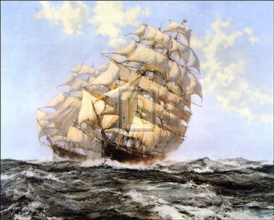

**How Did Imperialism Affect European Worldviews?**

**Ideas and Knowledge**

* Exploration of new lands/peoples altered Europeans view of geography and history
* Europeans considered their way superior to other cultures, they were impressed with first nations or North American indigenous people way of life:
  + personal liberty,
  + ideas about government/consensus and
  + lack of emphasis on personal property/wealth
* these ideas of freedom/leadership became apart of Western North American worldview later on
* European citizens saw new lands in north America as opportunities to live independent lives, not influenced by traditional European restraints
* Europeans chose free land in North America
* Europeans escape religious persecution in North America
* This believe in religious freedom was eventually made into law in Canada and American constitutions

**Economic System**

* Economy of European countries changed due to wealth coming from colonies
* Gold/silver coming in from Aztec/Incan empires into Spain upset the balance in Europe – more gold meant gold lost it’s value
* Portugal and Spain didn’t develop industries or manufacturing facilities as it could buy it all
* Other countries: England, Germany and Netherlands developed these industries and facilities to provide the goods for Spain/Portugal and the colonies
* The more money in circulation , the less it was worth, inflation happened (an increase in prices and a decrease in the purchasing power of money)

**7. *List* the three factors that contributed to expansionism.**

**__________________________________________________________________________**

**__________________________________________________________________________**

**__________________________________________________________________________**

**8. Describe the relation between Humanism, Consumerism and Expansionism.**

**__________________________________________________________________________**

**__________________________________________________________________________**

**__________________________________________________________________________**

**__________________________________________________________________________**

**9. Describe how the Europeans were ethnocentric and give an example.**

**__________________________________________________________________________**

**__________________________________________________________________________**

**__________________________________________________________________________**

**__________________________________________________________________________**

**10. What four European countries were dominant in exploration? Name one explorer for each.**

**__________________________________________________________________________**

**__________________________________________________________________________**

**__________________________________________________________________________**

**__________________________________________________________________________**

**Multiple Choice questions.**

1. Which country was the first to cross the Indian Ocean?
   1. Spain
   2. Denmark
   3. France
   4. Portugal
2. Martin Luther believed that
   1. Following the rituals of the institution of the Church was not enough to go to heaven.
   2. Individuals should seek personal religious understanding
   3. Individuals should not pay the Church to receive forgiveness for their sins
   4. All of the above
3. Which country was the first to circumnavigate the globe?
   1. Spain
   2. Greece
   3. England
   4. Portugal
4. Which of the following had the greatest immediate impact on the indigenous people of the “New World”?
   1. Guns
   2. Disease
   3. Horses
   4. Religion

**CHAPTER 4**

**How Did Beliefs, Values, and Knowledge Shape the Worldview in Japan Between 1600 and 1900?**

**1. What does isolate mean?**

**__________________________________________________________________________________**

**__________________________________________________________________________________**

**__________________________________________________________________________________**

**2. What does adaptation mean?**

**__________________________________________________________________________________**

**__________________________________________________________________________________**

**__________________________________________________________________________________**

**3. What does modernize mean?**

**__________________________________________________________________________________**

**__________________________________________________________________________________**

**__________________________________________________________________________________**

**Japan Between 1600 – 1900**

**1500** Japan was divided among more than 250 warring feudal lords.

**1603 Edo Period: Isolation -** Japan entered a long period of relative peace and development and tried to **isolate** itself from the rest of the world.

**1868 Meiji Period: Adaptation and Modernization -** Japan rapidly **modernized** using ideas collected from around the world.

**1912 Modern Period -** Japan modernized.

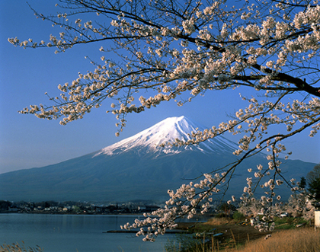

**2000 Present-day Japan -** Japan is an influential world leader.

**What Were the Effects of Japan’s Policies of Isolation During the Edo Period?**

* Edo Period (1603–1867)
* architecture, education, culture, and the arts flourished
* peace for more than 200 years
* country chose to isolate itself from most of the world

**How Did the Geography of Japan Affect Its Worldview?**

* composed of a long, narrow series of islands along the Eastern Pacific coast of Asia
* four main islands, running from north to south: Hokkaido, Honshu(the main island), Shikoku*,* and Kyushu
* 3000 smaller islands, including Okinawa Island
* total area is 377 835 square kilometres, about three-fifths the size of the province of Alberta
* 73% of the country is mountainous
* little flat area for cultivation, so farming is done in the valleys, along the coastline, and on terraces on the hills and mountainsides
* situated on the volcanic zone that rings the Pacific Ocean
* frequent earth tremors, with occasional volcanic activity
* high levels of rainfall and tends to be very humid
* moderate moist climate allows farmers to grow rice and fruits

**4. Describe Japan’s geography and how did it affect their worldview?**

**__________________________________________________________________________________**

**__________________________________________________________________________________**

**__________________________________________________________________________________**

**How Did the Edo Era of Great Peace Begin?**

* In 1500, Japan was not a united country
* consisted of about 250 small regions, all under the rule of an **emperor**
* each region under the rule of a commander called a **daimyo**
* daimyo were constantly at war with each other, trying to increase their holdings and power
* real power and authority was with the **shogun -**  the leader of the military government
* Three shoguns are given credit for unifying Japan in the late 1500s: Oda Nobunaga, Toyotomi Hideyoshi, and Tokugawa Ieyasu.

**5. Define:**

**emperor: _________________________________________________________________________**

**daimyo: _________________________________________________________________________**

**shogun: _________________________________________________________________________**

**entourage: ______________________________________________________________________**

**metropolis: _______________________________________________________________________**

**Changes that the Three Shoguns made to achieve peace were:**

* reduced the influence of Buddhist control over Japanese politics
* built a series of castles to defend lands
* introduced new administrative practices to pave the way towards a unified Japan
* continued centralizing government power
* surveyed the country and changed the tax on the land from money to quantities of rice. The wealth of a landowner determined how many **koku** were paid as taxes.
* created a society based on a formal class structure that included samurai, who were warriors, farmers, artisans, and merchants
* created a standing army
* disarmed the farmers by making a rule that men could no longer be part farmer or part warrior. They had to choose to be one or the other.
* tried to expand his territory by attacking both Korea and China, but was defeated by both countries
* supported painters and new types of drama
* established his government base in Edo
* finalized the unification of Japan

**6. Multiple Choice - *Identify the choice that best completes the statement or answers the question.***

I. **Geography had an affect on Japan and the lives of the Japanese in all but one of the following ways. Which statement is incorrect?**

|  |  |
| --- | --- |
| A. | Japan’s varied climate supported it’s agricultural needs. |
| B. | Japans’s rugged terrain helped to limit control and access by it’s enemies. |
| C. | Japan’s landscape provided plenty of good farmland. |
| D. | Being surrounded by the sea provided food for the people of Japan. |

**II. A form of poetry which consists of three lines of five, seven and five syllables respectively is called**

|  |  |
| --- | --- |
| A. | prose |
| B. | limericks |
| C. | ballads |
| D. | haiku |

**III. A/An __________ was group of people who followed the daimyo to and from Edo.**

|  |  |
| --- | --- |
| A. | entourage |
| B. | han |
| C. | edict |
| D. | geisha |

**7. True/False - *Indicate whether the statement is true or false.***

A. ____ The Edo period in Japan was an exciting time because Japan had chosen to completely isolate itself from most of the world.

B. ____Japan is part of the Ring of Fire, which is a narrow zone active volcanoes that nearly encircles the Pacific Ocean.

C. ____ Although the true ruler of Japan was the emperor, the daimyo had the real power and authority.

**Why Did Japan Isolate Itself from Much of the World?**

**Foreign Influences**

* beginning of the Edo Period, Japan was actively trading with many countries.
* Strong trading with Korea and China
* trading ships were traveling to the Philippines and as far as Siam (present-day Thailand)
* Tokugawa Ieyasu did not want the Japanese people exposed to Western ideas - concerned because Europeans were establishing colonies in the areas they explored - wanted to ensure was safe and left alone (no european colonies)
* foreign ships could only land at one port: the island of Deshimain the Nagasaki Bay.

**The Spread of Christianity**

* European ships carried Roman Catholic missionaries who wanted to convert the citizens of Japan to Christianity
* between 1549 and 1587, Jesuit missionaries under Francis Xavier converted 150 000 Japanese to Christianity in the Nagasaki area
* in 1587, Shogun Hideyoshi ordered all missionaries to leave and later had 26 Franciscan missionaries executed
* the **Bakufu (the centralized military government, headed by the shogun)** became concerned about the spread of Christianity, they felt that a Christian daimyo, would follow their spiritual leaders rather than the shogun – the feared a loss of absolute control
* shoguns decided to isolate Japan, primarily from the Western world
* they introduced a series of **edicts** **(legal order)**

8. **During the Edo period, the shogun closed Japan off from the rest of the world and minimized its contact with the outside in order to retain power. Describe the effects of this isolation on Japan and its citizens. Be certain to give examples, both positive and negative, using lessons from the textbook and class discussions.**

**__________________________________________________________________________________**

**__________________________________________________________________________________**

**__________________________________________________________________________________**

**__________________________________________________________________________________**

**__________________________________________________________________________________**

**__________________________________________________________________________________**

**Closed Country Edict of 1635**

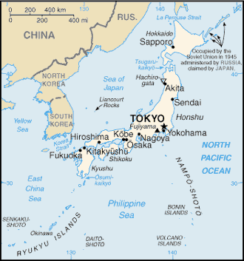

* Japanese ships were forbidden to travel to foreign countries.
* No Japanese is permitted to go abroad or face execution
* If any Japanese returns from overseas after residing there, he must be put to death.
* if any southern barbarians (Westerners) teach Christianity or commit crimes, they may be put into prison.
* No single trading city shall be permitted to purchase all the merchandise brought by foreign ships.
* European ships banned - any ship disobeying will be destroyed and its crew and passengers executed.

**The National Seclusion Policy**

* Bakufu passed a series of edicts to control the influence of foreigners and to tighten control over the daimyo
* National Seclusion Policy (1633-1639), as it was called, was an effort by the Bakufu to strengthen its authority and maintain a strong centralized government
* set out controls on the interaction between Japanese and foreigners

9. **Describe what the Closed Country Edict of 1635 was and what the National Seclusion Policy was?**

**__________________________________________________________________________________**

**__________________________________________________________________________________**

**__________________________________________________________________________________**

**__________________________________________________________________________________**

**__________________________________________________________________________________**

**How Did the Political System During the Edo Period Reflect Worldview?**

* political system was very hierarchical
* domains (provinces) were governed by daimyo, feudal lords, who were required to give allegiance to the shogun
* Japan’s hierarchical system similar to the feudal system in Europe
* each daimyo had full administrative control over his land and expected those living on it to swear allegiance to him
* two levels of government
  + local government in each domain, called the **Han** which was ruled by a daimyo

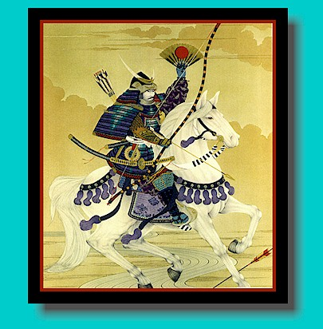

* + centralized higher level of government, called the Bakufu, was led by the shogun
    - also a feudal lord and ruled his own Han
    - additional responsibility of controlling the social classes, maintaining order throughout all of the domains, and making national policies.

**How Did the Bakufu Control the Daimyo?**

* political structure relied on relationships between daimyo and shogun
* daimyo were divided into three classes:
  + most trusted and loyal
  + nobles
  + little standing
* daimyo could never move out of their class
* Bakufu kept daimyo in “place” by ensuring he could not gain enough power and wealth and by daimyo must adhere to laws:
  + no unnecessary contact between neighbouring daimyo, report any suspicious activities and do not allow criminals or traitors to enter your domain.
  + only one castle in each domain and detailed maps of their landholdings where provided to the Bakufu.
  + Daimyo must support public building projects.
  + Daimyo are required to spend every second year in Edo.
  + All commoners must register at Buddhist temples.
  + Marriages of daimyo must have the permission of the Bakufu.
  + Travel and shipbuilding are restricted.
* ranking of a daimyo affected every aspect of his life
  + determined the location and size of his residence at Edo
  + number of samurai allowed
  + where he would be seated in the audience chamber
* status of the daimyo determined the status of all who lived under his Han
* affected his credit rating and commercial relationship with the artisans and merchants.

**10. True/False - *Indicate whether the statement is true or false.***

D. _____ Tokugawa Ieyasu did not want European explorers to set up colonies in Japan so he only allowed them to land at one port.

E. _____ The era after the final edicts of national isolation is referred to as sakoku, which means closed country, because Japan was entirely closed to the rest of the world.

.F. _____ The daimyo were not allowed to associate with each other because the Bakufu wanted to prevent from putting their money and resources together and attempting to overpower the shogun.

**11. Multiple Choice - *Identify the choice that best completes the statement or answers the question.***

**IV. The Closed Country Edict of 1635 was set out to control the interaction between Japan and foreigners. Which of the following statements is not in the edict?**

|  |  |
| --- | --- |
| A. | Japanese ships are strictly forbidden to travel to foreign countries. |
| B. | No Japanese is permitted to go to another country. Anyone who attempts to do so must be executed. |
| C. | Trade will only be permitted between China, Korea and the Netherlands. |
| D. | Portuguese ships are banned from Japanese ports. |

**How Did Social Systems Change During Isolation?**

* Japan’s social structure during isolation was a hierarchical system in which the shogun and samurai were the highest classes
* Farmers, artisans, and merchants followed
* lowest classes included the outcasts and the non-humans
* citizens had almost no opportunity to move out of the class they were born into

**Vocabulary Social System**

**Samurai -** Men who were hereditary warriors Some samurai were daimyo.

**Farmers -** People who farmed the land

**Artisans -** People who made useful or decorative objects

**Merchants -** People who distributed goods but did not contribute directly through labour

**Outcasts or Eta -** People who had jobs related to the death of animals or humans, such as tanning hides and removing corpses

**Non-Humans or Hinin -** People who survived by begging, acting, telling fortunes, and other activities that were frowned upon

**Samurai**

* held the most prestigious position in society next to the shogun
* code of behaviour for samurai was called bushido (way of the warrior)
* based on Confucianism, they were to be models of cultural, moral, and intellectual development and to set the example for duty and loyalty
* The samurai practised the belief, “It is better to be known for your accomplishments than for your rank.”
* Samurai were warriors but in non war times, they helped govern the domain, manage the affairs of the daimyo household, and maintain and support daimyo residences
* During this time period the Bakufu changed how the samurai could gain court title and rank
* Bakufu would give the highest ranks to their supporters
* 1611 and 1615, the Bakufu removed the names of warrior leaders from the court lists so that warrior offices and ranks were kept separate from the nobility
* samurai class was the first to become literate and help bring Japan into the modern world
* during the 200 years of isolation, the role of the samurai changed from a warrior to a civil administrator

**Farmers**

* privileged position just below samurai because they produced rice, the most important commodity and basic food for the country
* not allowed to leave their lands or village, as the daimyo did not want to lose the profits of their labour
* very restrictive rules on dress
* Two groups of farmers lived in the villages
  + Honbyakusho - principal farmers, controlled specific land plots, may own home, held supervisory positions
  + hyakusho - ordinary farmers, were the tenant farmers who were forced to work yet could own nothing

**Artisans**

* artisans lived in the cities and towns
* referred to as townspeople
* contributed to society by making objects for trade and decoration

**Merchants**

* gain wealth from their labour and formed the growing core of middle class
* became more important as Japan’s cities grew
* powerful and played important roles in establishing Japan’s banking industry
* carried out international trade until borders closed
* merchant class helped Japan with its later transition to a modernized society

**Outcasts or ETA**

* forced to live outside the villages and towns
* occupations: slaughtering animals, disposing of and tanning animal carcasses, carrying out executions, and removing corpse
* touching the dead was in violation of Buddhist doctrines, they were shunned
* status was hereditary

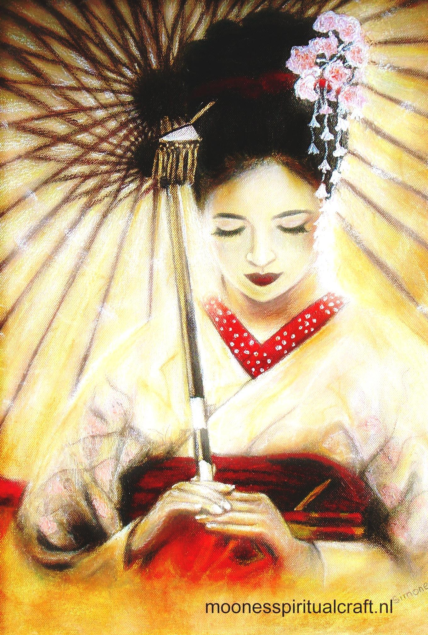

* were not allowed to have any occupations other than those assigned to their class
* allowed to enter towns for selling but not allowed to shop

**Non-Humans or HININ**

* regarded as inferior
* status was not hereditary
* often included fortune telling, begging, acting, and prostitution
* lived by their wits, therefore outside of the rules of the hierarchy and frowned upon
* given licences to live in specified quarters in each city
* had their own laws and chiefs
* any person from a higher social class could join the hinin
* because the hinin were looked upon as non-human, the killing them was not considered to be murder

**Social Hierarchy Made Law**

* Bakufu government legally formalized social classes and made it almost impossible for individuals to move from their inherited social status to a higher one
* this legalization of the classes encouraged feelings of prejudice

**12. True/False - *Indicate whether the statement is true or false.***

G. _____ According to the hierarchical social class system the samurai were next in line to the shogun.

H. _____ Non-humans (hinin), like the geisha, were people who survived by begging, acting, telling fortunes, or other activities that were considered inferior.

I. ____ The samurai believed that it was better to be known for your accomplishments than for your rank. They also believed in loyalty to their family, honor and personal integrity, courage, and honorable death.

J. ____ The Japanese people did not believe in surgery because they thought the body was inherited from one’s ancestors and that surgery would damage the body.

K. ____ Edo (Tokyo), Osaka and Kyoto continue to be the three largest metropolises in modern-day Japan.

L. ____ Banraku theatre was a children’s puppet theatre in Japan during the Edo period.

**How Did Communities Change During Isolation?**

* network of quality roads was needed in Japan to transport the daimyo to and from Edo
* shogun created and controlled five major roadways
* regular movement of people (daimyo and entourages) created industries along the roads:
  + accommodations, food, and other goods and service
  + artisans and merchants provide trade
  + road side centres developed
  + centres of larger populations could not be self-sufficient, so the economies of the rural and urban areas became intertwined.
  + castle towns grew as well
* Over time, Japan became a modern country with extensive road and communication networks that connected communities across the length of the country. The growth of large cities created the need for good travel and communication networks to allow for economic trade among them.

**Japan’s Principal Cities and Travel Routes,18th Century**

**Japan’s Three Metropolises**

* By the 18th century, three urban centres were important in Japan. The Japanese called them the three **metropolises**.
  + Edo was a large city and government centre.
  + Osaka was a large commercial centre.
  + Kyoto was an ancient capital of Japan and the home of the imperial palace where the emperor resided.

**13. Multiple Choice - *Identify the choice that best completes the statement or answers the question.***

**VII. The largest city in Japan during the 18th century was**

|  |  |
| --- | --- |
| A. | Osaka |
| B. | Nagoya |
| C. | Kyoto |
| D. | Edo |

**VIII. As the cities grew, the merchant class became more wealthy and the samurai turned their energies to things other than war, the __________ of Japan began to change.**

|  |  |
| --- | --- |
| A. | education |
| B. | popular culture |
| C. | government |
| D. | social system |

**IX. This social class lived outside the rules but met some of the needs of the Japanese society.**

|  |  |
| --- | --- |
| A. | eta |
| B. | merchants |
| C. | artisans |
| D. | hinin |

**X. Because it was mass produced __________ was/were not initially considered an art form.**

|  |  |
| --- | --- |
| A. | silk screen |
| B. | woodblock images |
| C. | porcelain figures |
| D. | movable print |

**XI. The role of the samurai changed during the Edo period from esteemed warrior to**

|  |  |
| --- | --- |
| A. | civil administrator |
| B. | educators |
| C. | architects |
| D. | artists |

**XII. Although they were highly respected for their singing and dancing and their appearance reflected the cultural values of Japan, this group was still considered to be non-human.**

|  |  |
| --- | --- |
| A. | samurai |
| B. | artisans |
| C. | geishas |
| D. | Eta or outcasts |

**XIII. Although printing was a private industry the Bakufu prevented all but one of the following subjects to be written about. Which did the Bakufu allow to be printed?**

|  |  |
| --- | --- |
| A. | books on Christianity |
| B. | political writings |
| C. | romance novels |
| D. | books on western culture |

**How Did the Popular Culture of Japan Change During Isolation?**

**Vocabulary**

**popular culture:** the cultural activities that appeal to the current tastes of the general public

**opulent:** luxurious or lavish

* **popular culture** of Japan began to change as the cities grew and the merchant class became more wealthy and influential
* people desired luxury items and had leisure time for entertainment such as theatre, literature, and the fine arts
* Samurai turned their creative energies to intellectual pursuits such as prose and poetry
* daimyo became patrons of the arts because they wanted to build elaborately decorated houses and beautiful gardens (supported artists, sculptors, painters, artisans, architects, and landscape gardeners)
* daimyo began to provide for the education of the samurai under their leadership
* end of the 17th century, the samurai began to be known more for their accomplishments rather than just for their rank

**Kabuki Theatre**

* very popular with all classes, but primarily the merchant class
* featured lively action, wild plots, and elaborate costumes and make-up
* mirror of Japanese life and focused on domestic dramas that depicted moral dilemmas (ie. conflict between obligation and happiness)
* first kabuki was performed in 1607 by a woman named Okini
* Bakufu believed public morality was being corrupted by female actresses
* 1629, banned females from the stage
* all parts in the plays were portrayed by males
* kabuki actors were treated like celebrities

**Banraku Theatre**

* Banraku or puppet theatre
* plays were for adults, not children
* banraku and kabuki were performed only by non-humans

**Geishas**

* women were employed in the entertainment business and trained as geishas
* trained in dancing, singing, witty conversation, the tea ceremony, and floral arrangement
* expected to be able to demonstrate all the correct forms of etiquette
* appearance and behaviour reflected the cultural values of the time

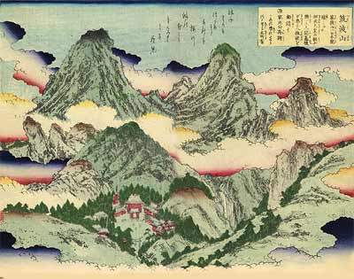

**Woodblock Images**

* woodblock images were prints of original paintings
* artist carved the major lines and details of the painting into a flat wooden block and printed
* copies of a painting could be made using this process, making them inexpensive and available to a wide audience
* artistic techniques became more refined and woodblock printing reached its high point in Edo

**Books**

* Commercial printing and publishing became popular in Kyoto in mid-17th century and and in the 18th century, established in Edo
* techniques of movable print and the printing press were available in Japan from the late 15th century
* 1626 the old technology using wooden printing blocks was in use again
* printing was a private industry not controlled by the Bakufu
* certain subjects were taboo: no writings on Christianity, no politics, nothing that would be offensive publically
* 17th century, handbooks on everything from household needs, farming to proper social skills

**Literature**

* Prose gradually became far less formal
* topics were similar to the themes used by the block printers, Japan’s ever day life
* many fictional books were tales of rascals and their adventures
* Basho Matsuo developed a new poetic form called haiku

**C H A P T E R 5**

**What Factors Influenced Change in Meiji Japan?**

* mid-19th century, Japan was changing into an urbanized society
* shogun, Bakufu, and many Japanese wanted to continue the isolation and seclusion policy
* outside world, would not leave Japan alone

**The Ainu**

* aboriginal of northern Japan, having lighter skin and hairier bodies, facial characteristics similar to those of Europeans than other Japanese.
* Ainu are considered to be descendants of Japan’s first Indigenous people, the Jomon

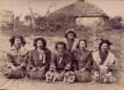

* they have their own language
* traditional Ainu believe that almost all natural things have a spirit
* Ainu were considered non-humans
* self-sufficient fishers, hunters, and food collectors, and lived in permanent villages, involved in trading furs and other goods with the Chinese and Russians
* Under the Tokugawa shoguns (1603 to 1867), the Ainu were forced to sign an agreement that gave the Japanese the right to fish, hunt, and log the lands of the Ainu. Under the agreement, the livelihood of the Ainu was greatly altered
* were forced to remain separate from Japanese society
* under the Meiji government (1867 to 1912), Japan became concerned about the Russia and took control of all the islands in Japan causing the Ainu to lose their political independence
* under this agreement, the Ainu were forced to **assimilate** with the Japanese
* Ainu language was forbidden and their customs and traditional ways of life were suppressed

**Dutch East India Company**

* 1602 - Dutch East India Company - largest European multinational trading company and first to sell stocks

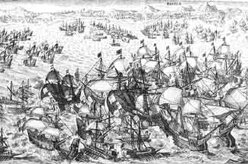

* Dutch government granted the company a **monopoly** on Dutch trade in the area stretching from South Africa to India, and all the way to Japan
* had permission to build forts, appoint governors, keep an army, and sign treaties in its name
* world trade in exotic Asian goods: spices, textiles, porcelain, and silk
* excellent records which today include the history and political, economic, cultural, religious, and social circumstances of the regions in 17th century
* only group that Japan would trade with
* Japanese began to learn about the West through this company

**A. True/False -** *Indicate whether the statement is true or false.*

____ 1. Russia and China were the first countries to have trade relations with Japan.

____ 2. The Ainu people were not considered descendents of the Japanese and thus were shunned from society.

____ 3. The Dutch were the first people to bring Western ideas to Japan.

**B. Multiple Choice -** *Identify the choice that best completes the statement or answers the question.*

1. The shogun and the Bakufu believed that the policy of isolation

|  |  |
| --- | --- |
| A. | was the last resort to maintaining their power and sovereignty |
| B. | was important to the identity of the Japanese |
| C. | was not detrimental to the people |
| D. | was a policy that other countries wanted to imitate in their governments |

2. The Japanese shogun forced the Ainu people to

|  |  |
| --- | --- |
| A. | to live on reserves |
| B. | sign a treaty giving up their land and resources |
| C. | become Japanese citizens |
| D. | move to Russia and China |

3. The influence of Europe on Japan was apparent by the need to

|  |  |
| --- | --- |
| A. | assimilate the Ainu people |
| B. | create and sign treaties with Russia |
| C. | educate Japanese officials in European languages |
| D. | build a stronger army |

4. During the Meiji period the __________ had the most influence in world trade.

|  |  |
| --- | --- |
| A. | Dutch East India Company |
| B. | Russian-American Company |
| C. | Russian- Chinese Company |
| D. | Dutch Japan Company |

**How Did Outside Influences Create a Crisis?**

* Japan’s contact with the outside world was inevitable - foreign ships sailed along Japan’s coast and some shipwrecked - sailors were cast ashore
* shogun and the Bakufu believed if they didn’t have the policy of isolation, they would have less power
* feared - Japan might lose its sovereignty if the influence of the other countries grew

**The Influence of Russia**

**Crisis with Russia**

1798 The Bakufu learned that Russian settlers had reached the third Kuril Island and were introducing the Ainu to Russian culture and to Christianity.

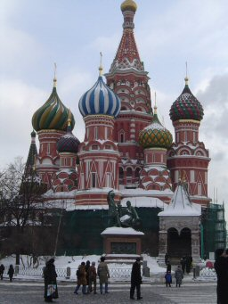

1801 Not wanting to lose these islands, a team of Japanese claimed the island for J apan and drove the Russians from it.

1804 A Russian envoy landed at Nagasaki with a letter from Czar Alexander I asking to establish trade relations with Japan. The Bakufu did not respond for six months and then answered that the Japanese government was not interested in trade with foreign countries.

1805 Angered at having been made to sit in Nagasaki for so long waiting for an answer, the ship’s captain authorized nuisance attacks on Japanese settlements. He thought Japan would respond to force and change its mind about trading with Russia.

1811 The Japanese government became more determined to maintain its isolation policy and also to keep control of its territory. To demonstrate its strength, the commander of a Russian ship was captured and kept in Nagasaki for two years before releasing him to the Dutch.

* 19th century, the Russians needed to continue supplying their outposts in central north Asia
* they increased their trading along the Pacific Coast
* **czar** gave the company the authority to trade with the Ainu and to gain control of the new territories
* Russia became involved in wars in Europe and left Japan alone
* Do to the treat of the Russians coming into Japan, the shogun warned the Bakufu to focus less on internal affairs and more on “treat” from the outside world.

**C. Define:**

**czar**: ________________________________________________________________________________

**crisis:** ______________________________________________________________________________

**The Influence of Europe**

* between 1799 and 1815, most of Europe were at wars
* Dutch East India Company, for whom the traders worked, decided to hire ships from other countries to carry on its trade in Asia
* Dutch were the only foreigners allowed to set foot in Japan, the ships were told to fly Dutch flags and hide any Bibles and weapons

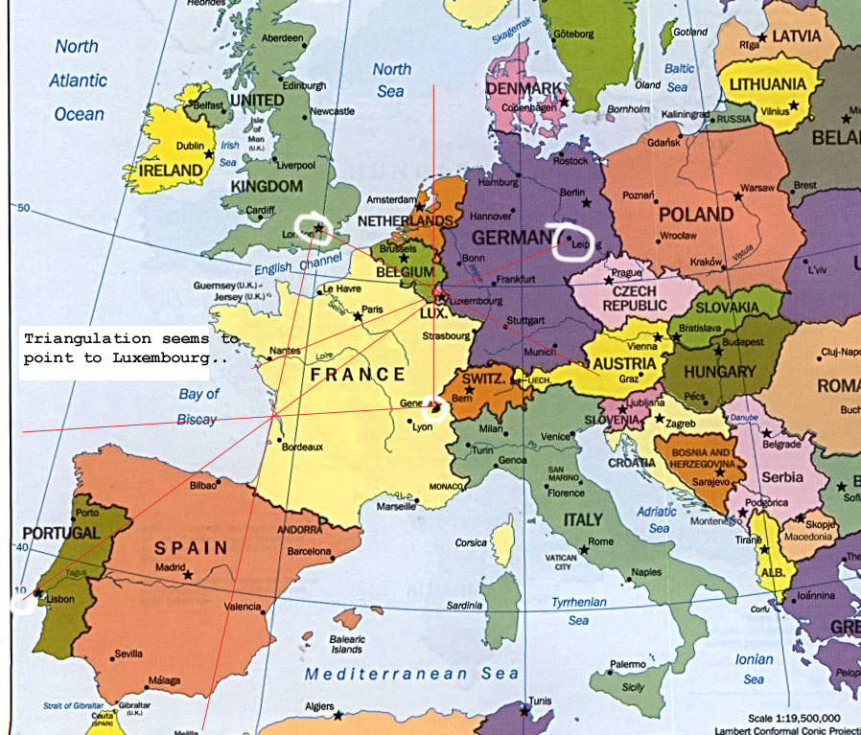

* Japanese officials decided it time for the government officials to learn about the West
* Japan started to import and translate books on European history, institutions, and military science, as well as astronomy and other sciences
* Japanese government officials who were learning French, Russian, and English
* Japanese officials concluded that since all the languages and fashions of Europe were similar, there must be one superpower in Europe

**Japan’s Response — Don’t Think Twice Treaty**

* Bakufu decided to expel all foreigners
* new edict began in 1825 on the advice of a government official named Takahashi
* Takahashi had studied Western countries and felt that Japan should be even more restrictive because foreign ships and foreigners were gathering around Japan
* Takahashi learned that other countries did not allow foreign ships to dock without proper papers/protocol and would be turned away

**The Influence of China**

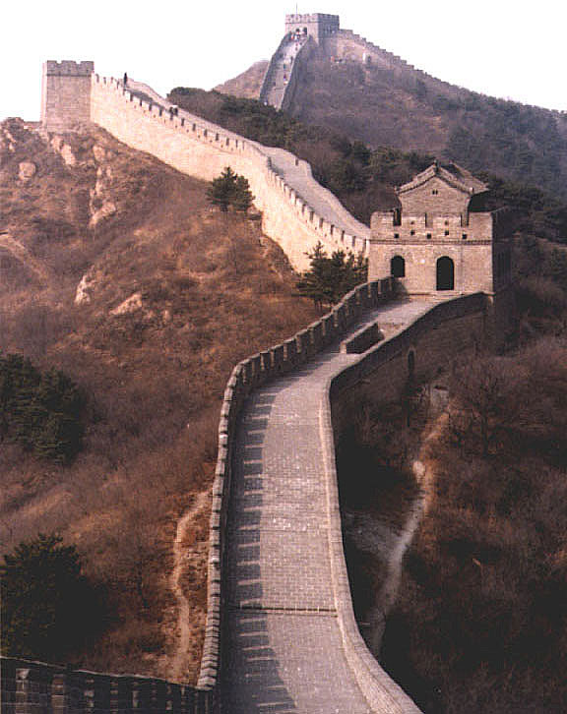

* 1842, China lost much of its control over its seaports when Britain won a war with China
* China forced to sign a treaty that gave Britain special privileges
* Special privileges included the right to land at specific ports, having low fixed tariffs on goods coming into and leav ing China, and not having Chinese law applied to Westerners on Chinese soil
* treaty did not treat each side equally
* China was seen as weak
* Britain also extended these rights to all Western countries who wanted to trade with China

**Japan’s Response — Retreat and Ignore**

* Bakufu officials were surprised that China had signed the treaty as they were a powerful country
* Japan now realized how large and powerful the English forces were
* noticed more American, Russian, and British activity along their own coastline
* Bakufu abandon the “don’t think twice treaty” because they were afraid the policy might cause Britain and other Western countries to invade Japan
* 1844, Netherlands sent a letter to the Bakufu recommending that they open Japan’s doors to the West for trade
* the letter warned that if these countries were not welcomed, they might come in by force
* Bakufu responded by saying that it was impossible for nations to come in by force but by the time the answer reached the Dutch, foreign ships were already reaching Japan’s harbours

**The Influence of the United States**

**The Crisis with America: Japan Feared for Its Sovereignty**

1845 US sent a representative to Japan to discuss trade and coal station, US returned to China empty handed

1853 Commodore Matthew Perry entered the harbour at Edo with four war ships, his objectives:

* get supplies and coal

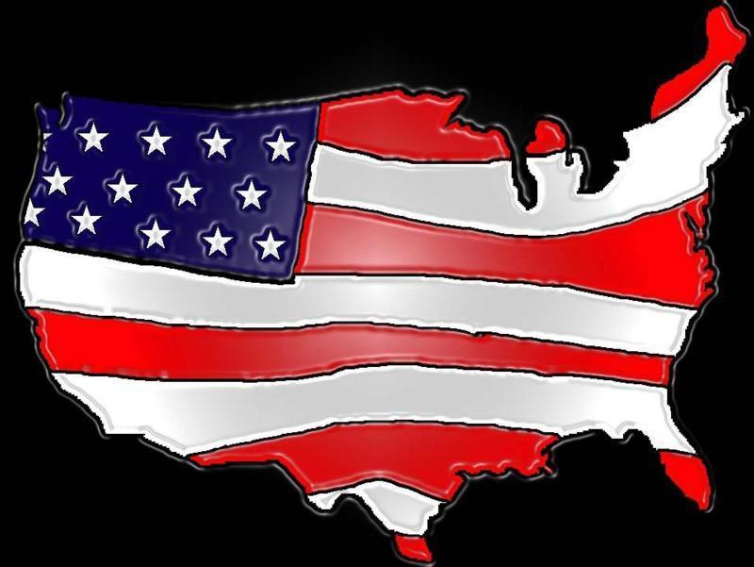

* protect sailors and American ships that might need help
* official trade agreement

1854 Commodore Perry returned with more warships and Bakufu signed the Treaty of Kanasawa - Japanese felt they achieved a major goal because they had entered into an agreement that allowed them to maintain independent authority and control over their country. Perry had two other objectives that were met:

* 2 ports were to be opened to US ships/coal and supplies would be available
* shipwrecked sailors would be helped

1856 Harris (American consul) was to organize a more complex trade agreement - shogun sought support for the treaty from the emperor, but did not receive it

1858 Harris Treaty was signed - allowed Americans to live in Edo and Osaka under the protection of American law

1863 5 ports were now open to the US, allowing goods to enter and leave Japan, also had an agreement to supply Japan with ships, arms, and technicians

* US wanted trade relations with Japan
* US wanted a coal station in Japan’s ports so that they could get fuel for their steamships on their way to China
* US wanted assistance for any US sailors shipwrecked on Japan’s shores

**Japan’s Response — Internal Unrest**

* Bakufu and samurai had heated debates regarding US
* saw the agreements with Perry and Harris as favouring the US - unequal treaties
* Japan then was pressured to sign treaties with Russia, Britain, France, and the Netherlands – also unequal
* Japanese felt that the shogun was no longer in control and had been humiliated
* Isolation was no longer possible
* therefore Japan needed to compete with the West and protect Japan’s sovereignty.

**D. True/False -** *Indicate whether the statement is true or false.*

____ 4. Russia and China were the first countries to have trade relations with Japan.

____ 5. Commodore Mathew Perry was intent on ending the Bakufu’s ni-nen naku (without thinking twice)

edict.

____ 6. Commodore Perry’s treaty forced Japan to consider signing unequal treaties with Russia, Britain,

and France

____ 7. After the shogun signed unequal treaties in the 1800s, the citizens felt that they did not have to

compete with the West anymore and they could maintain their policy of closed doors and isolation.

**E. Multiple Choice -** *Identify the choice that best completes the statement or answers the question.*

5. The influence of Europe on Japan was apparent by the need to 3

|  |  |
| --- | --- |
| A. | assimilate the Ainu people |
| B. | create and sign treaties with Russia |
| C. | educate Japanese officials in European languages |
| D. | build a stronger army |

6. The Bakufu edict ni-nen naku, meaning **Without Thinking Twice or Don’t Think Twice,**

was applied to 4

|  |  |
| --- | --- |
| A. | soldiers were in battle and it meant to never turn back. |
| B. | treaty relations between the shogun and foreigners |
| C. | the unique Japanese way of life |
| D. | expelling foreigners who may have been shipwrecked on Japanese shores |

7. During the Meiji period the __________ had the most influence in world trade. 5

|  |  |
| --- | --- |
| A. | Dutch East India Company |
| B. | Russian-American Company |
| C. | Russian- Chinese Company |
| D. | Dutch Japan Company |

8. The United States favored trade relations with Japan because they wanted 6

|  |  |
| --- | --- |
| A. | access to all the goods and resources |
| B. | to build a world trade center in the East |
| C. | to establish a coal station for fuel on one of the Japanese ports |
| D. | to free the Japanese from the isolation policy |

9. The major factor that led the Japanese to open the door to the West was the 7

|  |  |
| --- | --- |
| A. | citizens rejection of the shogun |
| B. | signing of the Treaty of Kanasawa with Commodore Perry |
| C. | need to protect the Japanese sovereignty |
| D. | need to compete with the West and ensure the Japanese national character |

**F. List 3 influences (causes) and 3 Japanese responses (effects) for each.**

|  |  |  |
| --- | --- | --- |
|  | **Influences or Cause** | **Japan’s Response or Effect** |
| **Russia** |  |  |
| **Europe** |  |  |
| **China** |  |  |
| **United States** |  |  |

**How Can Individuals Change the Way Others View the World?**

* 2 people changed the way Japan looked at the world: Sakuma Shozan and Yoshida Shoin
* both inspirational samurai teachers who were interested in Western technology and war against West was inevitable
* valued and taught the Confucian teachings of loyalty, dedication to society, and combining knowledge with action
* taught questioning and inquiry, along with the bushido ideals
* pupils needed to have many experiences and to consider the good ideas from many sources
* urged their students to visit foreign countries to find out about foreign technologies such as guns and steamships
* Sakuma and Yoshida watched Commodore Perry’s warships
* both knew that if Japan were to win a war against the west they needed to know more about the West
* believed that a mix of the strengths of the two worldviews would make Japan more powerful and independent
  1. Eastern morality
  2. Western skills
* did not agree on how Japan should maintain its sovereignty or become a world leader
* Yoshida urged the overthrow of the Bakufu and return power to the emperor
* Sakuma work with Bakufu and promote the learning of West technology
* Yoshida decided to find out more about the West by foreign travel and boarding US ships
* Both were arrested and imprisoned
* Yoshida - was eventual arrested again for trying to assassinate one of the shogun’s officials - beheaded - 29 years old
* both are heroes in Japanese history even though broken many of the nation’s laws (regarded as courageous and brilliant)
* examples of *shishi*, which means “people of spirit,” or “people of high purpose.”

**G. Completion -** *Complete each statement.*

1. The signing of ____________________ created an internal crisis for Japanese citizens.

2. Under the Meiji government the ____________________ were forced to assimilate with the Japanese and their language and customs were suppressed.

3. The ____________________ were the only foreigners prior to the Meiji period that were allowed to trade with Japan.

4. Commodore Perry wanted to establish a ____________________ station on a Japanese port so that his steamships would get fuel.

5. Sakuma and Yoshida believed that a combination of Eastern ____________________ and Western ____________________ would liberate Japan.

**How Did Japan Respond to the Crisis?**

**Different Points of View**

* Two conflicting viewpoints caused a great deal of internal conflict in the Bakufu during this period

1. One group thought it was only matter of time before Japan would be forced to trade with Western nations - believed impossible to remain isolated - needed to use Western technologies to become more powerful and to remain independent
2. Another group believed that Japan could remain isolated, that it should declare war on the Western countries, and that all foreigners in Japan should be killed - believed exposure of the west on the common Japanese (peasants, merchants, etc) would destroy their social system

**Civil Unrest**

* mid-1800s farmers and peasants were starving
* people questioned the taxes they were forced to pay
* questioned if the Bakufu was the cause of the unrest; support for the Bakufu weakened
* samurai began to support the emperor
* Samurai were angry because the Harris Treaty had been signed against the wishes of the emperor
* Some samurai leaders had secretly travelled to England and did not actually fear the presence of the foreigners
* critics of the shogun wanted to create a new government headed by the emperor - used slogan “Sonno Jo” which means “Revere the emperor! Expel the barbarians.”
* increased military supplies, purchased weapons and ships from the West
* groups of women broke with tradition to form military brigades to fight the shogun’s troops
* new government started to form but some Samurai;s fought, won and proclaimed Meiji as the emperor
* emperor quickly abolished the office of the shogun and ordered the current reigning family to return to their farm lands
* shogun’s military forces were defeated
* Emporer won again and renamed Edo the city Tokyo, which means “Eastern Capital”

**H. What were the 2 conflicting viewpoints that caused internal conflict in the Bakufu?**

**______________________________________________________________________________________**

**______________________________________________________________________________________**

**______________________________________________________________________________________**

**I. What were some of the civil unrest that happened during this period? List at least 5 points.**

**______________________________________________________________________________________**

**______________________________________________________________________________________**

**______________________________________________________________________________________**

**______________________________________________________________________________________**

**______________________________________________________________________________________**

**______________________________________________________________________________________**

**How Did the Political System Change?**

* Meiji leaders declared the emperor sacred and **inviolable** through a “creation story”
* appeal to the Japanese traditionalists and build loyalty to the government by using the young emperor as a symbol of unity
* emperor was considered a divine being until after WWar II when a new constitution made him a symbol of the state

**The Charter Oath**

* April 1868, Emperor Meiji signed the Charter Oath that outlined the goals of the new regime, this was to gain the confidence of all of the domains for the new government
* It decreed:
  + policies would be based on the consensus of the daimyo of all domains
  + showed change in all three elements of worldview:
    - political and economic systems
    - social systems
    - culture

**The Charter Oath**

1. Deliberative assemblies shall be widely established and all matters decided by public discussion.
2. All classes, high and low, shall unite in vigorously carrying out the administration of the state.
3. The common people, no less than the civil and military officials, shall each be allowed to pursue their own calling so that there shall be no dissent.
4. Evil customs of the past shall be ended and everything shall be based on the just laws of nature.
5. Knowledge shall be sought throughout the world so as to strengthen the foundations of Imperial rule.

**J. Matching**

*Match the following words or terms to their correct description below.*

|  |  |  |  |
| --- | --- | --- | --- |
| A. | The emperor | E. | regalia |
| B. | consensus | F. | Commodore Perry |
| C. | Ainu | G. | The Charter Oath |
| D. | inviolable | H. | samurai |

____ 1. __________ is a decision reached through common agreement.

____ 2. The __________ wanted a new government headed by the emperor.

____ 3. __________ means not to be injured or tampered with.

____ 4. The __________ are considered descendants of Japan’s first indigenous people.

____ 5. __________ is distinctive clothing and jewelry.

____ 6. __________ was considered an icon that bound the Japanese nation.

____ 7. __________ opened Japan up to the west.

____ 8. __________ outlines the goals of the new regime.

**How Did Japan Reshape Its Worldview and Begin to Modernize?**

**New Leadership**

* emperor was the official head of the government he did not rule directly
* new government was in charge
  + young intelligent samurai’s (average age 30)
  + academic and military skills
  + many had travelled to other countries or had met Westerners
  + many had studied under Yoshida or Sakuma
  + realized the quality of Western technology would prove beneficial
* created changes in Japan that promoted economic growth and industrialization
* slogan was “Enrich the country; strengthen the military.”
* They had two key goals:

• to modernize Japan and make the economy grow

• to renegotiate the unequal treaties

* challenge of the Meiji leaders was to develop a nation that would be competitive in the modern world and yet continue to be Japanese
* Japan must remake its society
* distance themselves from old traditions and build a new, modern Japan
* looked to Western nations for models because they saw Europe and North America as being wealthy and powerful
* Japan’s worldview changed drastically
  + Japan welcomed foreigners
  + Foreign educators and experts in manufacturing and industry were invited to assist with the move towards modernization
  + sent half their new government to Europe/US to learn about the institutions, laws, and customs of the successful Western nations.

The ambassadors made these conclusions:

* West is wealthy and powerful because of a representative government
* Charter Oath should be used as the foundation for a national constitution that will shape the laws of Japan
* Cautious - **representative government** should not be considered until the people are ready for a parliamentary system of government
* importance of religious freedom
* encourage private enterprise and business innovation
* value competition, participation and colonial expansion
* develop a new educational system for Japan based on Germany and US system

**The Iwakura Mission**

**December 1871–September 1873**

* 1871 - new government sent 50 officials and 50 students on a 22-month world trip of 12 countries
* purpose - find best ideas around the world and bring them back to Japan
* concluded Japan was not in any immediate danger of losing its independence
* Japan needed to modernize its society
* Japan was not hopelessly behind as they had feared

No other country in the world had ever sent its *government* on a voyage of exploration, such as the Iwakura Mission.

**K. True/False -** *Indicate whether the statement is true or false.*

____ 7. A political strategy that was used by the samurai to bind the citizens during the mid 1800s when there was civil unrest was to portray the emperor as an icon for the people.

____ 8. The Charter Oath was a measure to outline the new rules of the Emperor and to present people with a new more democratic model of leadership.

____ 9. The Japanese people were envious of the Western way of life, characterized by wealth and power, and wanted to adapt new leadership models in their own country.

____ 10. During the Iwakura Mission, Japanese officials traveled the world to learn about new defense strategies from other countries.

____ 11. Japan began to modernize under the Emporer Meiji.

____ 12. Civil unrest in the country after the unequal treaties increased support of the Bakufu.

____ 13. Europe became dominant once China lost its power in Asia.

____ 14. Many countries would use the Dutch flag so that they could sail in Japanese territory for trading purposes.

____ 15. Japan felt they had to agree to trade relations with the U.S.A and were pressured into signing a treaty.

**L. Multiple Choice -** *Identify the choice that best completes the statement or answers the question.*

____ 8. Sakuma and Yoshida were two influential samurai teachers and they believed that Japan would become more independent and powerful if

|  |  |
| --- | --- |
| A. | the treaties with all of Europe were signed |
| B. | all officials learned the European languages |
| C. | there was a mix of Eastern morality with Western skill set |
| D. | Japan maintained its isolation policy |

____ 9. In the mid-1800s there was civil unrest in Japan due to the Western influence. As a result

|  |  |
| --- | --- |
| A. | the shogun was viewed as the savior and was an icon in the citizens eyes |
| B. | the bakufu was stronger than ever and had developed armies to defend the country against invasion |
| C. | the citizens were disappointed in the Bakufu and wanted the emperor to take control of the country |
| D. | the samurais were in agreement with the West and conspired to overthrow the Bakufu |

____ 10. The most important reason for the development of the Charter of Oath by Emperor Meiji was to

|  |  |
| --- | --- |
| A. | ensure the loyalty of all Japanese citizens |
| B. | show the nation that he was serious about his new rule |
| C. | show confidence in all areas of the new government |
| D. | appease the Western nations and prevent more treaties from being signed |

____ 11. Japan began to reshape its worldview by

|  |  |
| --- | --- |
| A. | allowing citizens to learn new languages and to travel |
| B. | trying to renegotiate the unequal treaties |
| C. | increasing manufacturing companies and textile mills |
| D. | accepting new immigrants into their country |

____ 12. The Iwakura Mission concluded that

|  |  |
| --- | --- |
| A. | Japan needed to restructure its education system |
| B. | there was an urgency to modernize Japan, as it was in danger of falling behind the West |
| C. | religious freedom was the key factor in reshaping the nation |
| D. | Japan was not in any danger of losing its independence to another nation |

____ 13. Japan could no longer maintain its policy of isolation due to a number of external and internal pressures. Which factor was most significant to the end of isolation?

|  |  |
| --- | --- |
| A. | Trade relations between countries were increasingly important and unavoidable in the world economy. |
| B. | Young Japanese studying at Deshima were exposed to Western thoughts. |
| C. | The Bakufu were viewed as too weak to run the country. |
| D. | Japan feared that it would lose its power to Europe as had China. |

**C H A P T E R 6**

**How Did Rapid Change During the Meiji Period Affect Japan’s Worldview?**

* Japan set out in the Meiji Period to become militarily powerful and economically self-sufficient that it would be considered an equal partner with the West
* adapt to many changes within a very short time

**How Did Japan Decide to Implement Change During the Meiji Period?**

* Japan would have to undergo dramatic changes in order to maintain control over its future
* have to become as strong and competitive as the Western nations
* implemented aspects of **democracy**, such as elected representatives
* public education as a necessary way to help Japanese society adjust to an **industrialized** nation
* embraced technologies, such as steam-powered machinery
* adaptations had a significant impact on changing the Japanese worldview: the values and beliefs it held about culture, social systems, and political and economic systems
* leaders carefully considered traditional aspects they would maintain and which could replace with systems from other societies

**A. List 4 things Japan did to implement change during the Meiji Period?**

______________________________________________________________________

______________________________________________________________________

______________________________________________________________________

______________________________________________________________________

**democracy:** a form of government in which the citizens have the power, exercised by them directly or their elected representatives

**industrialized:** having large industries as an important feature in a country or an economic system

* Japan used the British navy as the model for its navy
* used the German army as the model for its army
* Ministry of Education established free education for everyone and provided a compulsory six-year education program for both boys and girls, modelled on France’s system
* New universities were founded and modeled after those in the United States.

**How Did Modernizing the Japanese Political System Reflect a New Worldview?**

* new leaders of the Meiji government decided to prepare carefully for a **constitutional government**
* first step was to establish strong central control - imperial capital moved from Kyoto to Edo and renamed Tokyo
* emperor’s living in the castle clearly showed the people that the shogun and Bakufu were no longer in power

**constitutional government:** a government in which operation is controlled by a set list of rules

**Unifying the Country**

* young leaders gained the support of the domains and daimyo surrendered there lands called Return of the Registers
* 1871 - all domains were officially abolished by imperial decree and replaced by a **prefecture** system.
* Return of the Registers was the first step towards the establishment of a centralized government
* young leaders recognized that the people needed a symbol to help develop **nationalistic** feelings - used the emperor to secure support for both the new government and the modernization of the country by making him the symbol of the newly unified nation

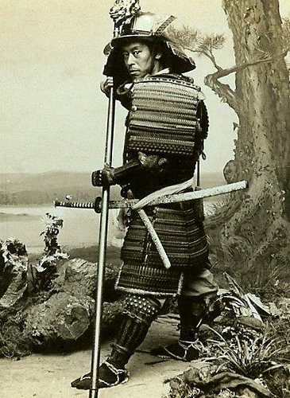

**prefecture:** an administrative district in Japan, somewhat like a large county

**nationalistic:** patriotic, sometimes to the extreme

To modernize the government of Japan, the new leaders decided that they would need to

• unify the territory of Japan

• look for a model of government that could be adapted to Japanese needs

• change the social order so that all Japanese citizens, no matter what their origins, would have the same obligations and loyalty to the state

• create a constitution so that the most important values and beliefs of Japan would guide the country in the future

**liberal:** favouring a relaxing of social traditions; favouring personal freedom

**human rights:** the basic rights believed to belong to every person, such as the rights to freedom, to justice, and to religion

**conservative:** averse to rapid change; favouring the status quo

**Dajokan:** the Japanese government structure implemented during the Meiji Period The Japanese parliament is opened by the Mikado (the emperor), Tokyo, 1891.

**Searching for a New Model of Government**

* new government’s goal was to be efficient and economical
* disagreement on how to build a new Japan
* **liberal** group supported the French and American ideals of **human rights** and a representative government
* **conservative** group was more comfortable with the German model of centralized control
* leaders decided to adopt a German-style government with a strong cabinet and limited powers of parliament it was called the **Dajokan** after an ancient Japanese imperial institution

**Political Change Affects the Social Systems**

* government wanted the population to be loyal to the central state/emperor and not local daimyo
* eliminated the hierarchical social order - feudal class system was abolished
* people chose their occupations and move about the country freely
* All Japanese now lived with the same obligation — be loyal to the emperor and to the state

**The Constitution of Japan — 1889**

*We hereby adopt a fundamental law of the State, to exhibit the principles by which We are guided in Our conduct, and to point out to what Our descendants and Our subjects and their descendants are forever to conform.*

* The Emperor is sacred and inviolable and is above the law of the Constitution.
* Government ministers are responsible to the Emperor.
* The Emperor has the power to
* command the military forces and control foreign policy
* appoint cabinet members, judges, and Privy Council members
* convene and dissolve the Imperial Diet (Parliament) at will
* The Imperial Diet is divided into two houses of equal power:
* The Upper House is called the House of Peers. Members are selected for life by the Emperor.
* The Lower House consists of 300 members who are elected by citizens for four years.
* Citizens are granted freedom of speech, religion, and association. However, the government reserves the right to withdraw these rights.

**Creating a Constitution**

* Japan believed it was as strong and capable as any other nation — a world leader
* leaders were in favour of developing a constitution for Japan:

• Most strong European countries had constitutions.

• Western countries would regard Japan as a stronger nation if it had a Western-style constitution.

• A constitution would unify Japan.

* leaders agreed with developing a constitution, they disagreed with model
* constitution and writing of it became a national issue
* many Japanese (including former samurai - now called *shizoku)* not satisfied with the control of the strong central government, they wanted greater participation

* Three political parties were formed and supported by different newspapers, debates happened in all parts of the country, and violent revolts erupted
* Meiji government reacted with more restrictions and passed a new law allowing the government to censor the newspapers
* Public assemblies were also banned
* In response to these new laws people called for a representative government
* new constitution was written similar to the constitution of Germany and reflected Japanese society

**domestic products:** the goods produced within a country

**import tariff:** the taxes on goods coming into a country; imposed to make imported goods more expensive in relation to domestic products

**How Did Japan Change Its Economic System?**

* road system, markets, merchant class, small businesses, and some banking institutions were already in place
* leaders believed they needed to become more industrialized
* Japan was restricted by the trade agreements it had signed with Western powers
* it was not allowed to lower the taxes on domestic goods or raise taxes on foreign goods
* unequal treaties made it difficult for domestic industries to survive

**Industrialization**

* new industries, such as munitions and gunpowder factories, were for the military
* other industries, such as the silk and textile industries and glass and chemical plants
* many new industrial and manufacturing projects were government funded and government owned it helped jump-start Japan’s modernization
* costs these industries were overwhelming except for military-based industries, most government supported industries went private
* country’s major industries came under the control of a small number of private companies which reduced economic competition, they were known as *zaibatsu* or financial cliques, ie. Mitsubishi family
* zaibatsu were closely tied to the government and strengthened support for the Meiji state

**Capitalism**

* Matsukata Masayoshi became the Minister of Finance
* Changes he made, small farmers lost their land and several small businesses went bankrupt
* industrial output increased and Japan’s **national income** doubled
* Japan quickly developed into a capitalist society

**national income:** the money received for all services, goods, and products produced by a country, usually measured quarterly or annually

* Using the developed countries of the West as models, the government helped the economy to change and grow:
  + New railroads were built to join all four major islands; roads and highways were paved
  + Deep water harbours were created at Yokohama and Kobe
  + Telegraph and telephone systems were built
  + New technologies and industries were imported, as well as hundreds of foreigners to train the Japanese
  + A Ministry of Banking was set up to provide subsidies to new businesses.

**What Is a Capitalist Society?**

* Individuals or the government are engaged in business.
* Focus is on entrepreneurs who establish and operate companies.
* Goal is to make a profit by producing or obtaining goods at one price and then selling them for more money.
* People work for wages, not goods. They use their wages to purchase the goods they need or want.

**B. Multiple Choice -** *Identify the choice that best completes the statement or answers the question.*

1. Which of the following statements does not describe Japan’s new worldview about its place among nations?

|  |  |
| --- | --- |
| A. | strong and capable nation |
| B. | a world leader |
| C. | a leading exporter |
| D. | a constitutional government |

2. What was the symbol that was used to help develop nationalistic feelings in the people of Japan during the Meiji era?

|  |  |
| --- | --- |
| A. | samurai |
| B. | emperor |
| C. | the military uniform |
| D. | Japanese Buddha |

3. The government of Japan wanted people to accept its new rules and reforms so they created a new long-term __________ plan which would instill in them common values of citizenship and duty.

|  |  |
| --- | --- |
| A. | financial |
| B. | national religion |
| C. | modernization |
| D. | education |

4. The Rescript to Soldiers was an updated version of

|  |  |
| --- | --- |
| A. | the oral traditions |
| B. | gunboat diplomacy |
| C. | the bushido moral code |
| D. | the hara-kiri ritual |

**How Did Japan Change Its Military System to Meet Political Needs?**

* wanted a strong military for several reasons:
  + centralized army of obedient and disciplined soldiers would strengthen the government, with a strong military, the government could bring about change and defeat any internal opposition
  + strong military force was necessary for Japan to renegotiate the unequal treaties
  + wanted to become a colonial power - believed countries that had colonies were highly respected
  + leaders needed a strong military to ensure they could meet their political goals (**defend themselves against enemy attack and preserve their independence**)
* Japan developed a powerful army and navy
* used the British navy and the German army as its models
* new leaders had military experience from the previous wars
* used Western models to train their armed forces
* Western nations were reorganizing and rebuilding their own armies

**1870 —** Imperial Guard was the first government-run army and the beginning of a national army.

**1873 —** The new army used the French idea of military conscription. All men, regardless of class or origin, had to serve time in the army for three years, followed by four years of service in the reserves.

**1876 —** Japan used **gunboat diplomacy**, learned from Commodore Perry, to force Korea to open its ports to trade. Japan made an unequal treaty with Korea that allowed Japanese citizens in Korea to live outside the laws of the country.

**1882 —** The army adopted a type of bushido moral code called the Rescript to Soldiers. It stressed complete loyalty to the emperor. It required loyalty, respect for superiors, valour, faithfulness, righteousness, and simplicity. Ironically, the new military was using the same principles by which the now-abolished samurai had once lived.

**gunboat diplomacy:** political negotiation supported by the threat or use of military force

* military changed the Japanese worldview by breaking down class
* Japanese peasants left their homes, received educational training, returned to their homes after conscription, they brought modern technology
* brought sense of nationalism and loyalty to the emperor and passed on to fellow villagers

**C. Completion -** *Complete each statement.*

1. During the Meiji period, Japan wanted to become a ____________________ power and ____________________ self-sufficient.

2. The people of Japan were now able to elect their representatives. This is an aspect of ____________________.

3. The only person guaranteed any rights in Japan during the Meiji period was the ____________________.

4. Getting rid of the _________________________ strengthened the national unity of Japan.

5. The unequal treaties made it difficult for Japan’s industries to survive because they were not allowed to lower taxes on domestic goods or increase the import ____________________.

6. _________________________ and laquerware are two examples of traditional products in Japan.

7. Japan believed that being a ____________________ power like Britain and France would make it more highly respected.

8. University tuition was free for those students who were accepted into the _________________________ universities.

9. New railroads and highways, a Ministry of Banking, and ______________________________ are all signs that the government helped the economy of Japan to change.

10. Being ____________________ means that you are averse to rapid change and favor the status quo.

**How Did Japan’s New Worldview Change Its Social Systems?**

* traditional feudal system was eliminated
* rigid class structures was dismantled
* Individuals free to better their status, change occupations, and move around the country
* education was key to change

**The Lives of the Daimyo Changed**

* nobility and the daimyo were merged into a single aristocratic class
* daimyo could no longer get money from their domains, government gave them a one-time lump sum of money and pensions
* invited to Tokyo national banks to invest their capital in new businesses

**The Lives of the Samurai Changed**

* samurai were given allowances, but reduced and eventually eliminated
* military conscription symbolically ended the importance and privilege of the samurai, forbidden to wear the ceremonial swords, special dress and hairstyle went out of fashion
* samurai were given permission to become tradespeople, farmers, and business owners
* samurai who had been educated became involved in business, government, and education

**The Lives of the Farmers Changed**

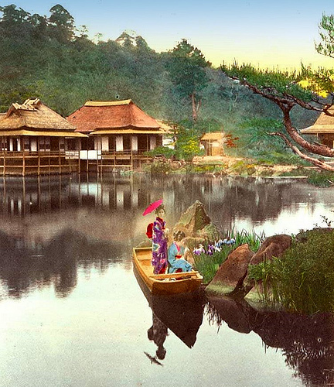

* Farmers were given ownership of their lands and free to grow what they wanted, had freedom to move about and sell their products at markets, had to pay a 3 tax on the land
* small farms were unable to pay their taxes, sold lands to wealthier farmers and became tenant farmers
* farmers were not able to negotiate with new bureaucracy (impersonal and inflexible) during famines and droughts
* 3% land tax, taxes rose and caused hardship, grew angry and notice merchant class was becoming wealthy

**.**

**The Lives of the Commoners Changed**

* feudal system was abolished, people with lower incomes had the opportunity to move to positions of higher pay
* commoners were allowed to have surnames
* ban on intermarriage between samurai and commoners was lifted
* lowest classes were raised to the status of commoner, now subject to tax and legal obligations like everyone else
* christians were allowed to practise their faith
* long-term education plan was needed, through education, the government could strengthen national and social unity, widen the support of the people, and ensure that values of citizenship and duty were taught to all
* technical schools were set up, and elementary school became compulsory for all children3
* standardized curriculum was developed for ALL children.
* 1871, Ministry of Education developed
* goal break down class and regional identities and help raise the standard of living in the country
* curriculum promoted strong, common moral values, a strong national identity, and loyalty to the emperor
* establish the Imperial University (Tokyo University) and a second national university in Kyoto
* tuition was free for those accepted into the government-run universities, and graduates were automatically qualified for jobs with the government
* private universities were also established.

**ratify:** to approve formally

**How Did Japan’s Culture Change?**

**What Role Did Religion Play?**

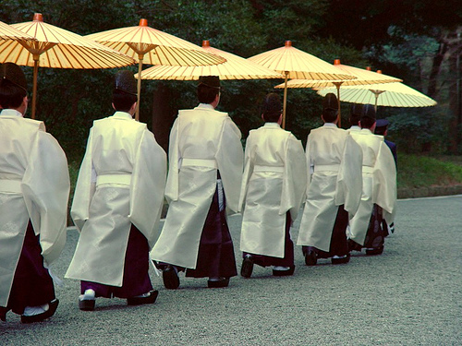

* government wanted to make Shintoism the national religion and part of the school curriculum
* everyone having the same belief system would create greater unity
* hoped the people would discard Buddhism and Confucianism
* but, confucian virtues were still being taught in the schools, the military, and through bushido
* many people practised Buddhism and Confucianism anyway
* eventually the government allowed Buddhism as a religion

**How Did Attitudes Change?**

* Young Japanese intellectuals believed that if Japan was to succeed, then the individual had to succeed
* used mottos to promote this idea: *bunmei kaika or*  “Civilization and Enlightenment,” and *risshin shusse or* “Be a Success.”
* newspapers wrote about the ideals of liberty and individualism
* individual was to work in harmony with family, community, or business groups.
* new sense of nationalism emerged
* failed to renegotiate the unequal treaties; people began to feel bitterness towards the West
* fear that the move towards a Western lifestyle had gone too far and Japan was losing its identity

**How Did Ideas of Citizenship and Participation Change?**

* increasing education, dismantling of the class hierarchy people started to voice their concerns and lobbied the government
* these new attitudes surprised and frightened the Meiji leaders who still believed there was a need for strict government control over the country

**filial:** showing proper respect

**D. Multiple Choice - -***Identify the choice that best completes the statement or answers the question.*

5. Once the borders opened and Japan could trade with the West __________ began to influence Western art and architecture.

|  |  |
| --- | --- |
| A. | Vincent Van Gogh |
| B. | Fukuzawa Yukichi |
| C. | Matsukata Masayoshi |
| D. | Japonisme |

6. Many changes occured in Japan from the Edo period to the Meiji period. Which of the following is one area in which very little changed?

|  |  |
| --- | --- |
| A. | culture |
| B. | social system |
| C. | political system |
| D. | education |

7. The domains were all abolished in 1871 and replaced by a __________ system.

|  |  |
| --- | --- |
| A. | nationalistic |
| B. | prefecture |
| C. | oligarchy |
| D. | Tokugawa |

8. Although Japan had begun to make economic changes the leaders believed that Japan needed to become more

|  |  |
| --- | --- |
| A. | industrialized |
| B. | conservative |
| C. | democratic |
| D. | adaptable |

**How Did Changes in the Edo Period Compare to Changes in the Meiji Period?**

This chart summarizes the key changes that occurred during the Edo and Meiji Periods. Think about these developments and imagine their impact on the people of the time.

**Government, Land Ownership, and Taxes**

|  |  |
| --- | --- |
| **Edo Period** | **Meiji Period** |
| * politics based on a feudal system * shogun demanded loyalty from the daimyo * daimyo set their own rules/regulations * decentralized form of government * domain was ruled by its own Han * shogun and Bakufu ruled over the daimyo * individual rights were not considered * daimyo were required to pay taxes * tax assessment was based on crop production; the koku * taxes were paid with products, not currency * taxes paid to the daimyo were the responsibility of each village unit | * + Feudalism was abolished   + loyal to the emperor   + centralized government dictated rules and regulations for the entire country   + emperor adopted a constitution that allowed some individual rights   + provide a mechanism for the will of the people to be expressed through the election   + domains were abolished   + country was divided into prefectures/districts   + farmers could own the land they worked   + taxes were collected directly by the central government   + based on 3% of the land value and were paid with money   + taxes were the responsibility of each individual landowner |

**Military, Foreign Relations, Education, Class Structure and Culture**

|  |  |
| --- | --- |
| **Edo Period** | **Meiji Period** |
| * shogun had the largest army * each daimyo had an army made up of their samurai * over time, armies became smaller, no need for large armies and too expensive * priorities of the shogun were peace and order * Bakufu believed that the best way to maintain peace and order was to isolate Japan from the rest of the world * established the National Seclusion Policy * the unequal treaties were signed * signing of treaties was major factor in the downfall of the Bakufu * no government-run schools * 2 types of schools: education to sons of the samurai class and schooling for the sons of commoners * usually run by a single person or couple * focused on literacy and numeracy * feudal system dictated strict class structure and social roles * society was very traditional, developing many artistic forms such as kabuki, tea ceremonies, and printmaking | * The Edict for Conscription made military service compulsory * foreign military models were studied * German model was used to organize the army * British model was used for the navy * priority to build up Japan’s strength to that of the Western countries * travelled abroad to study Western military practices and learn about Western technology * experts from the West were invited to Japan * renegotiate the unequal treaties * Ministry of Education was established * standardized school curriculum was set * 3 levels of schools were established: primary, middle, and university * primary schooling was compulsory for boys and girls * feudal system was abolished * class hierarchy was dismantled * individuals could move in social classes * society adopted ways of the West but maintained most cultural traditions |

**Conclusion**

* Meiji Era ended with the death of the emperor in 1912
* key advisors committed **seppuku** when they lost their lord, just as samurai had done for centuries

**seppuku:** ritual suicide by disembowelment by a sword; also known as hara-kiri Crown Prince Yoshihito

**E. Multiple Choice - -***Identify the choice that best completes the statement or answers the question.*

9. The emperor’s key advisors committed seppuku when he died. Which of the following reasons would accurately describe why this was done?

|  |  |
| --- | --- |
| A. | To show the ultimate loyalty towards the emperor. |
| B. | To avoid having to work for another emperor. |
| C. | To be punished for the emperor’s death. |
| D. | To show their disagreement with the selection of the new emperor. |

10. Which of the following was not a motto used by the young intellectuals to help Japan be successful?

|  |  |
| --- | --- |
| A. | Civilization and Enlightenment |
| B. | Be a Success |
| C. | Unify the territory of Japan |
| D. | For the sake of the country |

11. Always respect the constitution, observe the laws, and be __________ to your parents.

|  |  |
| --- | --- |
| A. | insolent |
| B. | filial |
| C. | A and B |
| D. | none of the above |

**F. Short Answer:**

1. Throughout the Meiji Period, the government of Japan wanted to unify the country. How did they attempt to do this? Did it work? Give your answer in essay format. Give examples from the text and class discussions to justify your answer.

_____________________________________________________________________

_____________________________________________________________________

_____________________________________________________________________

_____________________________________________________________________

_____________________________________________________________________

_____________________________________________________________________

_____________________________________________________________________

_____________________________________________________________________

_____________________________________________________________________

_____________________________________________________________________

_____________________________________________________________________

_____________________________________________________________________

_____________________________________________________________________

_____________________________________________________________________

_____________________________________________________________________

_____________________________________________________________________

**Chapter 7**

**HOW DID GEOGRAPHY AND HISTORY AFFECT THE WORLDVIEWS OF THE AZTEC AND THE SPANISH?**

**The Aztecs**

* Aztec called themselves Mexica, this is the origin of the name of the country of Mexico
* Geography of Mexico includes: deserts, mountains, tropical forests, ranchland, rich farmland and seacoasts (east and west)
* 2 largest rivers are Rio Grande and Usamacinta
* Northern Mexico is desert (Chihuahua and Sonoran)
* Only 10% of land can produce crops in Mexico
* Mountain ranges located in central plateau of Mexico
* Large basin between mountain range referred to as Valley of Mexico
* Temperatures in basin are always spring like
* South Mexico has dense forests and tropical climate with lots of rainfall
* Tropical beaches line both Pacific Ocean and Caribbean Sea
* Pre-columbian societies lived in central basin (basin had plenty of water from 5 lakes, largest: Lake Texcoco (all water drained into Lake Texcoco making it saline – soil around the lake not suitable for agriculture
* Aztec civilization lived in this valley – small agriculture that existed around the lakes supplied food for whole civilization, nobles/elite lived in cities and farmers grew the agriculture
* Basin had different ecological zones – farmers grew a variety of items and had different farm techniques based on the zones they lived in - this diverse zone created a market system for distribution of food and other items
* Canals and waterways main form of transportation

**Spain**

* Spain occupies about 80% of Iberian Peninsula
* Due to Spain being located on the ocean, it had an advantage in the exploration race
* Mountain ranges: Pyrenees (largest) separates Spain from France
* Fast flowing and difficult to navigate rivers
* Central Plateau called Meseta Central is treeless, dry and drought like – plateau is isolated from the north and south of Spain by mountain ranges
* Climate is rainy in the north and moderated by the ocean, winters are mild and summers cool
* Southern part of Spain is dry and little rainfall
* Due to the geography of Spain, the kingdoms were usually localized, small and based on mountain ranges, or rivers, this helped to shape Spain’s history

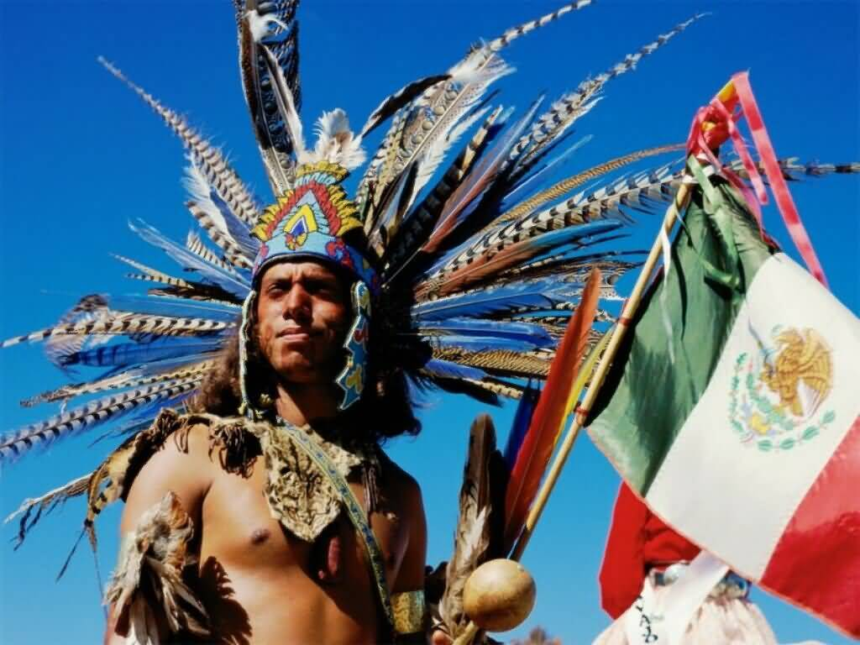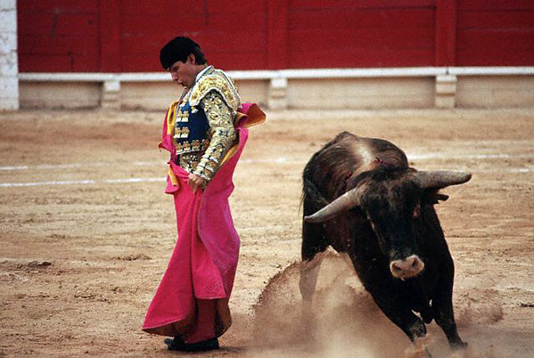

**A. Define:**

**plateau ______________________________________________________________________________**

**pre-Columbian** _______________________________________________________________________

**ecological zone ________________________________________________________________________**

**semi-nomadic** ________________________________________________________________________

**incentive _____________________________________________________________________________**

**Meso-America ________________________________________________________________________**

**HOW DID THE HISTORY OF THE AZTEC AFFECT THEIR WORLDVIEW?**

**Long Migration**

* Aztec were one of several Nahuatl-speaking groups who left the desert like country of northern Mexico and migrated southward looking for a place to settle
* Other groups went north (ie. Comanche into US)
* roughly 200 year led a semi-nomatic life and finally settled in the Valley of Mexico
* Aztec followed during their migration the orders of their patron god – Huitzilopochtli who spoke to the priests
* Priest would force followers to keep moving upon instruction from Huitzilopochtli, even if it meant leaving unharvested crops
* They believed they were the chose people and the god would lead them to their land and destiny
* Tenoch was chieftain who lead them to the Valley of Mexico
* In the Valley city/states of various other groups were already settled and wouldn’t let Aztec settle as they were barbarous and uncultured
* Other societies were: Tlaxcalans, Cholulas and Tepanecs – all would have conflicts with Aztecs

**Tenochtitlan, The City of Tenoch**

* Finally Aztecs found a swampy island in the middle of the Lake Texcoco
* Priests had saw a eagle perched on a cactus holding a rattlesnake – sign that had been foretold of the “right” place
* After settled dealt with the other societies they would continue to have conflict with
* Many Aztec worked as mercenaries and servants for other societies especially the Tepanecs
* Became skilled hard workers and ferocious warriors, build aqueducts to bring fresh water and connected their island to mainland by 3 causeways (provided protection against attack)
* Use waterways to trade with other societies around the lake
* City grew, roughly 1,000,000 people in Valley and 150,000 on island (larger than any European city)
* Once settled into new city, a new culture was built on history of migration, strong religious beliefs and what made them strong/able to flourish (ie. hard work, faith, negotiation skills, etc.)

**B. How did 200 years of semi nomatic life affect the Aztec’s worldview?**

_________________________________________________________________________________

_________________________________________________________________________________

_________________________________________________________________________________

_________________________________________________________________________________

_________________________________________________________________________________

**HOW DID THE HISTORY OF THE SPAIN**

**AFFECT THEIR WORLDVIEW?**

Iberian Peninsula had successive waves of invasion and colonization over the years:

* romans (Christian),
* then the Ostrogoths, Franks and Visigoths (also Christian),
* then the Moors (mostly muslim from North Africa)

**History - The Reconquista**

* Muslim rule in Spain lasted more than 700 years - Muslims, Jews, and Christians were **all** allowed to practice their own beliefs.
* few northern regions in spain resisted the Muslim invaders and remained Christian and over the centuries became more powerful and continuously fought to get lands back
* the Reconquista, was the move to retake the Iberian land under Muslim control
* during the 1100 and 1200’s the Christian regions were successful at reconquista and now the muslims only held one small kingdom
* in 1492 the last small kingdom was captured by the **conquistadors** of King Ferdinand and Queen Isabella, the Moorish control of Spain was over
* the Spanish conquistadors were christians and believed that it was their duty to convert non-believers to Roman Catholicism
* the Spanish conquistadors fought for both religious and nationalistic reasons
* the two largest kingdoms, Aragon and Castile, were unified with the marriage of Ferdinand and Isabella
* Spain was not yet a nation but was now made up of several kingdoms brought under the authority of the monarchy

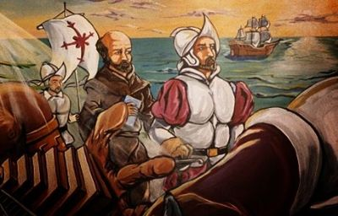

**Spanish Inquisition**

* After the Reconquista, the Roman Catholic faith was considered the only true faith in Spain
* Ferdinand and Isabella used this to their advantage because it would united everyone if they followed one religion and it was a way to control people
* In 1492, the Spanish Inquisition was instated
* the Inquisition was both a civil and a religious court
* the court was set up to judge if the converted Jews and Muslims were true Roman Catholics
* it also judge any citizen who was accused of not following the Roman Catholic faith (punishable by confinement to dungeons, torture, or death)
* If an individual was simply accused, but not proven guilty, property was confiscated and the person was forbidden from holding any public office
* Eventually, all Jews and Muslims were expelled from Spain
* the Spanish Inquisition did not officially end until 1834.

**C.** **What is the difference between the Reconquista and the Spanish Inquisition? What was the purpose of the Spanish Inquisition?**

_________________________________________________________________________________

_________________________________________________________________________________

_________________________________________________________________________________

_________________________________________________________________________________

_________________________________________________________________________________

**Desire for Exploration**

* Spain and rest of Europe were benefiting from better economies, new technologies, and more stable government
* the Spanish had a strong desire for exploration to find new lands because the routes to the East around Africa had already been explored by other countries
* in 1492, Christopher Columbus sailed west across the Atlantic, reaching land in the Caribbean and claiming it for Spain.
* with any new lands capture or recaptured, Ferdinand and Isabella considered themselves as the rightful owners including all resources and goods
* missionaries were sent to teach the beliefs and customs of the Roman Catholic Church
* the conquistadors had an imperialistic view of the new world, Superior in culture and religion therefore, conversion happened either peacefully or forcefully

**HOW DID CONTACT WITH THE MOORS**

**INFLUENCE SPAIN?**

* When the Moors conquered regions of the Iberian Peninsula, they imported their Islamic culture and with it there knowledge and ideas.
* the legacy left by the Muslims influenced Spanish learning, architecture, and design (architectural styles, mosaic tiles and carpets)
* muslim scholars and Jewish scholars, were involved in the revival of the study of ancient Greek and Roman culture and philosophy.
* The legacy included the following:
* important schools of astronomy, mathematics, and architecture
* illuminated manuscripts and murals from the 9th and 10th centuries that showed the strong influence of the Islamic and Byzantine artistic style known as Mozarabic.
* great libraries containing books, classical documents (ie. works of Aristotle) all which contributed to the idea of humanism
* beautiful buildings that included enclosed courtyards with fountains and decorative tiles (ie. palaces and mosques)

**Definitions**

**Conquistador** one who conquers; specifically, a leader in the Spanish conquest of America and especially of Mexico and Peru in the 16th century

**codex:** an ancient manuscript in book form

**destiny**: all that is supposedly predetermined to happen to someone or something in spite of all efforts to change or prevent it.

**Incarnation:** a deity or spirit taking a physical form

**Meso-American Societies :** other societies which existed the same time the Aztecs did in the Americas

**HOW DID CONTACT WITH OTHER MESO-AMERICAN SOCIETIES INFLUENCE THE AZTEC?**

* each of the Meso-American societies had its own unique customs and traditions.
* many similarities between Aztecs and other civilizations because they all had incorporated the ideas and beliefs of the **ancient** societies

**Earlier Societies of Meso-America**

* the three greatest earlier civilizations in the Valley of Mexico were:
  + Olmec - 1200 to 400 BCE
  + Teotihuacan - peak of power between 150 and 450
  + Toltec - 900 to 1150

**The Olmec**

* said to be the founding society, or mother culture, of all Meso-American civilizations
* lived in the lowlands near the Gulf of Mexico
* considered to be the greatest sculptors – ie. the colossal heads
* had several gods, including: a fire god, a rain god, a corn god, and the Feathered Serpent.
* Pyramid of the Sun in the city of Teotihuacan was the largest structure in the Western hemisphere until 1960s.

**The Teotihuacan**

* *Teotihuacan* refers to the ancient civilization and to its **altepetl (a meso-american city-state)**
* altepetl was located what is now Mexico City.
* the Aztec, impressed by the enormous ruins believed it was a holy place where the sun, moon, and universe were created
* Aztec copied the way Teotihuacan was laid out (ie. the temples in the city centre) when building their city of Tenochtitlan
* within the centre of Teotihuacan was a temple to the god Quetzalcoatl

**The Toltec**

* capital city of the Toltec was called Tula, located about 100 km northwest of present-day Mexico City
* Aztec believed the Toltec were masters at creating a refined civilization
* each time the Aztecs lived among new people, they absorbed many of their customs and beliefs

**Effects of Other Meso-American Societies on Aztec Cultures**



**Social Systems**

* a hierarchical society with both a noble class, priests, and commoners
* a government with a strong central authority
* use of militaristic practices to build an empire

**Religious Beliefs and Practices**

* the belief that gods could take on different forms such as the jaguar (an earth mother goddess) and the serpent (a water goddess)
* a belief in many gods, including Quetzalcoatl (the gentle plumed serpent god) and the god of rain Tlaloc
* religious practices that centred on seasonal cycles, emphasizing astronomy and the calendar
* a belief that human sacrifices were necessary to sustain the gods with human hearts and blood

**Architecture and Art**

* huge pyramid-shaped temples to honour the gods
* beautiful murals, large sculptures, and monuments of both humans and animals, mainly with religious motifs
* the art of fine jewellery making, ceramic pottery, mosaic, metalworking, and featherworks

**D. Multiple Choice -** *Identify the choice that best completes the statement or answers the question.*

**1. The center of the Aztec civilization was established in**

|  |  |
| --- | --- |
| A. | the desert of Mexico |
| B. | the valley of Mexico |
| C. | the mountain region |
| D. | near the coast of the Gulf of Mexico |

**2. The ecological zones of the land found in Mexico primarily influenced**

|  |  |
| --- | --- |
| A. | lifestyle |
| B. | crop growth |
| C. | market trade |
| D. | transportation |

**3. Spain was made up of many small kingdoms due to the**

|  |  |
| --- | --- |
| A. | way the monarchs had decided to divide the land |
| B. | many rivers that ran throughout the country side |
| C. | enormous mountain regions |
| D. | outcome of wars which determined the regional boundaries for the kingdoms |

**4. The long migration was characteristic of Aztec culture. They were nomadic because they believed**

|  |  |
| --- | --- |
| A. | the gods did not want them to live in the same place all the time |
| B. | they needed to find all the riches they could in Mexico |
| C. | a true Aztec never settles |
| D. | that their god Huitzilopochtli would let them know of their true place of destiny |

**5. The Aztec people knew that the island in Lake Texcoco was their destination to settle as they had received a sign from their God which had taken the form of a/an**

|  |  |
| --- | --- |
| A. | bear eating fish off the coast |
| B. | fox chasing a rabbit |
| C. | eagle holding a snake in its beak |
| D. | rooster sitting on a cactus tree |

**6. The characteristic that was most honorable of the Aztec people and which helped them to become leaders was their**

|  |  |
| --- | --- |
| A. | hard working nature |
| B. | belief in God |
| C. | ingenuity and creativity |
| D. | patience and respect for others |

**HOW DID THE AZTEC EMPERORS BECOME**

**THE MOST POWERFUL RULERS IN THE**

**VALLEY OF MEXICO?**

* While the Spanish were struggling to unify their kingdoms, the Aztec were establishing an empire.
* when Spanish arrived in the early 1500s, the Aztec controlled most territories left in Meso- America

**The Aztec Rise to Power**

* Aztec emperors increased their power by creating alliances with other powerful rulers, often through arranged marriages that were direct descendants of the Toltec
* the Aztec gained power and respect in the Valley, they formed a Triple Alliance of the city-states of Texcoco, Tlacopan, and Tenochtitlan to fight the rival Tepanec.
* most of the region from the Pacific to the Gulf of Mexico was under the control of the Alliance

**Conquering New Societies**

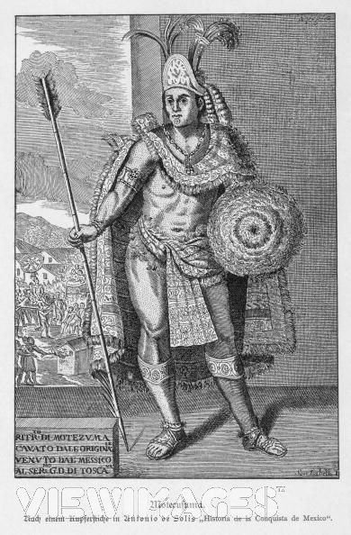

* Life in Aztec society developed around a culture of war. The goals of battle were:
  + to seek an honourable defeat for the enemy and then make them pay tribute and provide labour to the empire
  + to gain soldiers for the human sacrifice to the god Huitzilopochtli
* Aztec had a conquering military strategy, first conquered weaker societies around those that were stronger then, they attacked the isolated society
* Aztec did NOT reorganize the societies they defeated
* defeated ruler continued to carry out the local laws and government, customs and beliefs and followed emperor’s orders
* if defeated societyrefused to pay tribute to the Aztec, they killed the people, sparing only the children, children then distributed throughout the empire (ie. as much as 40,000 children)
* When a city-state was defeated, its citizens were required to:
  + promise allegiance to the emperor
  + pay tribute to him in either goods or services
  + worship the god Huitzilopochtli
* when no formal wars were being fought, the Aztec and their allies often challenged the rulers of other regions to participate in battles, this provided opportunities for young warriors to train and improve their skills and to take captives for sacrifices

**What Political Structure Developed in the Aztec Empire?**

* governing the empire were the nobility, the pipiltin , the emperor was the highest-ranking noble and held the greatest power
* Chief of Internal Affairs was the closest advisor to the emperor and the second in command
* The tlatoque ruled, kept the records, managed the marketplace and resources, general of the military and members of the advisory group, of the major towns and cities and the Tecutin ruled smaller areas
* Priests, advised the emperor, studied religious calendar to determine which days would be lucky

**E. True/False -** *Indicate whether the statement is true or false.*

____ 1. Semi-nomadic nature of the Aztec can be attributed to their belief that life was not constant and one had to always seek new things.

____ 2. Contact with other Meso-American cultures affected the social structure of the Aztec nation making them more hierarchical.

____ 3. The Aztec people did not believe in interracial marriages as they wanted to preserve their unique culture and people.

____ 4. The goal of a battle for the Aztec people was to capture enemy soldiers to sacrifice to their god.

____ 5. When the Aztecs conquered a nation they left a military team behind to ensure allegiance to the Aztec emperor.

**How Did the Spanish Monarchy Become So Powerful?**

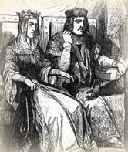

* During King Ferdinand and Queen Isabella ruled they increased the powers of the throne and decreased the powers of the Cortes (the Spanish parliament).
* To do this, they:
* centralized government under their control
* created a more efficient government bureaucracy
* imposed new taxes
* took control of the Roman Catholic Church in Spain
* began the Spanish Inquisition
* forbid any faith but Roman Catholicism

**Reducing the Powers of the Aristocracy**

* Cortes (aristocrats) were established to keep the power of the monarchs under control by controlling the national treasury, and needed approval for all major expenditures
* Ferdinand and Isabella reduced the power of the aristocracy by having men not from the aristocracy, selected for the Cortes
* allowed nobles to participate in parliamentary proceedings, but not vote
* reorganized important financial and judicial institutions
* centralized the powers of the government under a Council of State, Finance, and Justice
* for loss of power, the aristocrats were granted huge tracts of land and exempted them from paying taxes
* Ferdinand and Isabella gained support of the merchants and townspeople by helping them financially and with their business and protection - merchants taxes increased to make up the shortfall

**Control of the Church**

* In 1486, Pope Innocent VIII gave Ferdinand and Isabella the right to choose whomever they wanted to fill Church positions
* the Roman Catholic Church gave up this power and in return, Ferdinand and Isabella agreed to set up the Spanish Inquisition

**The Spanish Begin to Build an Empire**

* the changes Ferdinand and Isabella made gave them greater authority and better resources to begin a policy of exploration and discovery
* in 1492, Columbus convinced the monarchs to support him in his explorations
* this decision led to Spain becoming the most powerful and wealthy country in Europe in the 16th century
* by the middle of the 1500s, Spain controlled large areas of the Caribbean, the Americas, and parts of Asia and Africa.

**F. True/False -** *Indicate whether the statement is true or false.*

____ 6 The Reconquista was a Spanish mission to retake the Iberian land under Muslim control.

____ 7. The Spanish desire for exploration grew after the government was assured that all their citizens were Roman Catholic and had one national identity.

____ 8 The Spanish nation did not believe they were superior to other nations and had to conquer other nations in order to establish themselves.

____ 9. The legacy left by the Moors in Spain influenced later learning and expansion.

____ 10. In an agreement with the pope, King Ferdinand and Queen Isabella set up the Spanish Inquisition in exchange for the right to select who would be appointed to important positions within the Roman Catholic Church.

**What Aspects of Worldviews Are Reflected in Creation Stories?**

* societies have creation or origin stories that explain the creation of the world and human beings often provide a way of understanding the religious and spiritual beliefs and customs of a specific society
* these stories were originally told through oral traditions of storytelling and often seen in art and sculpture
* Aztec believed the gods had created and destroyed the world four times.
* Aztec believed they were living in this fifth world, known as the fifth sun, and that it was their duty to keep the sun alive to prevent the destruction of the Earth and its people.
* studying the traditional stories of Aztec, we can learn about their beliefs and gain understanding of the reasons for their behaviour
* Aztec stories reinforce their beliefs that there must be some form of sacrifice in order for the sun to shine and the world to exist and remain in balance
* this belief was an important part of their worldview and led them to perform human sacrifices
* believed the blood of humans was the most precious offering they could give to their gods
* Aztec considered warriors who were sacrificed to the gods to be great heroes
* Captured enemies would all be sacrificed
* Gods and humans worked together to maintain the balance of the universe of the fifth sun

**G. Multiple Choice -** *Identify the choice that best completes the statement or answers the question.*

**7. In the early 1100s Spain was predominately**

|  |  |
| --- | --- |
| A. | Christian |
| B. | Muslim |
| C. | multi-religious |
| D. | Jewish |

**8. The underlying purpose of the Reconquista was to**

|  |  |
| --- | --- |
| A. | invade all monarchies in Spain |
| B. | develop strong armies by recruiting all young men |
| C. | deliver Christianity to all |
| D. | ensure Spanish was the only language spoken |

**9.. The main purpose of the Spanish Inquisition was to**

|  |  |
| --- | --- |
| A. | ensure all citizens were Christian |
| B. | eliminate all non-Christians |
| C. | ensure loyalty to the King and Queen |
| D. | ensure loyalty to the aristocrats |

**10. The Moors left a lasting impact on Spain through their contributions to**

|  |  |
| --- | --- |
| A. | trade and market economy |
| B. | architecture, design, and science |
| C. | defense and military strategy |
| D. | religious freedom and individuality |

**11. When the Aztec’s came into contact with all the other Meso-American nations they**

|  |  |
| --- | --- |
| A. | retreated |
| B. | learned and adopted many new skills and values |
| C. | fought to maintain their freedom and individuality |
| D. | became pluralistic in nature through this contact |

**12. The Aztec emperors became very powerful because they**

|  |  |
| --- | --- |
| A. | established alliances with other powerful rulers |
| B. | married rich women |
| C. | conquered most of Mexico |
| D. | had explorers venturing and bringing back goods for trade |

**13. Life in Aztec society developed around the concept of**

|  |  |
| --- | --- |
| A. | religion |
| B. | tradition |
| C. | war |
| D. | sacrifice |

**14. The factor that helped King Ferdinand and Queen Isabella the most in developing the power of the Spanish monarchy was**

|  |  |
| --- | --- |
| A. | reducing the power of the church |
| B. | reducing the power of the Cortes |
| C. | ensuring the only religion would be Roman Catholic |
| D. | reducing the power of the merchants |

**15. During the period of Exploration, view of the following best describes the Spanish beliefs about the people and places they encountered:**

|  |  |
| --- | --- |
| A. | All resources can & should be used for the financial benefit of Spain |
| B. | All indigenous people should be taught about Catholicism. |
| C. | All indigenous people are inferior to the Spanish. |
| D. | All of the above |

**16. The marriage of Ferdinand and Isabella was mostly an arrangement**

|  |  |
| --- | --- |
| A. | to increase the power of the Spanish Monarchy |
| B. | based on true love. |
| C. | to elevate Ferdinand’s social status. |
| D. | that would make them both filthy rich. |

**17. When a city-state was defeated by the Aztecs, its’ citizens were required to do all of the following EXCEPT:**

|  |  |
| --- | --- |
| A. | promise allegiance to the Emperor |
| B. | pay tribute to him in either goods or services. |
| C. | worship the god Huitzilopochtli. |
| D. | change their entire way of doing things. |

**C H A P T E R 8**

**How Did the Aztec and the Spanish Ways of**

**Life Reflect Their Worldviews?**

* Aztec society was highly structured
* based on agriculture and trade
* guided by a religion that was part of every aspect of life
* cities were dominated by giant stone pyramids topped by temples where human sacrifices provided the gods with the human blood that the priests and people believed kept their world in balance
* hierarchical system divided into three social classes: upper, middle, and lower:
  + The pipiltin, the upper class, were the ruling class made up of nobles, high-ranking warriors, and high-ranking priests.
  + Commoners were divided into two classes: the middle class, and the peasants - provided all the labour to keep the economy of the empire flourishing and made up most of the military
* individual born into a social class generally remained a member of that class

**Nobility**

* The pipiltin, the upper class, were the ruling class
* top positions in government, the army, and the priesthood
* top noble was the emperor, political ruler, highest-ranking priest
* amount of land each noble family owned was based on their social position in society and the administrative positions they held in the community
* follow a strict code of behaviour
* role models for the commoners
* when they broke the law, they were punished even more severely than a commoner
* held the jobs of administrators, judges, and clerks
* noble warriors could gain entry into the two military orders: Eagle Knights and Jaguar Knights

**Commoners**

* the middle class, were able to improve their status by gaining recognition in the military or by becoming priests, merchants, artisans, or long-distance traders
* small number of middle class managed to become wealthy through trading
* warriors were next in social status to the nobility, which reflected their importance in the Aztec worldview
* allowed to become priests and fill the more lowly religious positions
* poorest peasants, worked the land of the nobles
* required to build and maintain temples of the cities and the palaces of the nobles
* they guaranteed a piece of land that they could cultivate for life and even pass on to their children
* received a share of the produce after taxes were paid
* lowest in status were the slaves

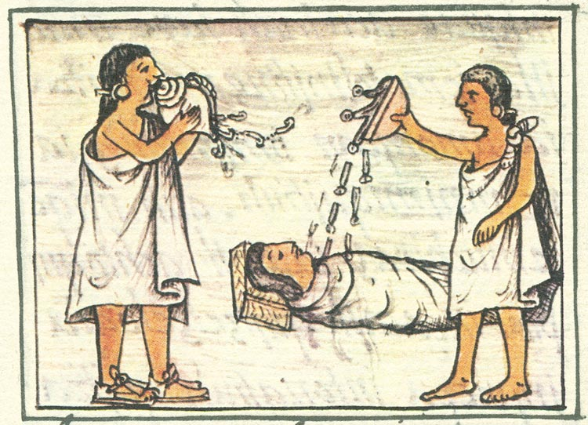

* no one was born into slavery - could sell himself/herself into slavery if unable to pay a debt or punishment for a crime and could buy back their freedom
* slaves were able to own property and marry, their children were free.

**Priests**

* all boys could study to become priests
* top-ranking positions in the priesthood were reserved for the upper class
* oversee important religious functions, advise emperor and to offer human sacrifices to the gods
* men in the priesthood did not marry.
* young women could enter the priesthood but were given specific roles to do with honouring goddesses.

**Roles of Men and Women**

* men and women had different roles
* women were expected to care for the household and family, and could be an artisans, run a business, and control their own property
* women had legal protections, along with a high degree of freedom.
* men did all other physical work and were forced to join the army when soldiers
* men held positions of power
* children work beside their parents age five
* girls married around the mid-teens; boys married in their late teens or early twenties

**Education**

* education was free for all girls and boys
* taught religious rituals and structured classes of singing, dancing, and music
* rhetoric and the ability to memorize long poems, stories, songs, and histories was important
* separate school systems for children of nobles and those of the middle class and lower classes
* schooling began in the early teens, and students attended classes until they married.
* schools for commoners
* boys and girls were taught separately
* children would learn a craft
* boys were taught occupational skills, history, religious practices, and the characteristics of good citizenship, warrior
* school for nobility lived at their schools
* training to be warriors
* trained for the high offices they would hold as adults
* taught rhetoric, music, history, and traditions, how to govern and advance within the imperial bureaucracy, and how to live wisely
* emphasized self control, humility, and unselfishness, highly valued qualities
* girls taught how to manage the households of their future spouses, spin and weave, morality, religion, history, and tradition.

**A. Multiple Choice -** *Identify the choice that best completes the statement or answers the question.*

1. A society’s way of life includes three elements of worldview: social systems, economic and political systems and __________.

|  |  |
| --- | --- |
| A. | government |
| B. | culture |
| C. | family |
| D. | employment |

2. __________ was the basis of the Aztec culture.

|  |  |
| --- | --- |
| A. | religion |
| B. | pipiltin |
| C. | agriculture |
| D. | tradition |

3. Aztec society was guided by __________ and was part of every aspect of life.

|  |  |
| --- | --- |
| A. | religion |
| B. | agriculture |
| C. | trade |
| D. | tradition |

4. Men and women from all classes could study to become __________ but the roles changed according to gender and class.

|  |  |
| --- | --- |
| A. | artists |
| B. | teachers |
| C. | physicians |
| D. | priests |

5. Education was free for __________ in the Aztec society.

|  |  |
| --- | --- |
| A. | boys |
| B. | girls |
| C. | boys and girls |
| D. | none of the above |

6. Unlike the Aztecs, the Spanish were aware of other __________ and were able to use the knowledge gained by this to expand their worldviews.

|  |  |
| --- | --- |
| A. | societies |
| B. | religions |
| C. | governments |
| D. | technologies |

**How Did the Spanish Social Systems Reflect**

**the Spanish Worldview?**

* Spanish society, the feudal system remained in place
* 1486 and was then replaced with a seigneurial system of landholding
  + - lands given to the nobles by the monarchy were operated as self-sufficient estates
    - Peasants were given sections of land by the lord of an estate to cultivate in return for money, goods, or services
    - right to cultivate the land could be handed down from peasant father to peasant son
    - lord of the estate did not have the right to withdraw the property or to increase the taxes

**Nobility**

* nobles were powerful, ruled their estates
* huge tracts of land were still in the hands of a small percentage of the population and given to eldest son
* other sons either became clergy or conquistador
* judged people by social position rather than by achievement through hard work, manual labour was frowned upon.
* highest class of nobility — the dukes, marquis, and counts
* lesser nobles were referred to as don
* minor nobles were referred to as the hidalgo were expected to follow a code of behaviour based on courage in battle

**Commoners**

* Commoners made up 90% of Spain’s population
* feudal peasant farmers or herders had the lowest status
* lived and worked on huge estates that belonged to the nobles
* tiny percentage of peasants eventually owned land
* due to Ferdinand and Isabella, a middle class began to grow
* professionals trained in religion, law, medicine, independent merchants, shopkeepers, artisans, and traders
* these groups shared the same lifestyles as the nobility

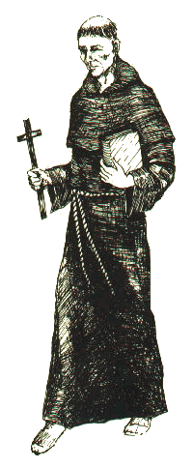

**Priests**

* Roman Catholic priests were the religious leaders in local **parishes,** Franciscans, Jesuits, or the Dominicans
* better educated and came from wealthier families
* religious orders operated many basic schools for commoners
* parish priests often look for other work to support themselves
* upper clergy had great status and rank, similar to that of the nobility

**Roles of Men and Women**

* women were expected to marry well and take care of the household
* divorce was forbidden by the Church
* some women became fine writers and artisans
* peasant women would cultivate the land
* no women could hold government positions or be involved in business

**Education**

* Spain under Moorish control far more tolerant of different religions
* Jews and Muslims in Spain providing an active merchant class and educated elite
* Spanish scholars began to focus on religious studies rather than humanist pursuits
* Roman Catholic Church offered schooling at the elementary level for most children and taught work-related skills (farming and carpentry) or (household skills – cooking/sewing)
* guilds provided training in specific crafts and trades
* noble boys were mostly tutored at home and went to university
* noble girls attended schools of the royal court or private lessons in their homes (taught art, music, and poetry)

B. Describe the educational programs for the Spanish and Aztec children. How were they similar? How were they different?

___________________________________________________________________________________________________________________________________________________________________________________________________________________________________________________________________________________________________________________________________________________________________________________________________________________________________________________________________________________________________________________________________________________________________________________________________________________________________________________________________________

**C. Completion -** *Complete each statement.*

1. The Spanish used ____________________ to buy and sell their products and the Aztecs used a barter system.

2. The Aztecs believed that ____________________ was the center of the universe.

3. The Aztecs valued _________________________ but the Spanish nobility looked down on it.

4. The position of king or queen was ____________________ in Spain but was not for the Aztec emperor.

5. ____________________ were floating gardens built up from swampy areas around the lakes to help increase food production for the Aztecs.

6. The roles of _________________________ were similar in both the Spanish and Aztec societies.

7. The Spanish nobility judged an individual’s worth by _________________________ rather than by achievement through hard work.

**D. Matching**

*Match the following words or terms to their correct description below.*

|  |  |  |  |
| --- | --- | --- | --- |
| A. | pipiltin | E. | god |
| B. | don | F. | sorcerers |
| C. | altepetl | G. | feathers |
| D. | monarchy | H. | cathedrals |

____ 1. The Aztecs valued __________ more than gold.

____ 2. The society living in a/an __________ practiced its own customs and beliefs, and prayed to its own patron

god.

____ 3. The __________ were lesser nobles in Spain.

____ 4. __________ were the nobility or ruling class in Aztec society.

____ 5. Along with temples, __________ were the largest and grandest buildings for both the Spanish and Aztecs.

____ 6. Those who did not accept the teachings of the Roman Catholic Church were thought to be disloyal to the

Spanish __________.

____ 7. __________ were thought to be able to cause and cure certain illnesses in the Aztec culture.

____ 8. The Spanish people believed in one __________ and the Aztecs believed in three.

**How Did the Political and Economic Systems**

**Reflect the Aztec Worldview?**

**Aztec Political System**

* The Aztec emperor, the huey tlatoani, was elected by a Council of Wise Men made up warriors and priests
* head of the government and the highest priest in the land
* decision of sentencing a criminal was his
* position of huey tlatoani was not hereditary, had to prove to the Council that he had the skills to be a good leader

**Altepetl**

* each person of the Aztec belonged to an altepetl, made up of a grouping of related calpulli (clans)
* similar to an Italian city-state or a domain in Japan
* practised its own customs and beliefs and prayed to its own patron god
* had its own origin stories and recorded history

**Role of Priests in the Government**

* priests that held high positions were nobility
* decided which days were lucky to go to war or to hold sacrificial ceremonies
* lowly priests were responsible for providing music and directing religious ceremonies

**Aztec Economy**

**Tribute**

* based primarily on agriculture
* payment of tribute to the Aztec emperor - support the cities and paid to by conquered societies
* territory located on the borders of the empire was required to protect outlying areas of the empire; this military service would be considered part of its tribute
* tribute could be in the form of food, **cacao beans**, natural resources such as lumber, special crops such as cotton, or beautiful luxury items such as featherwork and precious metals. Huge amounts of food, clothing
* movement of different kinds of products throughout the empire encouraged the development of new businesses and improved the economy
* no coins were used, but cacao beans were often used to purchase products
* marketplace where goods and services could be traded or bartered was another important part of the economy

**Farming**

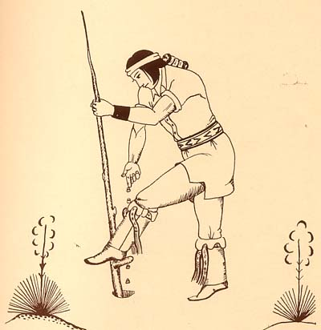

* backbone of economy was farming
* products were used for tribute and to pay taxes
* technological innovations such as irrigation and dike systems increased agricultural productivity
* farmers began to plant on terraced hillsides and chinampas (raised land and fertilized by human waste collect at public latrine boats), food production increased.

**Other Goods and Services**

* marshland farmers worked full time on the chinampas
* inland farmers often had the time to develop a part-time specialization (ie. mined products such as salt)
* producing these local goods eventually developed into **cottage industries** that supplied products for neighbours and other citizens
* other services such as barbers and herbalists and individuals who sold prepared food and drink

**Marketplace**

* goods that were not used for tribute or taxes went to the markets
* no draft animals such as horses or oxen, nor use of the wheel, all goods were transported by porters or by canoe along the waterways

**How Did the Political and Economic Systems**

**of the Spanish Reflect Their Worldview?**

**Spanish Political System**

* king and queen were the highest political power
* god had appointed the monarch, no king or queen could be removed from power
* King and Queen had near absolute power

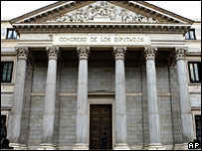

**Spanish Parliament**

* Spanish parliament was called the Cortes
* any new legislation was supposed to be approved by the Corte
* king and queen could call and dismiss the Cortes whenever they wished
* Cortes did have some power because it controlled the treasury
* Due to King and Queen reducing the powers of the Cortes meant a weakened parliament

**Role of the Church in Government**

* Roman Catholic Church closely linked to the monarchy
* pope had the authority to ask members of the clergy to oppose royal actions or decrees
* King and Queen reduced the powers of the Roman Catholic Church and gained the right to place individuals of their own choosing in important positions within the Church

**Spanish Economy**

* after the first cycle of the Black Death, the population of Spain decreased this resulted in a decline in both agricultural and manufacturing output
* seaports also suffered from labour shortages
* sheep-farmers guild formed a powerful organization called the Mesta
* minimum of agricultural products created a lack of money to support the development of larger industries
* therefore, Spain imported more products than it exported.

**Economic Problems**

* manual labour, such as farming and running commercial businesses, was not held in high regard by the nobility or by anyone who wanted to gain social prestige
* nobility saw farming as something the lower classes but did like to own land, land would then remain uncultivated
* little investment in agriculture or commercial efforts, the economy of Spain suffered
* nobility did become involved in overseas trading when Spain established its colonies, but Spanish manufacturing could not produce enough products for both local use and export to the colonies
* the colonies increased their own manufacturing production
* over time, huge amounts of gold and silver were exported back to Spain and it became one of the richest and most powerful countries in Europe
* large influx of gold and silver eventually caused massive inflation in Spain and other parts of Europe

E. **Multiple Choice -** *Identify the choice that best completes the statement or answers the question.*

**8. In both the Spanish and Aztec societies it was the __________ who provided the labor to keep the economy of their empires flourishing.**

|  |  |
| --- | --- |
| A. | nobles |
| B. | commoners |
| C. | kings |
| D. | priests |

**9. The Aztec emperor had a strong belief that religion and __________ needed to be connected.**

|  |  |
| --- | --- |
| A. | family |
| B. | traditions |
| C. | marriage |
| D. | politics |

**10. One of the biggest differences in worldviews between the Aztecs and the Spanish was their attitudes about __________.**

|  |  |
| --- | --- |
| A. | agriculture |
| B. | education |
| C. | religion |
| D. | culture |

**11. The __________ were sometimes called spying merchants because they would go in to enemy territory to sell their goods.**

|  |  |
| --- | --- |
| A. | farmers |
| B. | pochteca |
| C. | artists |
| D. | equinox |

**12. The Aztecs would often use __________ instead of money to pay for products.**

|  |  |
| --- | --- |
| A. | lumber |
| B. | precious metals |
| C. | cacao beans |
| D. | featherwork |

**13. The Spanish parliament, called the __________ could approve new legislation that it deemed to be in the best interest of the country.**

|  |  |
| --- | --- |
| A. | Roman Catholic Church |
| B. | Cortes |
| C. | Moors |
| D. | troubadour |

**14. The Aztec emperor was elected by**

|  |  |
| --- | --- |
| A. | God |
| B. | a council |
| C. | the Church |
| D. | none of the above |

**15. The Spanish king and queen were thought to be appointed by**

|  |  |
| --- | --- |
| A. | God |
| B. | a council |
| C. | the Church |
| D. | none of the above |

**How Did the Culture of the Aztec Reflect Their Worldview?**

* everyday activities of the Aztec provide insights into their worldview
* their religious beliefs, their architecture, and the arts they supported all show what was important to them
* Aztec worldview and culture evolved without knowledge of any societies
* believed Tenochtitlan was the centre of the universe

**Religious Beliefs and Practices**

* humans played only a small role in the world
* duty was to fight and die for the gods
* to keep the world order in balance
* believed futures were already determined by the gods, and that their life after death depended on the gods’ decisions and living a balanced life
* it was their duty to make sure the sun never died and the Earth survived
* believed in many gods and goddesses (male and female/life and death/creation and destruction)
* each god or goddess was dual in nature, neither purely good nor purely evil
* gods had a physical image, often with both human and animal features
* during religious festivals and ceremonies, individuals were chosen to **impersonate** the gods
* Three gods dominated the Aztec religion: Huitzilopochtli, Tezcatlipoca, and Quetzalcoatl
* each neighbourhood had their personal patron deities
* each house had a shrine where family members would ask the gods for help and make offerings of thanks

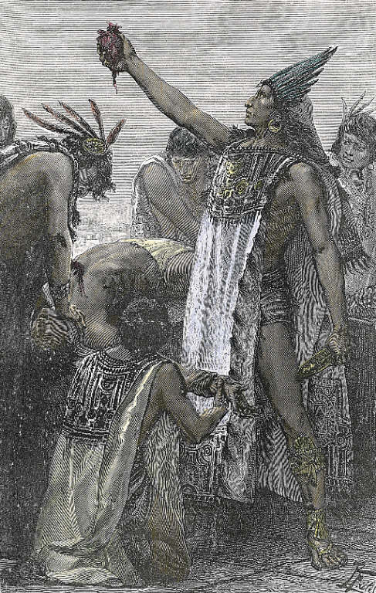

**Ritual and Sacrifice**

* practice of human sacrifice that most collided with the Western worldview of the Spanish
* believed the world was created through sacrifice; their role was to maintain the universe in balance through their rituals and sacrifice
* It was the Aztec view that human behaviour could affect the stability of the universe and that it was through their rituals and sacrifices that the universe could continue to exist.
* Offerings often consisted of different foods, paper, liquid rubber, feathers, grasses, jewels, textiles, and the blood of animals, but the most important offering was human blood
* without human sacrifices, the Earth would dry up and the sun, moon, planets, and stars would not be able to travel across the sky
* human sacrifices were performed on altars at the top of their temples
* the best nourishment for the gods was the still-living hearts of the sacrificed warriors
* some records show that at times, thousands of warriors were sacrificed in a single day.

**Medicine Bundles**

* among the sacred objects of the Aztec were bundles containing items used in their rituals and ceremonies
* bundles contained objects such as blessed corn, feathers, rubber, and precious stones
* each object referred to an important sacred episode or event
* bundles were carefully guarded, treated with the utmost respect and ritual, and were carried safely with the people whenever they had to migrate

**Medicine**

* ideas about illness and medicine were a blend of religion, magic, and medicine:
  + • religion — Certain gods were thought to either send illnesses or heal them.
  + • magic — Certain illnesses were thought to be the result of black magic by some sorcerer
  + • medicine — great deal of knowledge of the healing properties of plants and minerals

**Books and Codices**

* created hundreds of manuscripts, called codices, they had no alphabet
* used a form of picture-writing that included pictographs, ideographs, number symbols, and calendar symbols to record information+
* scribes and priests recorded poetry, history, moral lessons, rituals, tribute lists, governmental records, and business records
* elite were taught to read these books or codices (often written on deerskin, cloth, or ornate paper made from the fibres of the inner bark of fig trees)

**Sculpture**

* sculpture was religious in nature
* shared a worldview with other Meso- American cultures that divided the universe into three general levels:
  + humans lived on the middle level, Earth
  + levels above and below the ground - statues were often placed below ground level in recognition of the underworld

**Architecture**

* largest and grandest buildings in any city were the temples
* developed distinct architectural design - the stepped pyramid form
* front of the temple looked west
* sun, during equinox, rose between the two shrines
* the sacrificial stone, on which humans were sacrificed, was at the entrance to Huitzilopochtli’s shrine.

**Featherwork and Luxury Items**

* Aztec prized feathers more than gold - feathers were rare, delicate, and brilliantly coloured
* most prized works were of ceremonial costumes, headdresses, and warrior shields
* luxury items such as jewels and ornaments had no religious importance but were created simply to satisfy the desires of the wealthy

**The Importance of Time to the Aztec**

* every aspect of Aztec life was coordinated by two calendars
* had a 365-day solar yearly calendar
* they had a main calendar and a second calendar was a ritual calendar based on a 260-day cycle
* each month was named for a god and incorporated a religious festival dedicated to that god
* this was a solar calendar, the festivals closely followed the seasons
* each day was associated with a specific fate that was good, bad, or indifferent - the day on which they were born would affect their destiny

**F. True/False -** *Indicate whether the statement is true or false.*

____ 1. Everyone in Aztec society was born into a clan but they did not generally stay in that clan as they got older.

____ 2. When a pipiltin broke the law they were not punished because they were the upper class of the Aztec society.

____ 3. The tlacotin were not born into slavery; they were enslaved either as punishment for a crime or to pay off a

debt.

____ 4. Religion was a controlling force in Aztec life.

____ 5. The Spanish believed that the gods had sacrificed themselves for mankind and that the sun was nourished

with the blood of human hearts. This belief led them to sacrifice many prisoners at their temples.

**How Did the Culture of the Spanish**

**Reflect Their Worldview?**

* culture of much of Spain was influenced by Moorish rule
* Spain was one of the most cultured and literate societies in western Europe
* Christian, Jewish, and Muslim scholars had all contributed
* after the Reconquista ended in 1492, when Jews and Muslims were driven from Spain, the culture of Spain changed.

**Religious Beliefs and Practice**

* all Spaniards were Roman Catholics, sharing a religious worldview of one God, who was always present in their lives, and of an afterlife in either heaven or hell
* believed that their place in the afterlife depended on whether they had followed religious teachings of the Roman Catholic Church
* Cathedrals, the grandest buildings in any city, were built as places of worship to honour God
* After the Reconquista, Roman Catholicism became the only religious faith you could practice
* Spanish RC often focused on the suffering of Jesus Christ - admired both courage and the willingness of individuals to withstand suffering and sacrifice in support of their principles

G. Religion played an extremely important role in both the Aztec and Spanish societies. Describe the role religion played for either the Aztecs or the Spanish. How did it influence their lives and their worldviews?

___________________________________________________________________________________________________________________________________________________________________________________________________________________________________________________________________________________________________________________________________________________________________________________________________________________________________________________________________________________________________________________________________________________________________________________________________________________________________________________________________________

**Literature**

* Latin was the language used by scholars/clergy
* each kingdom had its own vernacular
* Castilian (also known as Spanish) became the language of choice - having one language helped unify the country, developing a common sense of citizenship and nationalism.

**Architecture and Sculpture**

* architecture was greatly influenced by the Islamic Moors
* beautiful mosaic decorations and inside courtyards modelled after Muslim buildings

**Painting**

* artists absorbed influences from different cultures, traditions, and religions, but still developed their own artistic styles
* the most impressive Spanish art was beautiful murals and frescoes, most often found on the walls of churches

**The Spanish Measurement of Time**

* until the year 1582, Europeans followed the Julian calendar that was introduced by Julius Caesar in 46 BCE - year equalled 365 1/4 days including adding an extra day to February every four year
* calendar was first adopted, the **solstices** and equinoxes occurred on the 25th day of the month

**Gregorian Calendar**

* In 1582, Pope change the dates of the calendar and called the Gregorian calendar
* regulated the ceremonial cycle of the Roman Catholic and Protestant Churches and, in Europe, became the standard calendar for everyday use and is still used today

**H. True/False -** *Indicate whether the statement is true or false.*

____ 7. Unlike the Aztecs who had a feudal system, the Spanish had a centralized government.

____ 8. Spanish children were highly educated but the Aztec children were not.

____ 9. Most of the people in Spain were Roman Catholics because Jewish people and Muslims were driven from

Spain in 1492.

____ 10. The Spanish, like the Aztecs, used their prisoners as a sacrifice to God.

____ 11. Solstice occurs twice a year and is when the sun is at its closest distance to the equator.

____ 12. Once the Reconquista was over, poetry in Spain became more lyrical and focused on courtly love and

chivalry.

____ 13. Troubadours were Spanish bullfighters who traveled from village to village and fought in front of

commoners and nobility as a way of celebrating their victory in the Reconquista.

____ 14. The Aztec calendar had 18 months, each having 20 days with 5 extra days at the end of the year.

____ 15. The Spanish would not accept the influence of other cultures in their worldviews.

**C H A P T E R 9**

**How Did Conflicting Worldviews Lead to the Spanish Conquest of the Aztec Civilization?**

* by 1500s, Spain was had established posts in the Caribbean islands
* exploring the coast of the Yucatan Peninsula (Mexico).
* Aztec Empire had reached great heights of wealth and luxury
* Aztec knew nothing of other civilizations across the seas, but they had receive reports of strange men in large boats

**How Did the Ambitions of the Aztec and the**

**Spanish Lead to Conflict?**

**The Spanish Empire**

* Queen Isabella and King Ferdinand, were expanding Spain’s influence and prestige by
  + establishing a large empire
  + building national unity
  + increasing its colonies and gaining wealth from any new lands
  + converting non-Christians to Roman Catholicism
* Spain’s explorer (Cortes) found a rich, complex civilization never before seen,
* Spain believed that it was theirs to take - it was their right (imperialism)

**The Aztec Empire**

* Same time, Aztec had conquered most of Meso-America and created a unified civilization
* established military outposts along their borders
* built powerful civilization and continued to
  + expand the empire for the glory of their god Huitzilopochtli
  + receive payments of generous tribute and taxes
  + profit from trade and marketing
  + take captives to be sacrificed to their gods
* Aztec saw Europeans for the first time when Cortés and his conquistadors landed on the coast of the empire in 1519
* Aztec lack of awareness of a different worldview (European worldview) led to tragic consequences

**A. What lead to the conflict between the Aztec and the Spanish. List at least 2 points for each.**

**________________________________________________________________________________**

**________________________________________________________________________________**

**________________________________________________________________________________**

**________________________________________________________________________________**

**________________________________________________________________________________**

**________________________________________________________________________________**

**________________________________________________________________________________**

**What Was the Aztec Understanding of the**

**Spanish Before Their Arrival?**

* Moctezuma became king in 1502, roughly the same time Europeans were arriving
* Spanish had established ports in the Caribbean and heard rumours from the inhabitants of the islands about a wealthy civilization that lived on the mainland
* Aztec heard rumours from the islanders about the Spanish and their ships (they had light skin, long beards, and hair that came only to their ears - descriptions reminded the Aztec of stories of the god Quetzalcoatl)
* Aztec worldview included a belief in the powers of the gods and supernatural signs
* these omens received by the priests and a belief that the god Quetzalcoatl was returning confused Moctezuma and his advisors in how to deal with the Spanish

**Omens and Gods**

* Aztec worldview affected the way they interpreted natural events, dreams, and unusual happenings
* feared the world would come to an end if its balance was lost and looked for omens or signs
* beliefs about omens and the gods influenced the decisions and behaviours
* Aztec legends told how a god told the people when to expect him – same year as Cortés and the Spanish arrived
* Aztec noted a series of strange and inexplicable omens the previous 10 years forecasting a great calamity
* arrival of Cortés, coincided with the heightened fears of Moctezuma and his people about the future of their world

**How Did the Spanish Conquer the Aztec?**

**The Aztec Meet the Spanish**

* Moctezuma heard Spanish had landed
* sent emissaries with gifts of jewels and fine featherworks for the Spanish leader
* hoped giving gifts to Cortés would make him leave
* Aztec believed - an individual who offered the richest gifts was more powerful than the one who received them which meant person receiving the gifts should either submit to that power or depart

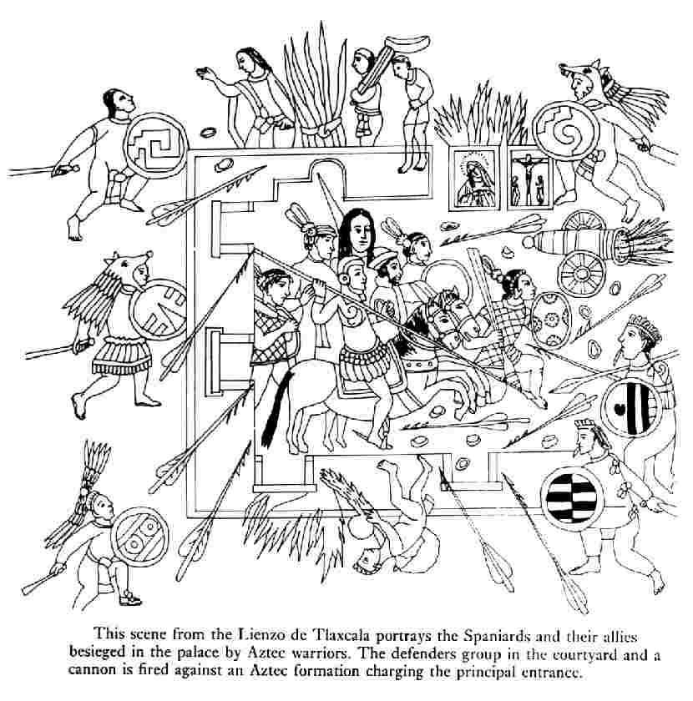

* Aztec religious ceremonies in which individuals would dress in the clothing of that specific god and believed the person became the god on Earth when the clothing was worn
* Cortes was given a feathered robe of the god Quetzacoatl, once Cortes put it on the Aztec thought he was the god but Cortes just thought it was a gift
* Moctezuma wanted more proof he was a god, Cortes was given food containing human blood, Cortes didn’t eat if for fear of poisoning and therefore confused Moctezuma

**The Spanish Learn About the Aztec**

* Cortés knew he could not defeat the Aztec with only 500 men - he needed a strategy
* learned that many city-states disliked being dominated by the Aztec therefore used Aztec political rival to his advantage
* eight months, Cortés gathered allies by means of trickery and force

**Using the Tlaxcalans and Cholulas**

* Tlaxcalans were enemies of the Aztec and also did not want to be under Spanish rule
* attacked the Spanish, but Cortés held them off with guns and steel armour
* Tlaxcalans decided it was in their best interests to make an alliance with the Spanish

**B. What did the Aztec know about the Spanish before they arrived and how were the Spanish able to conquer the Aztec with so little men.**

**________________________________________________________________________________**

**________________________________________________________________________________**

**________________________________________________________________________________**

**________________________________________________________________________________**

**________________________________________________________________________________**

**________________________________________________________________________________**

**________________________________________________________________________________**

**The First Meeting Between Cortés and Moctezuma:**

**Two Worldviews**

* 1519, two leaders with conflicting worldviews met
* Cortés was determined to conquer the empire for his king, his God, and for riches, no matter how many lives were lost
* Cortés sent messages to Aztec saying that he was coming in peace and wished to meet the emperor to extend his greetings
* Cortés met Moctezuma on November 8, 1519
* Moctezuma greeted Cortés and addressed him if he were a god, Quetzalcoatl.

**Records of the First Meeting**

* Thousands of Aztec warriors protected Moctezuma and could have killed Cortés
* but Cortés and his men were treated royally and given luxurious accommodations
* Moctezuma toured them around Tenochtitlan and were amazed at the marketplace and palaces
* Cortés waited for an opportunity - within one week Cortés took Moctezuma hostage
* Cortés replaced the Aztec idols in the palace where he was staying with statues of Roman Catholic saints
* Aztec people were disgusted with the Spanish setting up their statues and felt Moctezuma was weak and had let down his people for letting them do it. They deserted him, leaving him hostage with the Spanish.

**Population in 1500**

* population of the Aztec Empire in 1500 is estimated to have been approximately 5 000 000.
* 10% and 20% of the population lived in Tenochtitlan
* largest city the Spanish had ever seen (London had a population of about 100 000, Florence about 60 000, and Paris about 300 000)

**C. True/False -** *Indicate whether the statement is true or false.*

____ 1. The Spanish monarchy wanted to expand their empire in order to increase their wealth and to compete with England.

____ 2. The Tlaxcalans surrendered to the Spanish and helped to defeat the Aztec.

____ 3. The only records of the first meeting between Moctezuma and Cortes were written by Father Bernardino de Sahagun and Father Diego Duran.

____ 4. One of the greatest advantages of the Spanish was the size of their population, which was much larger than that of the Aztec.

____ 5. The Spanish said that the beauty of Tenochtitlan could be compared to that of Venice, despite their demolition of the city.

____ 6. The Spanish forces were kept hostage because they had killed worshipers at one of the temples of Technohtitlan.

____ 7. With the emergence of smallpox the population of Tenochtitlan was completely wiped out.

____ 8. The Aztec eventually surrendered because Cortes had succeeded in cutting off their access to food and clean drinking water.

**How Did the Battles for the Empire Unfold?**

**Massacre of Unarmed Aztec**

* next six months, Cortés and his men remained in Tenochtitlan
* tensions between the Spanish and the Aztec increased
* Cortés received a message from Spanish Governor - upset with Cortes and was to arrest him
* Cortés left Tenochtitlan and left Pedro de Alvarado in charge
* Aztec main annual festival was held and Alvarado and his men massacred the unarmed worshippers
* Aztec were outraged – they fought the Spanish so ferociously that the Spanish had to retreat
* chance of a peaceful agreement between the Spanish and the Aztec was gone

**Noche Triste (Sorrowful Night)**

* Cortés and his allies, the Tlaxcalans, defeated the Spanish who had been sent to arrest him
* Cortés returned to Tenochtitlan, ordered Moctezuma to speak to his people to persuade them to let the Spanish return in peace
* Moctezuma was seriously hurt by stones hurled at him - died few days late
* new Huey Tlatoani elected and continued the attack
* June 1520, the Spanish tried to escape in the middle of the night, but the Aztec discovered them and attacked
* Spanish were carrying stolen gold, unwilling to give up the gold, many were quickly killed or drowned
* 700 Spanish and 2000 to 3000 Tlaxcalans — were killed

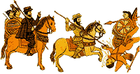

**An Unforeseen Enemy**

* Aztec began dying from smallpox
* half the city population of Tenochtitlan may have died from smallpox
* new Aztec leader died from small pox 80 days after the battle

**The Final Battle**

* Cortés returned to Tenochtitlan with his allies, (Tlaxcalans and Texcoco - members of the Triple Alliance)
* Aztec had no allies, half the population already dead, defending against the Spanish became difficult
* Aztec in Tenochtitlan withstood the siege for 75 days
* Aztec Empire was crumbling, waterways block preventing food and water from reaching the city
* last group of Aztec surrendered on August 13, 1521
* Aztec Huey Tlatoani, Cuauhtemoc, was taken prisoner and hanged
* great Aztec Empire was no more
* Cortés finally took over the city - Spanish destroyed the city
* 1522 - less than three years after he arrived, Cortés became governor and captain-general of New Spain

**D. Multiple Choice -** *Identify the choice that best completes the statement or answers the question.*

**1. Hernan Cortes left Spain and traveled to the Caribbean colonies because he wanted to**

|  |  |
| --- | --- |
| A. | explore a new world |
| B. | gain wealth |
| C. | experience new cultures |
| D. | escape imprisonment |

**2. Cortes was able to defeat the Aztec because he**

|  |  |
| --- | --- |
| A. | greatly outnumbered the enemy |
| B. | surrounded the enemy and ambushed them |
| C. | got the Aztec to fight each other |
| D. | used stealth and cunning as well as military strategies |

**3. The Spanish believed they were**

|  |  |
| --- | --- |
| A. | inferior to other nations and needed to acquire more power |
| B. | superior and needed to save the Aztec from themselves |
| C. | superior and had a right to imperialism |
| D. | superior and needed to spread their religion around the world |

**4. The Aztec had conquered their known world and continued to**

|  |  |
| --- | --- |
| A. | expand, receive payments from tribute and taxes, trade, and sacrifice captives to their gods |
| B. | kill all who opposed them, plunder the nations, and destroy lands that they ruled over |
| C. | take all captives to their lands and incorporate them into their society, trade, and sacrifice to the gods |
| D. | value human life, trade, explore, and curse the gods for their omens of coming doom |

**5. The Aztec believe that Cortes was a god because he**

|  |  |
| --- | --- |
| A. | resembled descriptions of a light skinned, long bearded, and short haired god |
| B. | had technology that they couldn’t understand |
| C. | had taken over other Caribbean peoples |
| D. | was kind and generous to the Aztec peoples |

**6. What was the savior god of Tenochtitlan said to represent?**

|  |  |
| --- | --- |
| A. | A god of wheat and child birth |
| B. | A bull god of knowledge |
| C. | A large eagle that led them into their land |
| D. | A serpent warrior god |

**7. Moctezuma sent gifts to the Spanish explorers because he hoped to**

|  |  |
| --- | --- |
| A. | convince them to stay |
| B. | see if Cortes really was a god |
| C. | appeal to their greed |
| D. | be given gifts in return |

**8. Cortes did not eat food containing human blood because he**

|  |  |
| --- | --- |
| A. | was in fact a god and knew there was human blood in it |
| B. | wanted his men to eat first |
| C. | feared being poisoned |
| D. | was forbidden by the Roman Catholic Church |

**9. How did the Spanish use superior technology and knowledge to their advantage?**

|  |  |
| --- | --- |
| A. | They used military tactics to surprise the Aztecs. |
| B. | They killed as many people as quickly as possible with their guns. |
| C. | They made sure to negotiate and demonstrate how superior they were before fighting. |
| D. | They would kill the nobility and show off their firepower. |

**10. Moctezuma welcomed Cortes into the city despite being unsure whether he was a god because**

|  |  |
| --- | --- |
| A. | Cortes had given gifts to Moctezuma |
| B. | he had taken over many other states |
| C. | Moctezuma hoped to gain knowledge of European technology |
| D. | he wanted to lure Cortes into a trap |

**11. How did the Spanish and Aztec treat each other at first contact?**

|  |  |
| --- | --- |
| A. | The Aztec deceived the Spanish and trapped them in the palace. |
| B. | The Spanish shared their knowledge with the Aztec in order to make their lives easier. |
| C. | The Spanish were given a palace to live in were and toured around Tenochtitlan. |
| D. | Both treated each other with great respect. |

**Why Did Moctezuma and Cortés Make the**

**Decisions They Did?**

**Moctezuma and the Aztec**

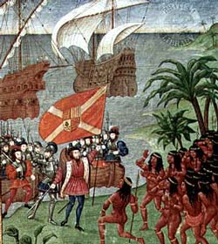

* Moctezuma’s decision making were made within a worldview that saw everything as being affected by the gods and every action of humans affecting the gods and the balance of the world
  + believed the stories about the god Quetzalcoatl (coming of Cortés and the conquistadors)
  + belief that the omens/bad luck would come to pass
  + Moctezuma’s belief was that if Cortés was indeed the god Quetzalcoatl, he dared not do anything that would show disrespect to him therefore welcomed Cortés
  + Aztec had no idea of the motives of the Spanish
  + Aztec view of warfare was very different, their objective was to:
    - negotiate a takeover of the desired territory,
    - negotiations failed, conduct a war
    - war had specific rules
    - aim was not to kill, but only to capture them
    - captives were then turned into slaves or sacrificial victims
    - did not destroy the property
  + Moctezuma did not understand the ruthless, conquering behaviour of the Spanish
  + Aztec did not understand the Spanish desire for gold
  + stone-bladed weapons of the Aztec were no match to the horses, guns, and steel swords of the Spanish
  + smallpox epidemic was the final blow to the morale of the Aztec - disease was will of the gods, Aztec believed that their world was coming to an end.

**Cortés and the Spanish**

* Reconquista, the Spanish conquistadors develop **confrontation** and religious intolerance as normal daily life
* believed that their culture and religion were superior to any other
* Cortés had strong religious beliefs – only one god and religion Roman Catholic Church - motivated
* Cortés was appalled at the Aztec practice of human sacrifice
* motivated by a desire for the gold, silver
* motto of the conquistadors was “For God, Glory, and Gold.”
* Spanish warfare was very different - planned surprise attacks and were interested in killing the enemy in order to defeat them
* used existing political rivalries of the Aztec to his advantage
* used a divide-and-conquer strategy that offset his being so outnumbered by the Aztec

**The Most Useful Weapons — Information and Communication**

* Cortés needed interpreters to help win over his allies and to communicate
* Cortés had two invaluable interpreters:
  + La Malinche, a local woman who was named Dona Marina, the property of a ruler in one of the coastal areas who gave her to Cortés as a gift
  + Spanish sailor, Geronimo de Aguilar, had been shipwrecked on the Mexican coast and was rescued by Cortés after living with the Maya for many years
* Spanish knew that interpreters were essential to their military conquest, used as guides, communicators, and military information and cultural information
* without the help of Dona Marina, the Spanish Conquest of the Aztec would likely not have been achieved
* She provided Cortés with detailed information about the Aztec Empire, its worldview, and the possible ways Moctezuma would react to events

**Spanish Treatment of the Aztec After the Conquest**

* In 1521, Cortés claimed the land of the Aztec for the Spanish crown and named it New Spain
* conquistadors were given huge tracts of land, including control of all its inhabitants
* conquistadors were the new nobility of New Spain - they would not do manual labour themselves
* Aztec forced to work as slave labourers for the landholders
* Queen Isabella died in 1504 – left a will that stated that Aztec people should be treated justly, not abused
* 1512, King Ferdinand enacted laws that called for fair treatment of the Aztecs - laid down specific rules to prevent abuse of the workers:
  + Aztec people could not be used to carry goods like pack animals
  + Children under 14 and pregnant women were not to do heavy work in the mines
  + prohibited from being beat or whipped

Note*: laws were frequently ignored and not enforced*

* Spanish wiped out Aztec culture, religion, arts, and sciences were destroyed - codices, sculpture, and other records were burned or smashed
* destroyed Aztec Temples and used the stones to build a Roman Catholic cathedral
* forced Aztec slave labour to build a new Spanish city on the site of Tenochtitlan: Mexico City - filled in and built over all of the lakes
* Spanish continued the tribute system that the Aztec had used
* conquistadors gained immense wealth - gold and silver mines of the colony made Spain, the wealthiest in Europe.

**Conversion**

* convert the population to Christianity as quickly as possible
* churches built
* images of the Virgin Mary, Christ, and Roman Catholic saints were placed in the new churches
* Aztec people adopted the Christian God, common practice in their own worldview to have more than one god
* RC priests established schools and hospitals to serve the communities
* Aztec people farmed the surrounding areas to produce food for the landholders and for export to Spain
* diseases continued to kill, often wiping out entire villages
* In 1821, after 300 years, Mexico finally regained its independence from Spain

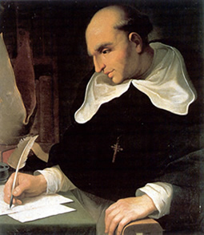

**Father Bartolome de Las Casas**

* (1474–1566), a Dominican friar, strongest defender of the Aztec peoples of New Spain
* improve conditions for the Indigenous peoples when he saw the way they were being treated by the Spanish landholders
* returned to Spain to promote his cause and became known as the “Protector of the Indies.”
* Largely because of his pressure, Spain passed *New Laws of the Indies for the Good Treatment and Preservation of the Indians* in 1542
* new laws abolished Indian slavery

**Adaptation to a New Society**

* Aztec nobles began to adapt Spanish ways
* learned to speak and write Spanish and were able to document Aztec history and traditional culture
* conquistadors settled their land grants, many took Aztec women as their wives
* people of mixed blood were called mestizos (Aztec and Spanish)
* formed a culture that grew into modern Mexico

**What Records Detail Aztec Life and Conflict with the Spanish?**

**Archaeological Finds**

* Spanish tried to destroy all physical evidence of the Aztec way of life, especially their religion
* Aztec artifacts and buildings were either reworked or built over
* Aztec sights are still being discovered today

**Spanish Documents**

* conquistadors and clergy recorded information about the Aztec
* reports and letters, kept diaries, and wrote entire encyclopedias about the Aztec
* Cortés wrote five letters detailing Tenochtitlan and its people

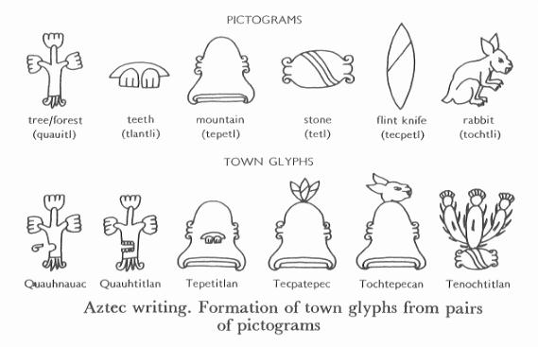

**Aztec Documents**

* Aztec created hand-painted manuscripts called codices (singular: codex) recording histories, religious information, and **genealogies**
* 11 and 15 codices survive

**E. Matching -** *Match the following words or terms to their correct description below.*

|  |  |  |  |
| --- | --- | --- | --- |
| A. | Father Bartolome de Las Casas | E. | confrontation |
| B. | 1 Reed | F. | mestizos |
| C. | genocide | G. | hacienda |
| D. | Father Diego Duran | H. | codices |

____ 1. The god of the Aztec’s was forecast to return from the Gulf of Mexico in __________.

____ 2. __________ is the clashing of forces or ideas which cause tension.

____ 3. A __________ was a plantation or estate which the Spanish conquistadors owned.

____ 4. __________ was the man called the Protector of the Indies.

____ 5. __________ is mass extermination of human beings, specifically belonging to one race/nation.

____ 6. __________ are children born with a mix of Spanish and Indigenous blood.

____ 7. __________ is credited with writing the History of the Indies of New Spain.

____ 8. __________ are a hand-painted manuscript which the Aztec were known to create.

F. Explain the different worldviews that the Spanish and Aztec held for the following: (include at least 2 to 3 points each)

|  |  |  |
| --- | --- | --- |
|  | Spanish Worldview | Aztec Worldview |
| Moctezuma sent emissaries with gifts to Cortes |  |  |

|  |  |  |
| --- | --- | --- |
| Cortes gathered allies as he traveled to Tenochtitlan |  |  |
| Cortes and Moctezuma met in Tenochtitlan |  |  |
| Spanish massacred the Aztecs at the festival |  |  |
| Spanish destroyed Tenochtitlan |  |  |

Answer Key **Key – Chapter 1 & 2**

***1. What are the elements of society affected by worldview:***

1. Social systems – organization and relationships among people, such as the types of education, medical and social services a society provides
2. Political and economic systems: political system relates to the way government is organized, the role of citizens in gov’t, and rights given to citizens; economic systems relate to methods by which people produce and distribute goods and services they need
3. Culture – way of life of a group of people, including language, rules of behaviour, religion, spirituality, arts, literature, sciences, traditions, and other everyday aspect of life

***2. What are the factors affecting worldview***

* 1. **Geography** – where a group of people live, the climate, land formations, plants and animals, bodies of water, and natural resources
  2. **Ideas and knowledge** – what a group knows; scientific, intellectual, technological, artistic, and spiritual knowledge
  3. **Contact with other groups** – contact and interactions between societies and between different groups in a society

***3. Define the following terms:***

**Renaissance -** A historical period that originated in Italy in the 14th century, known for the revival of classical art, architecture, literature and learning

**CE** – common era, referring to a way of numbering years, accepted commonly throughout the world, numbering from the birth of Jesus Christ

**Era** – a historical time period

**Century** –every 100 years is a century , started with the 1st century 0 – 99, 1300 – 1399 is the 14th century

**Middle Ages** – a historical period in Europe stretching from the fall of the Roman Empire in the 4th century to the beginning of the Renaissance in the 14th century

**Astrolabe:** an instrument used to measure the locations of stars and planets as an aid to navigation

**Crusade** – a campaign in favour of a cause; a medieval Christian military expedition to recover the Holy Land from the Muslims

**Judaism** – the religion of Jews, based on a belief in one god, old testament only, does not believe in Jesus Christ

**Christianity** – religion of Christians, based on belief in one god, both old and new testament

**Islam** – religion of Muslims, based on a belief of one god, based on teaching of Muhammad as revealed in the Koran

**Pilgrim** – a person who journeys to a sacred place for religious purposes

**Feudal system** – a political economic social system of landholding during the Middle ages in Europe, class structure and roles were very rigid

**diplomacy** – the skill or tact in handling negotiations, esp. in gov’t

**alliance** – formal agreement to cooperate

**hierarchical** – based on classes of status or authority ranked one above the other

**4. What is the Silk Road and what role did it play in the development of the Renaissance? Include at least 5 points.**

* interconnected series of ancient trade routes through various regions of the Asian continent mainly connecting [China](http://en.wikipedia.org/wiki/China), with [Asia Minor](http://en.wikipedia.org/wiki/Asia_Minor) and the [Mediterranean](http://en.wikipedia.org/wiki/Mediterranean)
* trade on the Silk Road was a significant factor in the development of the great [civilizations](http://en.wikipedia.org/wiki/Civilization)
* it helped to lay the foundations for the modern world
* traded exotic goods: silks, glassware, paper, spices (pepper/cinnamon), apples/oranges, etc.
* trade went both ways from china to Mediterranean and back
* ideas and knowledge, understandings of religion, science, technology, philosophy, music, math passes from society to society also on the route – sharing worldviews.
* inventions such as irrigation waterwheels also moved along the trade route
* Diseases also passed through the route (ie. black death or plague)

**5. Islamic civilization impacted the renaissance. In what ways did it impact? Include at least 3 points.**

* + Islamic faith spread from the Arabian area to other areas east to Spain and west to Indonesia
  + Centre of Islamic world was at crossroads of Silk road
  + Muslim became the middlemen for the Silk road and became very wealthy
  + Muslim empire also became the centre of learning during the middle ages
  + Scholars collected knowledge, documents, took math ideas from the far east and refined them into the understanding of numbers known today
  + Invented aids to help with navigation, such as the astrolabe
  + Medical textbooks were written based on studies of disease

***6. Define crusade***

* Jews, Christians and Muslims considered these areas holy
* Sanctioned by the pope, crusades originally had the goal of recapturing Jerusalem and the Holy land from Muslim rule
* Europe tried to recapture areas of Middle East under Muslim control
* Campaigns against pagans or heretics and people who had been excommunicated for a mixture of religious, economic, and political reason
* Exposed Europeans to more cultures and ways of life
* Thousand of religious pilgrims traveled to these sites to seek god’s favor
* Travelers on these pilgrims brought back new ideas and attitudes that led to new ways of thinking about their own lives and society

***7. Match the following words with there definition.***

**H Urbanization –** the movement of population away from the countryside and into cities

**C Value judgment** – an opinion based on a person’s individual values and beliefs

**A papacy** – pope and the gov’t of the Roman Catholic Church

**J republic –** a state in which power is held by the people or their representatives

**G despot** – leader with unlimited power; a tyrant or oppressor

**K oligarchy –** a form of government in which a few people have the power

**F sovereignty** – a supreme power and authority; the freedom of a country or political unit from outside control

**B guild –** an organization of craftsmen or merchants

**E aristocracy** – the nobility or those with inherited titles

**D basilica** – a Roman Catholic cathedral of particular honour

**I armory –** a place where weapons and ammunition are kept

**L fresco** – a watercolour painting done on a wall or ceiling on wet plaster

***8. Why was trade so important in the growth of the city-states?***

* European wanted more exotic spices, silks, etc,
* Merchants hired to open new trade routes to all parts of known world (North Africa, Middle East, India and China)
* New trade routes began a revival in business and shipping
* Increase contact with traders from Islamic societies
* Merchants and traders grew wealthy in Europe and a new class outside of the feudal system was forming
* Increase trading meant increase in city growths (ie. Paris, Florence, Venice, population of at least 100,000 each)
* Increase population meant demand for foods and products and led to change in way people lived:
  + Establishment of new business
  + Industries began to form (textile, furniture, handicrafts, etc.)
  + Workers finding jobs and less dependent on nobles
  + Communities became prosperous/powerful in trade, industry and banking and formed city-states(a city that governs itself and the countryside surrounding it)
  + Individuals began to feel sense of belonging to a community (citizens) vs serf belonging to a local lord

***9. List 3 points for each of the city states (Florence, Venice and Genoa) why they were important in shaping the renaissance worldview?***

**Florence**

* During renaissance time trade increased and became centre of successful bankers, silk and wool merchants
* Bankers supported pope and pope gave bankers papacy financial business
* Started as a republic, many to power struggles among groups ending in Medici family taking control of city
* Florence based on class system but merchant class people moved up the social ladder
* Merchant class people organized into guilds (silk manu, wool manu., bankers, etc.)
* Workers and shopkeepers called *popolo minuto* (little people), peasants from the country, not allowed to belong to the guilds
* Florence became major centre of Renaissance culture under Medici family control
* Medici family support arts, architects and scholars developing the city
  + Ideas of citizenship were promoted

**Venice**

* Stable form of government
* Successful sea trade (shipyards, naval base, armory)
* Merchant class support the arts
* First city-state to use mechanical printing press and you could get books
* Created university to promote science, medicine and law

Controlled most of the ports in Adriatic Sea and Eastern Mediterranean

**Genoa**

* Port city surrounded by high walls to protect inhabitants from invaders
* Major city of trade and commerce
* Played strong role in crusades for transporting crusading armies to the Holy Land
* Genoa citizens paid well for this service
* Genoa’s traders quickly developed markets at key ports on the Black sea and trade flourished as did the navy, shipbuilders, traders
* Venice and Genoa were rivals and fought to gain control of lucrative trading posts

***10. Define a Capitalist Society -*** an economic system that depends on private investment and making a profit

***11. List 3 reasons why the renaissance was slow to spread before the 15th century and why it began to spread in the 15th century.***

|  |  |
| --- | --- |
| **Before 15th century** | **Early 15th century** |
| Feudalism   * lands beyond Italy were agricultural and therefore feudal system well established and being used, not welcome to new ideas * monarchs wanted change but nobles didn’t * nobles undermined the monarch | Decline of feudalism helped monarchs gain more power and allow people more freedom to explore changes in society and new ideas in arts, sciences and philosophy |
| War   * 15th century many wars between England, France, Germany * Resources used for military campaigns, survival expansion and not arts/science * War also limited travel | * War between France/Germany and Italy brought the Renaissance movement into the spot light: northern Europe hired many Italy craftsmen and scholars to come to their courts to show what they could do and to increase the sophistication of their people |
| Religion   * Church played strong role in Northern Europe due to move to Avignon France in 1309 to 1377 * Church maintained status quo and didn’t want people to think for themselves | * Growth of humanism and power of the monarchs led to competition for the authority over the people against the RC church * Invention of the printing press, books could now be produced and distributed for anyone to read instead of the previous copying the book by hand. Allowed anyone to learn to read. |

***12. Vocabulary Crossword***

|  |  |
| --- | --- |
|  | |
| **ACROSS**  3. **discipline** – a branch or category of learning or study  4. **humanism** – a system of thought that centres on humans and their values, potential and worth; concerned with the needs and welfare of humans  9. **rhetoric** – the art of persuasive speaking and writing  10. **fiefdom –** a piece of land under a person’s control  11. **contemporary** – of the time  12. **secular** – having to do with physical things; the opposite of spiritual  13. **Flemish** – the language and nationality of the powerful medieval principality of Flanders, now divided among Belgium, France, and the Netherlands  14. **perspective -**  the artistic technique of showing depth and 3-dimensional objects on a 2-dimensional surface  15. **quality of life** – the sense of safety, comfort, security, health and happiness that a person has in his or her life | | **DOWN**  1. **status quo** – the existing way of doing things  2. **trinity** – a Christian belief that God consists of 3 parts: the father, the son and the Holy Spirit  5. **logic** – the science of reasoning and proving arguments  6. **utopia** – a perfect world  7. **heresy** – an opinion against the beliefs of a given religion  8. **vernacular** – a local, common, or native, referring in particular to languages | |

***13. Humanisn was a major factor in the Renaissance time period. Describe what humanism is.***

* became more aware of classical writings of the Greeks, Romans and Islamic cultures
* felt these classical writings were superior to their own thinking and writings
* Classical writings also suggested that people as INDIVIDUALS could do great things in their lives and not be limited to strict social roles of the middle ages
* Humanism thus was born – it focused on human beings, their values, abilities and individual worth and human society that could be improved
* Humanism led to new attitudes, people started to surround themselves with beautiful art and architecture, wanted a rich and full life now as well as preparing for the afterlife
* Humanism also led people to learn new languages such as Greek, Latin and Hebrew so they could read the original documents (to find the truth for themselves) not just the translators version

***14. Complete the following chart. What contributions did philosphers, artists, writers, and mathematicians/scientists contribute to humanism and the renaissance movement. Include 3 points for each and contributing individuals.***

|  |  |  |
| --- | --- | --- |
|  | **Contribution Points** | **Individuals** |
| **Philosphers** | * Scholars/philosophy travel to from different university exchanging ideas * Nobles now started to believe that civic duty was important and promoted these ideas at their courts and to their subjects * Northern Europe humanism differed slightly by combining the bible with the study of the classics (roman/greek writings) – they wanted to become better citizens and better Christians | Petrarch  Erasmus  Guillaume Budé  Michel de Montaigne |
| **Artists** | * Created more realistic image of human form * Shared techniques with other artists * Free to paint subject matter as how they saw it (within limits) * Paid for work * Gained class status and respected | Donatello  Brunelleschi  Masaccio  Michelangelo  Leonardo da Vinci 2. |
| **Writers** | * Sense of pride and national identity began to develop in states leading to writers writing in their own languages * Therefore, standardization of language developed in areas of vocab, spelling and grammar | Geoffrey Chaucer  Sir Thomas More  François Rabelais  William Shakespeare |
| **Mathematicians/Scientists** | * Scientific questioning discourage in favour of religion * Money spent on arts/architecture * Education on classical liberal arts not science/math * ask questions and search for natural cause vs supernatural powers * Scientists recorded observations which later led to scientific discoveries | Copernicus  François Viète  Peter Henlein |

***15. List 4 changes to the Social and Economic systems during the Renaissance.***

* feudal system broke down,
* rural peasants moved to urban areas,
* middle class of trade and manufacturing,
* increase number of people learn to read, write and do arithmetic
* creation of the middle class contributed to the growth of a capitalist society based on trade and MONEY (barter system was used up to this time)
* religion remained central to people’s lives but middle class/merchants wanted to improve their lives and surrounding by beautifying it through support of the arts and architecture - this made everyone’s lives better
* belief system changed from their lives were no longer destined to remain the same as their parents and ancestors, bug could see that through hard work and taking advantage of opportunities they ***could*** improve their lives and social class – individuals could create their own identity

***16. What was the role of the father during the renaissance?***

* father ruled, finances, property decision making for EVERYONE

***17. What was the role of the mother during renaissance?***

* mother maintain household and help children and father succeed

***18. What was the role of the children during the renaissance?***

* children were considered mini adults and treated as such: duties, respect father decision’s until death
* children had arranged marriages (unless peasant) to improve social status, political or financial, girls married by 16 and boys not until 30’s or 40’s

**19. How were woman viewed differently during the Renaissance than they are today?** Humanist believed in education for both sexes, males tended to be educ more

* Poor males/females had no opportunity for education
* Wealthy women were not usually allowed to be educated, but some were, most never received education past marriage
* Women were under authority of their father or husband, if widowed could live independently if they had money, if not they had to move in with a male relative or join a convent
* Some notable writers of the renaissance were: Agrippa of Nettelsheim, Maria de Zayas Y Sotomayer, Christine de Pizan
* Some women supported and promoted Catholicism, felt they should be able to preach and teach the scriptures but were not allowed to be part of the decision making process

***20. Multiple Choice***

1. Humanism was rediscovered when scholars discovered old writings from which culture?
   1. The Greek culture
2. The Silk road was responsible for which of the following:
   * 1. all of the above
3. What was Nicolaus Copernicus most noted for?
   1. Proving the Earth revolved around the sun

4. An opinion against the beliefs of a given religion is called

|  |  |
| --- | --- |
| B. | heresy |

5. Copernicus’ view that the sun, not the Earth, was the center of the universe conflicted with whose theory?

|  |  |
| --- | --- |
| A. | Roman Catholic Church |

6. The exchange of __________ was a key part of the Renaissance spreading throughout Europe.

|  |  |
| --- | --- |
| B. | ideas |

**KEY – Chapter 3**

**2. What did Martin Luther believe in? This was the bases of religious reformation.**

* + - * following rules/rituals of church was not enough to go to heaven
      * individuals should seek religious understanding
      * don’t need to pay to receive forgiveness for their sins.

**3. Why was Martin Luther considered a heretic?**

* he felt that following the rituals of the institution of the Church was not enough to go to heaven.
* Individuals should seek personal religious understanding
* Individuals should not pay the Church to receive forgiveness for their sins
* he wrote a book and published it stating his views
* his book was burned in Rome and he was expelled from the Church as a heretic

**4. After the Protestant reformation what two “types” of Christians were there?**

* + Protestant
  + Roman Catholic

**5. Give three ways that national identity and citizenship began to develop during the Renaissance.**

* move to urban from rural, monarchs supported growth of cities through trades laws and other laws and in turn cities gave them alliegance and wealth
* development of local identities through language, religion and beliefs
* gunpowder was brought in from China and the ways wars were fought changed, monarchs used taxes from the cities and hired mercenaries to overpower nobles, king gained control of large chunks of land
* printing press brought information and stories about local heroes/tales to the people creating a sense of history and identity
* exploration of other lands led to establishment of colonies and brought prestige and wealth to founding countries

**6. List 3 examples of each in terms of Culture, Social Systems and Political/Economic System in changing European society?**

**Culture**

* common language unified citizens
* middle and upper class became literate
* religious literature published in common language to state
* national language chosen to unify state/country

**Social Systems**

* people became citizen of country and gave allegiance to monarch
* exploration of new lands promoted feelings of hope and possibilities
* move out of the class structure
* public services began to be provide by central government
* size and power of states gave the authority of the church competition

**Political/Economic System**

* monarchs began to centralize their government structures and clearly defined lines of authority, this allowed freedom in dealing with nobles
* government policies set up to ensure political/economic independence
* permanent armies set up paid by taxes
* resources provided to large state projects: exploration, war
* centralized laws/rules set by monarch and government
* state policies (tax and trade) created to control trade and business

**7. *List* the three factors that contributed to expansionism and *explain how*.**

* Silk road wasn’t good enough anymore
* Trading trips were organized and went directly to the source and not the middleman
* New trade route to the east had to be found in order to go directly to the source and to avoid middleman, and to find a safe route

**8. Describe the relation between Humanism, Consumerism and Expansionism.**

The relationship between expansionism, consumerism and imperialism is if a country has an imperialistic attitude in which they extend their authority by political, economic or military means into another territory or country to collect and use the new territory or countries’ materials for their own profit and/or usage.

**9. Describe how the Europeans were ethnocentric can give an example.**

Europeans were ethnocentrism, meaning they believed that their own race/culture was superior to others. This was shown regularly when they took over other territory and countries and gave NO notice to the individual race that was currently residing. They treated the indigious people of that territory/country as if they were barbarians and were inferior. The Europeans established colonies and built their empires and established control over land, inhabitants and resources

**10. What four European countries were dominant in exploration? Name one explorer for each.**

**Portugal - B**artholomew Diaz or Vasco da Gama

**Spain -** Columbus or Magellan

**England -** Giovanni Caboto, John Cabot or Martin Frobisher

**France -** Jacques Cartier

**Multiple Choice questions.**

I. d. Portugal

II. d. All of the above

III. a. Spain

IV. b. Disease

**KEY – Chapter 4**

**1. isolate:** to seclude; to follow a policy of having no relationships with other nations

**2. adaptation:** the changing of attitudes and behaviours to suit a new situation

**3. modernize:** to adopt new ideas and technologies that are considered to be of the present time or times not long past

**4. Describe Japan’s geography and how did it affect their worldview?**

Japan was composed of a long, narrow series of islands along the Eastern Pacific coast of Asia. It consisted of 4 main islands. 73% of the country is mountainous and therefore had little flat area for cultivation, so farming is done in the valleys, along the coastline, and on terraces in which they developed in order to farm on the hills and mountainsides. Farming was looked at high in the social class system. Japans’s rugged terrain helped to limit control and access by it’s enemies

.

**5. Define**

**emperor:** the hereditary ruler of Japan

**daimyo:** a feudal lord of a region in Japan

**shogun:** the leader of the military government in Japan

**entourage:** a group of attendants or other people who accompany someone, usually of important rank

**metropolis:** a large, important city of a country or region

**6. Multiple Choice - *Identify the choice that best completes the statement or answers the question.***

I. **Geography had an affect on Japan and the lives of the Japanese in all but one of the following ways. Which statement is incorrect?**

C. Japan’s landscape provided plenty of good farmland.

**II. A form of poetry which consists of three lines of five, seven and five syllables respectively is called**

**D.** haiku

**III. A/An __________ was group of people who followed the daimyo to and from Edo.**

**A.** entourage

**7. True/False - *Indicate whether the statement is true or false.***

A. **False** - The Edo period in Japan was an exciting time because Japan had chosen to completely isolate itself from most of the world.

B. **True** - Japan is part of the Ring of Fire, which is a narrow zone active volcanoes that nearly encircles the Pacific Ocean.

C. **True** - Although the true ruler of Japan was the emperor, the daimyo had the real power and authority.

8. **During the Edo period, the shogun closed Japan off from the rest of the world and minimized its contact with the outside in order to retain power. Describe the effects of this isolation on Japan and its citizens. Be certain to give examples, both positive and negative, using lessons from the textbook and class discussions.**

**Positive**

- no war; the country was at peace

- contributed to the unification of Japan

- Confucian beliefs and values influenced the Tokugawa shoguns to rule in a caring manner

- metropolises developed

- popular culture diversified and increased (eg. art, theatre, literature)

- internal infrastructure was developed (e.g., roadways)

- new agricultural techniques

**Negative**

- hierarchical and rigid social class system

- isolation from the rest of the world; no travel or contact

- shogun had supreme power and authority

**9. Describe what the Closed Country Edict of 1635 was and what the National Seclusion Policy was?**

**Closed Country Edict**

* Japanese ships were forbidden to travel to foreign countries and No Japanese permitted to go abroad or face execution
* If any Japanese returns from overseas after residing there, he must be put to death.
* if any southern barbarians (Westerners) teach Christianity or commit crimes, they may be put into prison.
* No single trading city shall be permitted to purchase all the merchandise brought by foreign ships.
* European ships banned - any ship disobeying will be destroyed and its crew and passengers executed.

**The National Seclusion Policy**

* Bakufu passed a series of edicts to control the influence of foreigners and to tighten control over the daimyo
* National Seclusion Policy (1633-1639), as it was called, was an effort by the Bakufu to strengthen its authority and maintain a strong centralized government
* set out controls on the interaction between Japanese and foreigners

**10. True/False**

D. **True** Tokugawa Ieyasu did not want European explorers to set up colonies in Japan so he only allowed them to land at one port.

E. **False** The era after the final edicts of national isolation is referred to as sakoku, which means closed country, because Japan was entirely closed to the rest of the world.

.F. **True** The daimyo were not allowed to associate with each other because the Bakufu wanted to prevent from putting their money and resources together and attempting to overpower the shogun.

**11. Multiple Choice - *Identify the choice that best completes the statement or answers the question.***

**IV.** The Closed Country Edict of 1635 was set out to control the interaction between Japan and foreigners. Which of the following statements is not in the edict?

|  |  |
| --- | --- |
| C. | Trade will only be permitted between China, Korea and the Netherlands. |

**12. True/False - *Indicate whether the statement is true or false.***

G. **True** According to the hierarchical social class system the samurai were next in line to the shogun.

H. **True** Non-humans (hinin), like the geisha, were people who survived by begging, acting, telling fortunes, or other activities that were considered inferior.

I. **True** The samurai believed that it was better to be known for your accomplishments than for your rank. They also believed in loyalty to their family, honor and personal integrity, courage, and honorable death.

J. **True** The Japanese people did not believe in surgery because they thought the body was inherited from one’s ancestors and that surgery would damage the body.

K. **True** Edo (Tokyo), Osaka and Kyoto continue to be the three largest metropolises in modern-day Japan.

L. **False** Banraku theatre was a children’s puppet theatre in Japan during the Edo period.

**13. Multiple Choice - *Identify the choice that best completes the statement or answers the question.***

**VII. The largest city in Japan during the 18th century was**

|  |  |
| --- | --- |
| D. | Edo |

**VIII. As the cities grew, the merchant class became more wealthy and the samurai turned their energies to things other than war, the __________ of Japan began to change.**

|  |  |
| --- | --- |
| B. | popular culture |

**IX. This social class lived outside the rules but met some of the needs of the Japanese society.**

|  |  |
| --- | --- |
| A. | Eta or Outcast |

**X. Because it was mass produced __________ was/were not initially considered an art form.**

|  |  |
| --- | --- |
| B. | woodblock images |

**XI. The role of the samurai changed during the Edo period from esteemed warrior to**

|  |  |
| --- | --- |
| A. | civil administrator |

**XII. Although they were highly respected for their singing and dancing and their appearance reflected the cultural values of Japan, this group was still considered to be non-human.**

|  |  |
| --- | --- |
| C. | geishas |

**XIII. Although printing was a private industry the Bakufu prevented all but one of the following subjects to be written about. Which did the Bakufu allow to be printed?**

|  |  |
| --- | --- |
| C. | romance novels |

**KEY - chapter 5**

**A. TRUE/FALSE**

1. T

2. T

3. T

**B. MULTIPLE CHOICE**

1. A

2. B

3. C

4. A

**C. Define**

**czar**: Russian monarch

**crisis:** a situation of urgent need or great danger

**D. TRUE/FALSE**

4. T

5. T

6. F

7. F

**E. MULTIPLE CHOICE**

5. A

6. C

7. C

**F.**

|  |  |  |
| --- | --- | --- |
|  | **Influences or Cause** | **Japan’s Response or Effect** |
| **Russia** | * 19th century, the Russians needed to continue supplying their outposts in central north Asia * they increased their trading along the Pacific Coast * **czar** gave the company the authority to trade with the Ainu and to gain control of the new territories   Russia became involved in wars in Europe and left Japan alone | * Do to the treat of the Russians coming into Japan, the shogun warned the Bakufu to focus less on internal affairs and more on “treat” from the outside world. |
| **Europe** | * between 1799 and 1815, most of Europe were at wars * Dutch East India Company, for whom the traders worked, decided to hire ships from other countries to carry on its trade in Asia * Dutch were the only foreigners allowed to set foot in Japan, the ships were told to fly Dutch flags and hide any Bibles and weapons | * Japanese officials decided it time for the government officials to learn about the West * Japan started to import and translate books on European history, institutions, and military science, as well as astronomy and other sciences * Japanese government officials who were learning French, Russian, and English * Japanese officials concluded that since all the languages and fashions of Europe were similar, there must be one superpower in Europe * Don’t Think Twice Treaty was implemented * Bakufu decided to expel all foreigners * new edict began in 1825 on the advice of a government official named Takahashi * Takahashi had studied Western countries and felt that Japan should be even more restrictive because foreign ships and foreigners were gathering around Japan * Takahashi learned that other countries did not allow foreign ships to dock without proper papers/protocol and would be turned away |
| **China** | * 1842, China lost much of its control over its seaports when Britain won a war with China * China forced to sign a treaty that gave Britain special privileges * Special privileges included the right to land at specific ports, having low fixed tariffs on goods coming into and leav ing China, and not having Chinese law applied to Westerners on Chinese soil * treaty did not treat each side equally * China was seen as weak * Britain also extended these rights to all Western countries who wanted to trade with China | * Bakufu officials were surprised that China had signed the treaty as they were a powerful country * Japan now realized how large and powerful the English forces were * noticed more American, Russian, and British activity along their own coastline * Bakufu abandon the “don’t think twice treaty” because they were afraid the policy might cause Britain and other Western countries to invade Japan * 1844, Netherlands sent a letter to the Bakufu recommending that they open Japan’s doors to the West for trade * the letter warned that if these countries were not welcomed, they might come in by force * Bakufu responded by saying that it was impossible for nations to come in by force but by the time the answer reached the Dutch, foreign ships were already reaching Japan’s harbours |
| **United States** | * US wanted trade relations with Japan * US wanted a coal station in Japan’s ports so that they could get fuel for their steamships on their way to China * US wanted assistance for any US sailors shipwrecked on Japan’s shores | * Bakufu and samurai had heated debates regarding US * saw the agreements with Perry and Harris as favouring the US - unequal treaties * Japan then was pressured to sign treaties with Russia, Britain, France, and the Netherlands – also unequal * Japanese felt that the shogun was no longer in control and had been humiliated * Isolation was no longer possible * therefore Japan needed to compete with the West and protect Japan’s sovereignty. |

**COMPLETION**

1. treaties

2. Ainu

3. Dutch

4. coal

5. morality, skills

**H. What were the 2 conflicting viewpoints that caused internal conflict in the Bakufu?**

* One group thought it was only matter of time before Japan would be forced to trade with Western nations - believed impossible to remain isolated - needed to use Western technologies to become more powerful and to remain independent
* Another group believed that Japan could remain isolated, that it should declare war on the Western countries, and that all foreigners in Japan should be killed - believed exposure of the west on the common Japanese (peasants, merchants, etc) would destroy their social system

**I. What were some of the civil unrest that happened during this period? List at least 5 points.**

* + - mid-1800s farmers and peasants were starving
    - people questioned the taxes they were forced to pay
    - questioned if the Bakufu was the cause of the unrest; support for the Bakufu weakened
    - samurai began to support the emperor
    - Samurai were angry because the Harris Treaty had been signed against the wishes of the emperor
    - Some samurai leaders had secretly travelled to England and did not actually fear the presence of the foreigners
    - increased military supplies, purchased weapons and ships from the West
    - groups of women broke with tradition to form military brigades to fight the shogun’s troops

**J. MATCHING**

1. B

2. H

3. D

4. C

5. E

6. A

7. F

8. G

**K. TRUE/FALSE**

7. T

8. T

9. T

10. F

11. T

12. F

13. T

14. T

15. T

**L. MULTIPLE CHOICE**

8. C

9. B

10. C

11. B

12. D

13. A

14. C

15. B

**KEY - chapter 6**

A. implemented aspects of **democracy**, such as elected representatives

* public education necessary way to help Japanese society adjust to an **industrialized** nation
* embraced technologies, such as steam-powered machinery
* leaders carefully considered traditional aspects they would maintain and which could replace with systems from other societies

**B. MULTIPLE CHOICE**

1. C

2. B

3. D

4. C

**C. COMPLETION**

1. military, economically

2. democracy

3. emperor

4. feudal clans, feudal system

5. tariff

6. Textiles or Silk or Porcelain dolls

7. colonial

8. government-run

9. telegraphs or telephone systems or technology or the creation of harbours

10. conservative

**D. MULTIPLE CHOICE**

5. D

6. A

7. B

8. A

**E. MULTIPLE CHOICE**

9. A

10. C

11. B

**F. SHORT ANSWER -** *Answers will vary but should include some of the following*

|  |  |
| --- | --- |
| - | conscription was thought to unify Japan, as all young Japanese men were forced to join the army and be trained. |
| - | education became compulsory for all children and a standardized curriculum was developed to ensure that all children learned the same things at the same time. |
| - | Shintoism was introduced to the Japanese and the government wanted to make it the national religion so that everyone would have the same belief system. |
| - | newspapers and periodicals were written to spread the ideals, “for the sake of the country” |
| - | the dismantling of the hierarchy or social class system allowed the peasants to become involved. |
| - | feudalism was abolished and all people were to be loyal to the emperor |
| - | a centralized government dictated rules for the whole country |

Key - C**hapter 7**

**A. Definitions:**

**plateau –** a large raised area of mostly level land

**pre-Columbian** – referring to the time in the Americas before Columbus arrived

**ecological zone –** a physical area with specific traits of climate, soil, altitude, etc. that determines plants and animals

**semi-nomadic** – partially settled and partially moving around

**incentive –** a motivation

**Meso-America –** a region stretching from central Mexico to Nicaragua, usually used in terms of the region’s ancient civilizations and Aboriginal cultures

1. **How did 200 years of semi-nomatic life affect the Aztec’s worldview?**

* Became fiercly loyal to their patron god – Huitzilopochtli who spoke to the priests
* Priest would force followers to keep moving upon instruction from Huitzilopochtli, even if it meant leaving unharvested crops
* They believed they were the chose people and the god would lead them to their land and destiny
* Religion played a very important role
* They learned to adapt to their surroundings and assimilated other cultures ideas/practices/policies if they were superior ideas/practices/policies
* Many Aztec worked as mercenaries and servants for other societies
* Became skilled hard workers and ferocious warriors
* Built culture on history of migration, strong religious beliefs and what made them strong/able to flourish (ie. hard work, faith, negotiation skills, etc.)

1. **What is the difference between the Reconquista and the Spanish Inquisition? What was the purpose of the Spanish Inquisition?**

* the Reconquista, was the move to retake the Iberian land under Muslim control
* the Spanish Inquisition was both a civil and a religious court set up to judge if the converted Jews and Muslims were true Roman Catholics. It also judge any citizen who was accused of not following the Roman Catholic faith (punishable by confinement to dungeons, torture, or death).
* the Spanish Inquisition was ensure all of spain was Roman Catholic. It was considered the only true faith in Spain. It would united everyone if they followed one religion and it was a way to control people.

**D Multiple Choice**

1. B. the valley of Mexico

2. D. transportation

3. C. enormous mountain regions

4. D. that their god Huitzilopochtli would let them know of their true place of destiny

5. C. eagle holding a snake in its beak

6. A hard working nature

**E. True/False***.*

1. F

2. T

3. F

4. T

5. F

**F. True/False***.*

6. T

7. T

8. F

9. T

10. T

**G. Multiple Choice**

7. C. multi-religious

8. C. deliver Christianity to all

9. A. ensure all citizens were Christian

10. B. architecture, design, and science

11. B. learned and adopted many new skills and values

12. C. conquered most of Mexico

13. A. religion

14. B. reducing the power of the Cortes

15. D. All of the above

16. A to increase the power of the Spanish Monarchy

17. D change their entire way of doing things.

Key - C**hapter 8**

**A. MULTIPLE CHOICE**

1. B

2. C

3. A.

4. D

5. C

6. A

1. **Describe the educational programs for the Spanish and Aztec children. How were they similar? How were they different?**

**Aztec** education was free for all girls and boys. Taught religious rituals and structured classes of singing, dancing, and music. Rhetoric and the ability to memorize long poems, stories, songs, and histories was important. Separate school systems for children of nobles and those of the middle class and lower classes. Schooling began in the early teens, and students attended classes until they married. Schools for commoners and boys and girls were taught separately. Boys were taught occupational skills, history, religious practices, and the characteristics of good citizenship, warrior.

School for nobility lived at their schools, training to be warriors, trained for the high offices they would hold as adults. Taught rhetoric, music, history, and traditions, how to govern and advance within the imperial bureaucracy, and how to live wisely. Emphasized self control, humility, and unselfishness, highly valued qualities.

Girls taught how to manage the households of their future spouses, spin and weave, morality, religion, history, and tradition.

**Spanish** education focus on religious studies rather than humanist pursuits. Roman Catholic Church offered schooling at the elementary level for most children and taught work-related skills (farming and carpentry) or (household skills – cooking/sewing). Guilds provided training in specific crafts and trades. Noble boys were mostly tutored at home and went to university. Noble girls attended schools of the royal court or private lessons in their homes (taught art, music, and poetry).

Similarities – both had different schools for nobility and commoners and boys and girls. Religion played a strong role in education as well.

**C. COMPLETION**

1. money/currency

2. Tenochtitlan

1. hard work/manual labor
2. hereditary
3. Chinampas
4. men and women
5. social position

**D. MATCHING**

1. G

2. C

3. B

4. A

5. H

6. D

7. F

8. E

**E. MULTIPLE CHOICE**

7. D

8. B

9. D

10. A

11. B

12. C

13. B

14. B

15. A

**F. TRUE/FALSE**

1. F

2. F

3. T

4. T

5. F

**G. Religion played an extremely important role in both the Aztec and Spanish societies. Describe the role religion played for either the Aztecs or the Spanish. How did it influence their lives and their worldviews?**

**Religion in Spain**

* all Spaniards were Roman Catholics, sharing a religious worldview of one God, who was always present in their lives, and of an afterlife in either heaven or hell
* believed that their place in the afterlife depended on whether they had followed religious teachings of the Roman Catholic Church
* Cathedrals, the grandest buildings in any city, were built as places of worship to honour God
* Spanish RC often focused on the suffering of Jesus Christ - admired both courage and the willingness of individuals to withstand suffering and sacrifice in support of their principles
* Believed that Roman Catholic was the only religion and therefore, it was there job to convert everyone to catholic even if it meant forcefully

**Religious in Aztec**

* humans played only a small role in the world and it was their duty was to fight and die for the gods, tto keep the world order in balance
* believed futures were already determined by the gods, and that their life after death depended on the gods’ decisions and living a balanced life
* it was their duty to make sure the sun never died and the Earth survived
* believed in many gods and goddesses (male and female/life and death/creation and destruction)
* each god or goddess was dual in nature, neither purely good nor purely evil
* gods had a physical image, often with both human and animal features
* during religious festivals and ceremonies, individuals were chosen to **impersonate** the gods
* Three gods dominated the Aztec religion: Huitzilopochtli, Tezcatlipoca, and Quetzalcoatl
* each neighbourhood had their personal patron deities
* each house had a shrine where family members would ask the gods for help and make offerings of thanks
* believed the world was created through sacrifice; their role was to maintain the universe in balance through their rituals and sacrifice
* without human sacrifices, the Earth would dry up and the sun, moon, planets, and stars would not be able to travel across the sky
* human sacrifices were performed on altars at the top of their temples
* the best nourishment for the gods was the still-living hearts of the sacrificed warriors

**F. TRUE/FALSE**

7. F

8. F

9. T

10. F

11. F

12. T

13. F

14. T

15. F

Key - C**hapter 9**

**A. What lead to the conflict between the Aztec and the Spanish. List at least 2 points for each.**

* **Ambition of the Spanish Empire** 
  + - establishing a large empire
    - increasing its colonies and gaining wealth from any new lands
    - converting non-Christians to Roman Catholicism
    - Spain’s explorer (Cortes) found a rich, complex civilization never before seen,
    - Spain believed that it was theirs to take - it was their right (imperialism)
  + **Ambition of the Aztec Empire**
    - conquered most of Meso-America and created a unified civilization
    - built powerful civilization and continued to
      * expand the empire for the glory of their god Huitzilopochtli
      * profit from trade and marketing
      * take captives to be sacrificed to their gods
    - Aztec lack of awareness of a different worldview (European worldview) led to tragic consequences

**B. What did the Aztec know about the Spanish before they arrived and how were the Spanish able to conquer the Aztec with so little men.**

**AZTEC**

* Aztec heard rumours from the islanders about the Spanish and their ships (they had light skin, long beards, and hair that came only to their ears - descriptions reminded the Aztec of stories of the god Quetzalcoatl)
* Aztec worldview included a belief in the powers of the gods and supernatural signs
* these omens received by the priests and a belief that the god Quetzalcoatl was returning confused Moctezuma and his advisors in how to deal with the Spanish

**SPANISH**

* Cortés knew he could not defeat the Aztec with only 500 men - he needed a strategy
* learned that many city-states disliked being dominated by the Aztec therefore used Aztec political rival to his advantage
* eight months, Cortés gathered allies by means of trickery and force

**C. True/False -** *Indicate whether the statement is true or false.*

1. F

2. T

3. F

4. F

5. T

6. T

7. F

8. T

**D. Multiple Choice -** *Identify the choice that best completes the statement or answers the question.*

1. B

2. D

3. C

4. A

5. A

6. D

7. B

8. C

9. D

10. B

11. C

**E. Matching -** *Match the following words or terms to their correct description below.*

1. B

2. E

3. G

4. A

5. C

6. F

7. D

8. H

F. Explain the different worldviews that the Spanish and Aztec held for the following: (include at least 2 to 3 points each)

|  |  |  |
| --- | --- | --- |
|  | Spanish Worldview | Aztec Worldview |
| Moctezuma sent emissaries with gifts to Cortes | * motivated by a desire for the gold, silver * motto of the conquistadors was “For God, Glory, and Gold.” * thought the feather gift was not that great as they preferred gold or silver * Cortes didn’t feel they needed to give the Aztec gifts as the Spanish were superior * Cortés sent messages to Aztec saying that he was coming in peace and wished to meet the emperor to extend his greetings | * sent emissaries with gifts of jewels and fine featherworks for the Spanish leader * hoped giving gifts to Cortés would make him leave * Aztec believed - an individual who offered the richest gifts was more powerful than the one who received them which meant person receiving the gifts should either submit to that power or depart |
| Cortes gathered allies as he traveled to Tenochtitlan | * Cortés knew he could not defeat the Aztec with only 500 men - he needed a strategy * learned that many city-states disliked being dominated by the Aztec therefore used Aztec political rival to his advantage * eight months, Cortés gathered allies by means of trickery and force * Spanish knew that interpreters were essential to their military conquest, used as guides, communicators, and military information and cultural information * Spanish warfare was very different - planned surprise attacks and were interested in killing the enemy in order to defeat them * used a divide-and-conquer strategy that offset his being so outnumbered by the Aztec | * Use of allies was a typical strategy that the Aztec had used as well |
| Cortes and Moctezuma met in Tenochtitlan | * Cortés met Moctezuma on November 8, 1519 * Cortes didn’t eat if for fear of poisoning and therefore confused Moctezuma * Cortés replaced the Aztec idols in the palace where he was staying with statues of Roman Catholic saints * Reconquista, the Spanish conquistadors develop **confrontation** and religious intolerance as normal daily life | * Moctezuma wanted more proof he was a god, Cortes was given food containing human blood * Thousands of Aztec warriors protected Moctezuma and could have killed Cortés * but Cortés and his men were treated royally and given luxurious accommodations * Moctezuma toured them around Tenochtitlan and were amazed at the marketplace and palaces * Aztec people were disgusted with the Spanish setting up their statues and felt Moctezuma was weak and had let down his people for letting them do it. They deserted him, leaving him hostage with the Spanish * Moctezuma’s belief was that if Cortés was indeed the god Quetzalcoatl, he dared not do anything that would show disrespect to him therefore welcomed Cortés |
| Spanish massacred the Aztecs at the festival | * tensions between the Spanish and the Aztec increased * believed that their culture and religion were superior to any other * appalled at the Aztec practice of human sacrifice | * Aztec were outraged – they fought the Spanish so ferociously that the Spanish had to retreat * If the Spanish upset their festival it could upset the gods and the sun may not come up tomorrow and it would be the end of the world * Aztec had no idea of the motives of the Spanish |
| Spanish destroyed Tenochtitlan | * strong religious beliefs – only one god and religion Roman Catholic Church therefore, the Aztec buildings were of no value * determined to conquer the empire for his king, his God, and for riches, no matter how many lives were lost * the Spanish tried to escape in the middle of the night, but the Aztec discovered them and attacked * Spanish were carrying stolen gold, unwilling to give up the gold, many were quickly killed or drowned * 1522 - less than three years after he arrived, Cortés became governor and captain-general of New Spain | * Aztec began dying from smallpox * Moctezuma’s decision making were made within a worldview that saw everything as being affected by the gods and every action of humans affecting the gods and the balance of the world * believed the stories about the god Quetzalcoatl (coming of Cortés and the conquistadors) * belief that the omens/bad luck would come to pass * Aztec view of warfare was very different * Moctezuma did not understand the ruthless, conquering behaviour of the Spanish * Aztec did not understand the Spanish desire for gold * Aztec believed that their world was coming to an end. |